September 14, 2021 | TSX-V: FCO

Fabled Continues To Intercept Gold Bearing Sheeted Vein Structure,
Intensity And Grade Increases With Depth

Vancouver, British Columbia – Fabled Silver Gold Corp. (“Fabled” or the “Company”) (TSXV: FCO; OTCQB: FBSGF, and FSE: 7NQ) announces the results of surface diamond drilling from the upgraded 14,200 meter drill program on the “Santa Maria” Property in Parral, Mexico.

Peter J. Hawley, CEO and President, remarks, “We are pleased to announce additional drill assay results for surface diamond drill holes SM20-28, SM20-29 and SM20-30, which continue to intercept the gold bearing sheeted vein structures with the grade and amount of sulphides increasing with depth. See Figure 1 below.”

Preamble
A sheeted vein structure is a hydrothermal, intrusive related sets of parallel quartz sulphide veins spatially associated with a nearby intrusive. They are closely spaced, distinct parallel fractures or veins filled with mineralization and separated from one another by thin screens or areas of barren country rock. Typically, they will become closer and closer together and mineralization and an increase in silification will be seen as one approaches the intrusive body, which is the source of the mineralization.

Given these new assay results from this new sheeted gold domain system, we once again find ourselves refining the interpretation of structural controls as seen in Figure 1, which is an isopac contour of gold grade multiplied by thickness. The new results have yet to be added.

Figure 1 – Longitudinal View of Area of Current Drilling
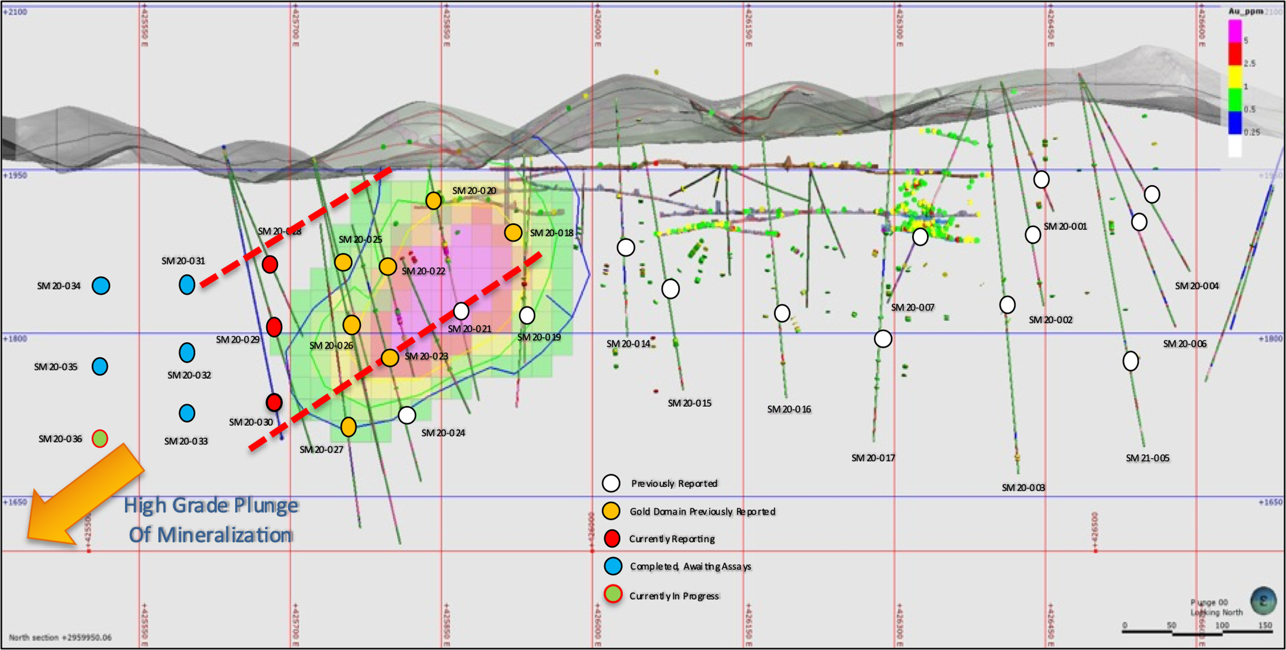

The fence of drill holes SM20-28, 29 and 30 are located 75 meters to the west of drill collars SM20-25, 26, 27, last reported, and were designed to once again tighten up the interpretation of the boundaries of the new Santa Maria gold domain structure with respect the highly auriferous sheeted vein intersected to the east in the previous fence of hole.

The drill holes targeted intercepting the main gold structure at vertical depths of -100, -150, and -200 meters, respectively. As one can see, the interpreted mineral / structural thesis which includes gold mineralization is plunging 45 degrees to the west, has now a true width of 50 meters and continues to validate the interpretation. The gold domain remains open in all directions, especially at depth. See Figure 2, below.

Figure 2 – Cross Section for Drill Hole SM20-28, 29, 30

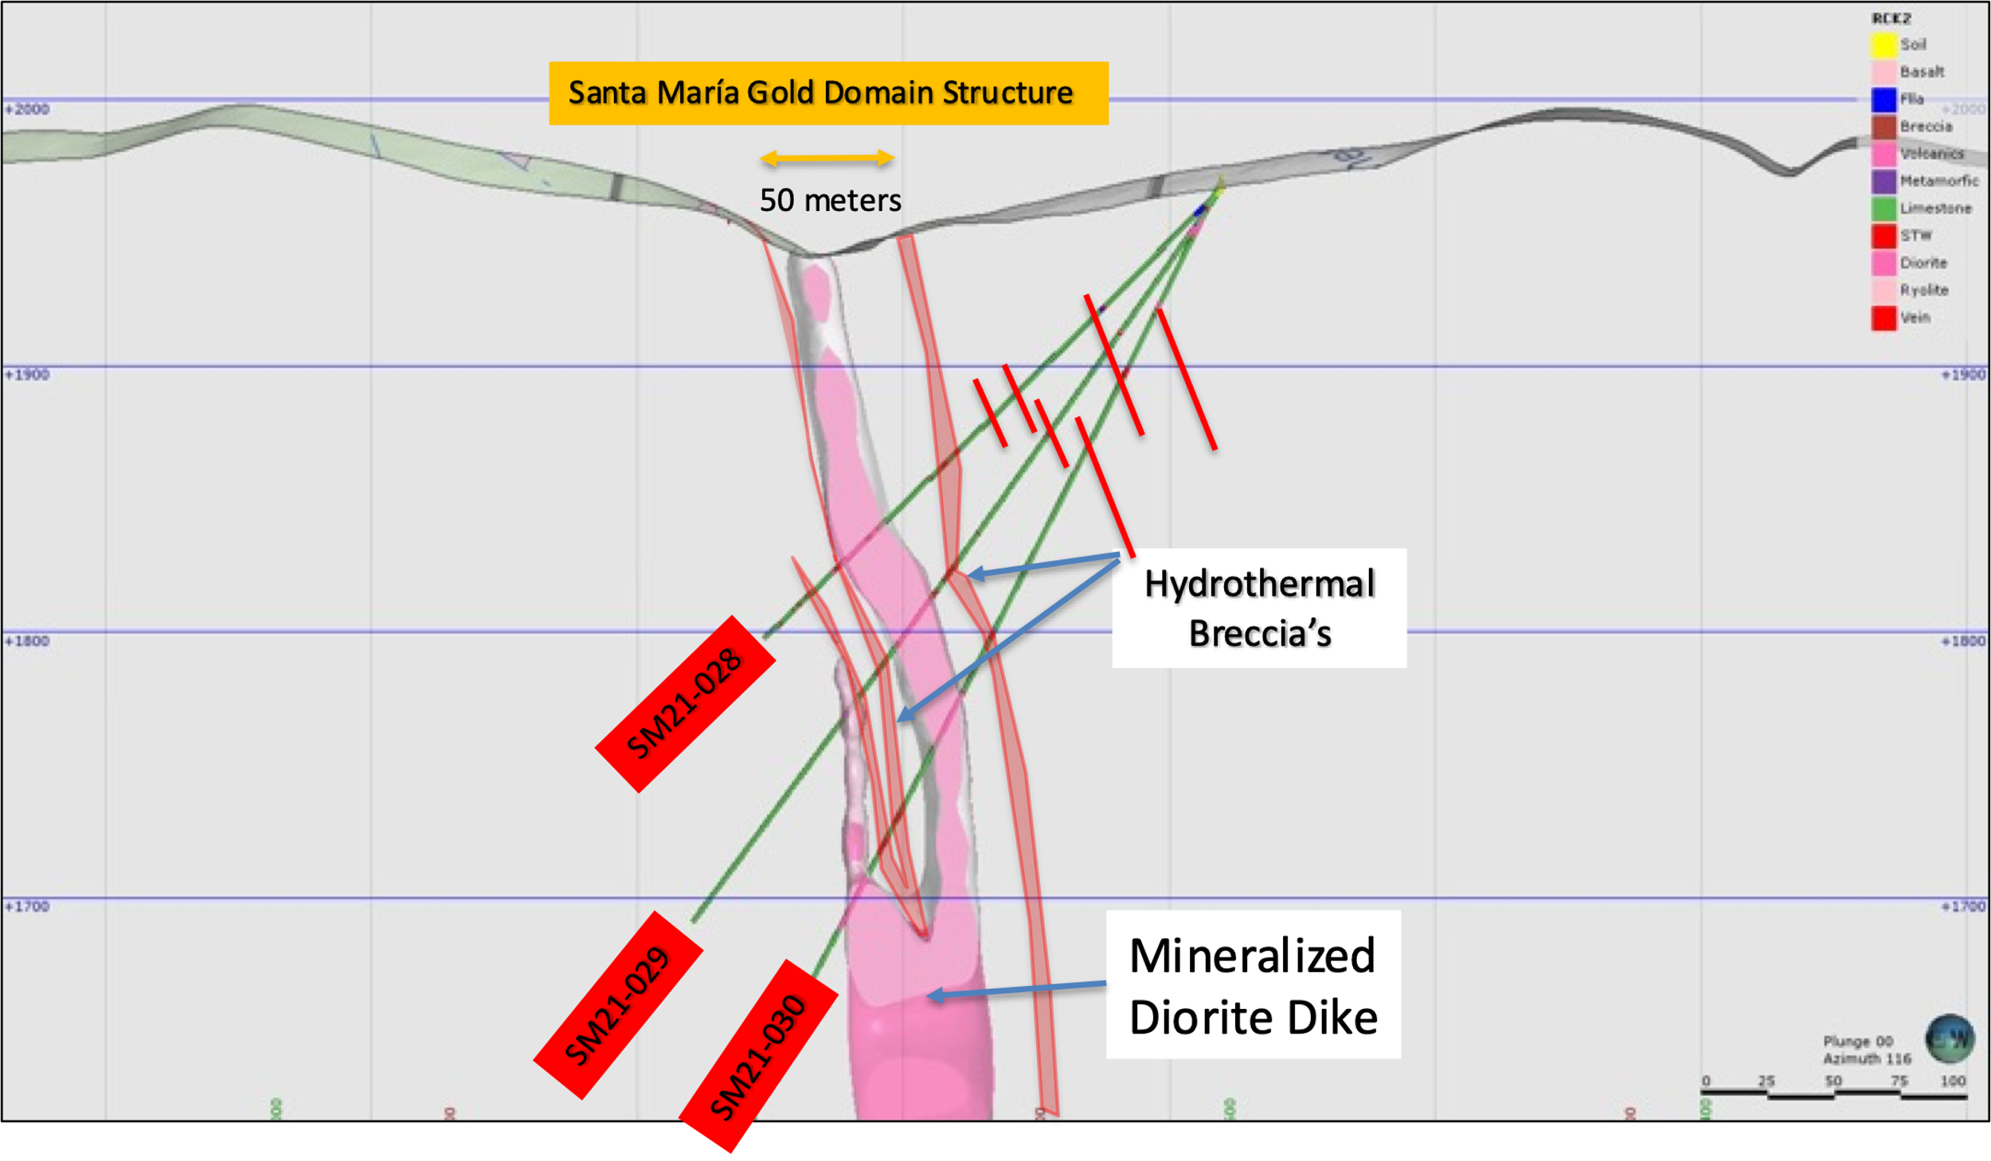

Any vein sheet, micro or macro in size, grading greater than 0.50 g/t gold is highly anomalous and of potential economic interest. Of the 3 holes being reported in this release, 28 and 29 reported 97% of sampled intervals above the gold detection limit and the deepest hole 30 reporting 100%. To try and explain the significance of this hydrothermal gold domain system, the holes and sections below will report all values greater than 0.10 g/t Au cut-off to demonstrate the gold population in the sheeted veins, hydrothermal breccias and mineralized diorite. As you will notice the grade and number of intercepts increases at depth as seen in hole SM20-30. We apologize that each hole results will be plotted on a duplicate section as there are too many intercepts to plot on one section.

SM20 – 28

A sheet vein silicified limestone, laminar or layered structure containing disseminated pyrite was intersected from the collar to approximately 200 meters, this was followed by a quartz cemented hydrothermal breccia with minor pyrite and sphalerite, then a gray porphyritic diorite dike with disseminated sulphides.

A total of 11 intercepts of 0.10 g/t gold were intersect in the hole either in sheeted vein structures, hydrothermal breccias or in the diorite dike including 1.15 meters of 0.51 g/t Au.

See Table 1, Photo 1 and Figure 3 below.

Table 1- Drill hole SM20-28 Assay Results
Drill Hole | From m | To m | Width m | Au g/t | Ag g/t | AgEq* g/t | Pb % | Zn % | Cu %
SM20-28 | 66.00 | 70.80 | 4.80 | 0.18 | 4.79 | 14.05 | 0.02 | 0.05 | 0.01
Including | 66.00 | 66.60 | 0.60 | 0.41 | 4.50 | 25.74 | 0.01 | 0.03 | 0.01
Including | 70.50 | 70.80 | 0.30 | 0.21 | 22.40 | 33.36 | 0.03 | 0.11 | 0.03
 | 109.00 | 111.00 | 2.00 | 0.10 | 9.57 | 14.71 | 0.11 | 0.14 | 0.01
Including | 109.00 | 109.50 | 0.50 | 0.14 | 14.70 | 21.95 | 0.12 | 0.27 | 0.02
Including | 110.20 | 111.00 | 0.80 | 0.14 | 8.60 | 15.60 | 0.08 | 0.10 | 0.01
 | 139.80 | 141.50 | 1.70 | 0.18 | 8.50 | 17.50 | 0.05 | 0.18 | 0.03
 | 146.60 | 147.00 | 0.40 | 0.10 | 7.00 | 12.20 | 0.09 | 0.13 | 0.01
 | 155.00 | 155.50 | 0.50 | 0.21 | 10.10 | 20.75 | 0.13 | 0.26 | 0.01
 | 202.75 | 209.20 | 6.45 | 0.13 | 7.60 | 14.29 | 0.06 | 0.20 | 0.01
Including | 204.40 | 205.55 | 1.15 | 0.51 | 26.50 | 52.73 | 0.21 | 0.63 | 0.01
Including | 205.55 | 205.75 | 0.20 | 0.10 | 14.40 | 19.60 | 0.01 | 0.02 | 0.00
Including | 208.70 | 209.20 | 0.50 | 0.15 | 11.00 | 18.72 | 0.23 | 0.79 | 0.03
 | 223.55 | 224.50 | 0.95 | 0.21 | 7.30 | 18.15 | 0.03 | 0.12 | 0.06
- ** Ag Equivalent (“Ag Eq”) grade is calculated using $20 per ounce Ag and $1,600 Au

Photo 1 – SM20-28
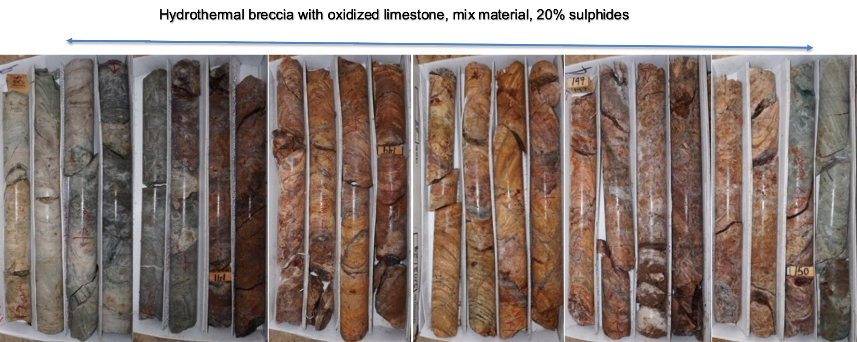

Figure 3 – Cross Section for Drill Hole SM20-28
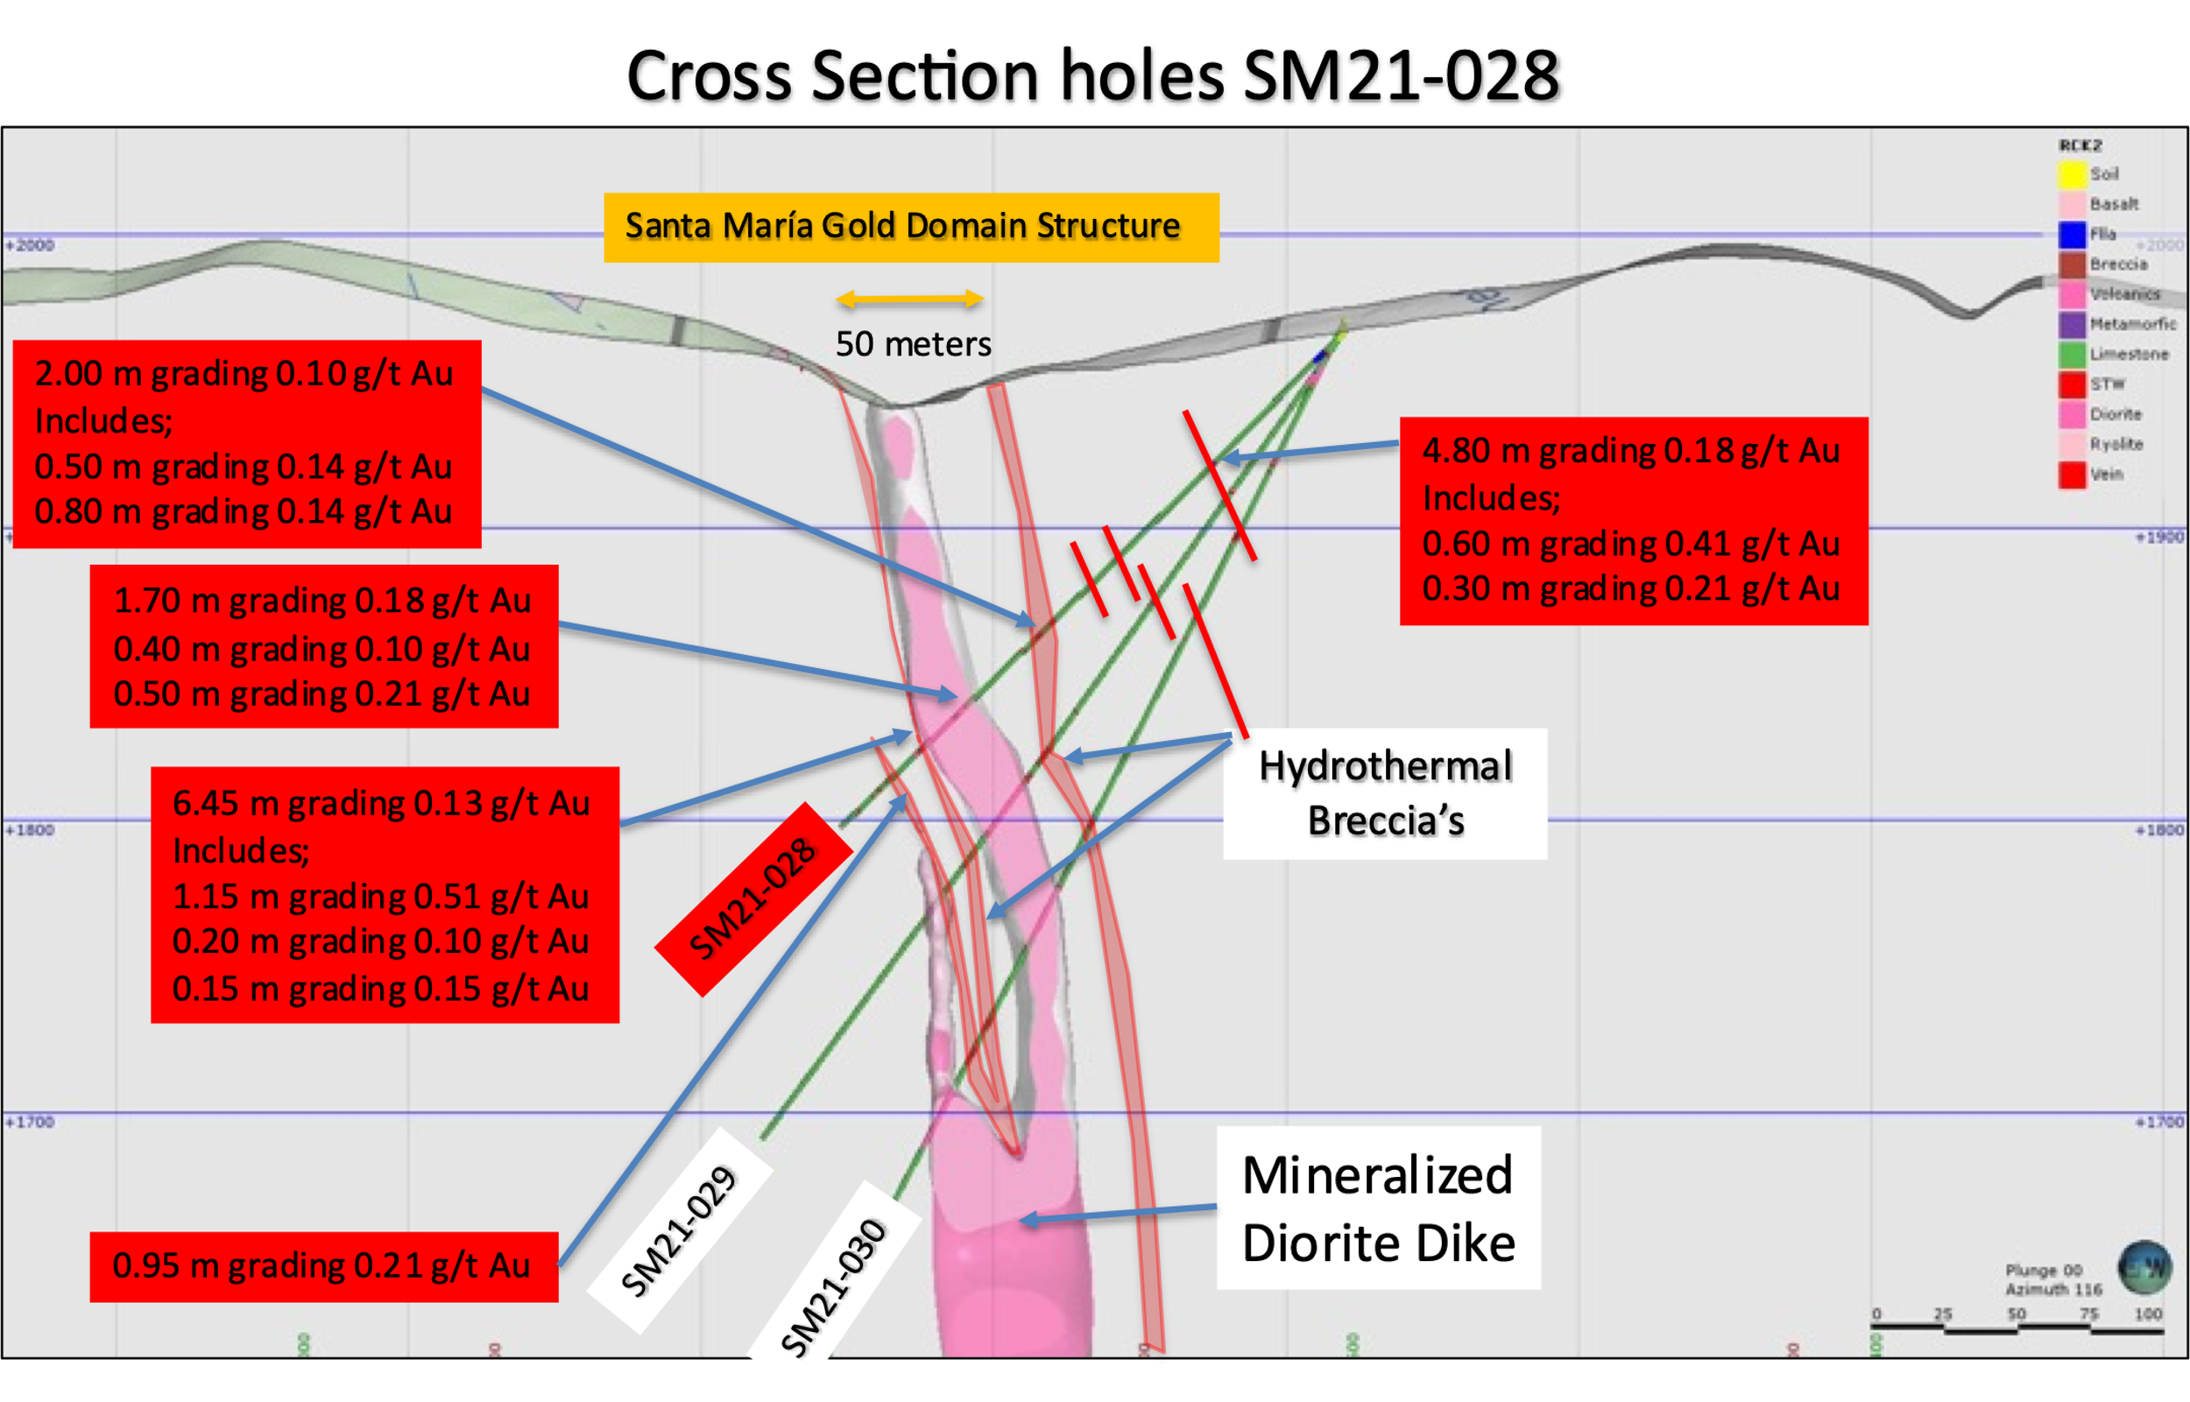

SM20-29

Surface diamond drill hole SM20-29 was drilled underneath hole 28 at -45 degrees to target an intercept at -150 meters and was successful.

A sheet vein, silicified limestone, gray to greenish in color, laminar, with calcite – carbonate veinlets with sulphide halos was intercepted to approximately 180 meters, followed by 12 meters of oxidized quartz cemented hydrothermal breccia with minor pyrite and sphalerite then 20 meters of sheeted veins as seen previously in the hole, followed by 19 meters of hydrothermal breccia, 8 meters of mineralized diorite dike and finally hydrothermal breccia

This time a total of 31 intercepts of 0.10 g/t gold were intersect in the hole either in sheeted vein structures, hydrothermal breccias of in the 14.50 meter diorite dike including base metal feeder type mineralization which reported 0.27 g/t Au with 75.59 g/t Ag Eq, 0.66% Pb, 11.90% Zn. The frequency of the mineralization has increase at depth. See Table 2, Photo 2 and Figure 4 below.

Table 2- Drill hole SM20-29 Assay Results
Drill Hole | From m | To m | Width m | Au g/t | Ag g/t | Ag Eq* g/t | Pb % | Zn % | Cu %
SM20-29 | 10.50 | 11.40 | 0.90 | 0.11 | 7.20 | 12.60 | 0.03 | 0.10 | 0.01
 | 29.70 | 29.90 | 0.20 | 0.12 | 4.90 | 10.97 | 0.09 | 0.11 | 0.00
 | 31.50 | 32.50 | 1.00 | 0.10 | 2.30 | 7.55 | 0.03 | 0.05 | 0.00
 | 47.25 | 47.80 | 0.55 | 0.11 | 6.00 | 11.86 | 0.04 | 0.09 | 0.00
 | 62.70 | 77.20 | 14.50 | 0.10 | 4.08 | 8.71 | 0.03 | 0.24 | 0.01
Including | 62.70 | 63.55 | 0.85 | 0.23 | 28.32 | 40.15 | 0.39 | 2.97 | 0.02
Including | 62.70 | 63.10 | 0.40 | 0.30 | 7.90 | 23.33 | 0.09 | 0.20 | 0.01
Including | 63.35 | 63.55 | 0.20 | 0.27 | 61.70 | 75.59 | 0.66 | 11.90 | 0.05
Including | 68.10 | 69.00 | 0.90 | 0.13 | 1.70 | 8.39 | 0.01 | 0.05 | 0.00
Including | 69.80 | 71.00 | 1.20 | 0.16 | 4.40 | 12.63 | 0.01 | 0.04 | 0.01
Including | 74.20 | 75.30 | 1.10 | 0.11 | 3.40 | 9.06 | 0.02 | 0.05 | 0.01
Including | 75.30 | 76.30 | 1.00 | 0.10 | 3.10 | 8.24 | 0.01 | 0.05 | 0.01
 | 86.20 | 95.05 | 8.85 | 0.15 | 2.36 | 10.08 | 0.02 | 0.03 | 0.00
Including | 86.20 | 87.00 | 0.80 | 0.22 | 0.09 | 11.41 | 0.00 | 0.01 | 0.00
Including | 87.00 | 87.30 | 0.30 | 0.58 | 6.60 | 36.44 | 0.04 | 0.05 | 0.01
Including | 87.30 | 87.70 | 0.40 | 0.84 | 21.20 | 64.41 | 0.15 | 0.15 | 0.02
Including | 87.70 | 88.10 | 0.40 | 0.12 | 2.80 | 8.97 | 0.01 | 0.01 | 0.01
Including | 91.40 | 93.00 | 1.60 | 0.13 | 1.70 | 8.39 | 0.02 | 0.05 | 0.01
Including | 94.30 | 94.80 | 0.50 | 0.14 | 1.20 | 8.40 | 0.01 | 0.01 | 0.00
Including | 94.80 | 95.50 | 0.25 | 0.17 | 3.80 | 12.54 | 0.02 | 0.06 | 0.01
 | 115.00 | 115.55 | 0.55 | 0.12 | 4.10 | 10.27 | 0.02 | 0.07 | 0.01
 | 118.50 | 120.90 | 2.40 | 0.11 | 13.20 | 18.86 | 0.12 | 0.13 | 0.08
Including | 118.50 | 119.60 | 1.10 | 0.15 | 11.30 | 19.07 | 0.13 | 0.06 | 0.07
Including | 120.50 | 120.90 | 0.40 | 0.10 | 23.50 | 28.85 | 0.18 | 0.35 | 0.15
 | 144.90 | 145.10 | 0.20 | 0.64 | 93.40 | 126.22 | 1.90 | 1.48 | 0.68
Drill Hole | From m | To m | Width m | Au g/t | Ag g/t | Ag Eq* g/t | Pb % | Zn % | Cu %
SM20-29 | 175.50 | 176.40 | 0.90 | 0.36 | 5.40 | 23.71 | 0.06 | 0.16 | 0.01
 | 190.20 | 190.55 | 0.30 | 0.67 | 29.50 | 63.91 | 0.35 | 1.10 | 0.10
 | 193.20 | 193.70 | 0.50 | 0.10 | 2.20 | 7.40 | 0.06 | 0.06 | 0.00
 | 197.70 | 198.30 | 0.60 | 0.60 | 6.80 | 37.66 | 0.11 | 0.22 | 0.03
 | 211.95 | 213.00 | 1.05 | 0.10 | 2.20 | 7.50 | 0.02 | 0.04 | 0.00
 | 224.80 | 226.20 | 1.40 | 0.53 | 7.90 | 35.16 | 0.11 | 0.30 | 0.01
 | 241.10 | 242.00 | 0.90 | 0.202 | 5.20 | 15.59 | 0.02 | 0.02 | 0.01
 | 248.45 | 249.80 | 1.35 | 0.14 | 6.80 | 14.05 | 0.08 | 0.24 | 0.02
 | 267.30 | 267.55 | 0.25 | 0.19 | 69.20 | 79.13 | 0.02 | 0.02 | 0.01
- ** Ag Equivalent (“Ag Eq”) grade is calculated using $20 per ounce Ag and $1,600 Au

Photo 2- Hole SM20-29
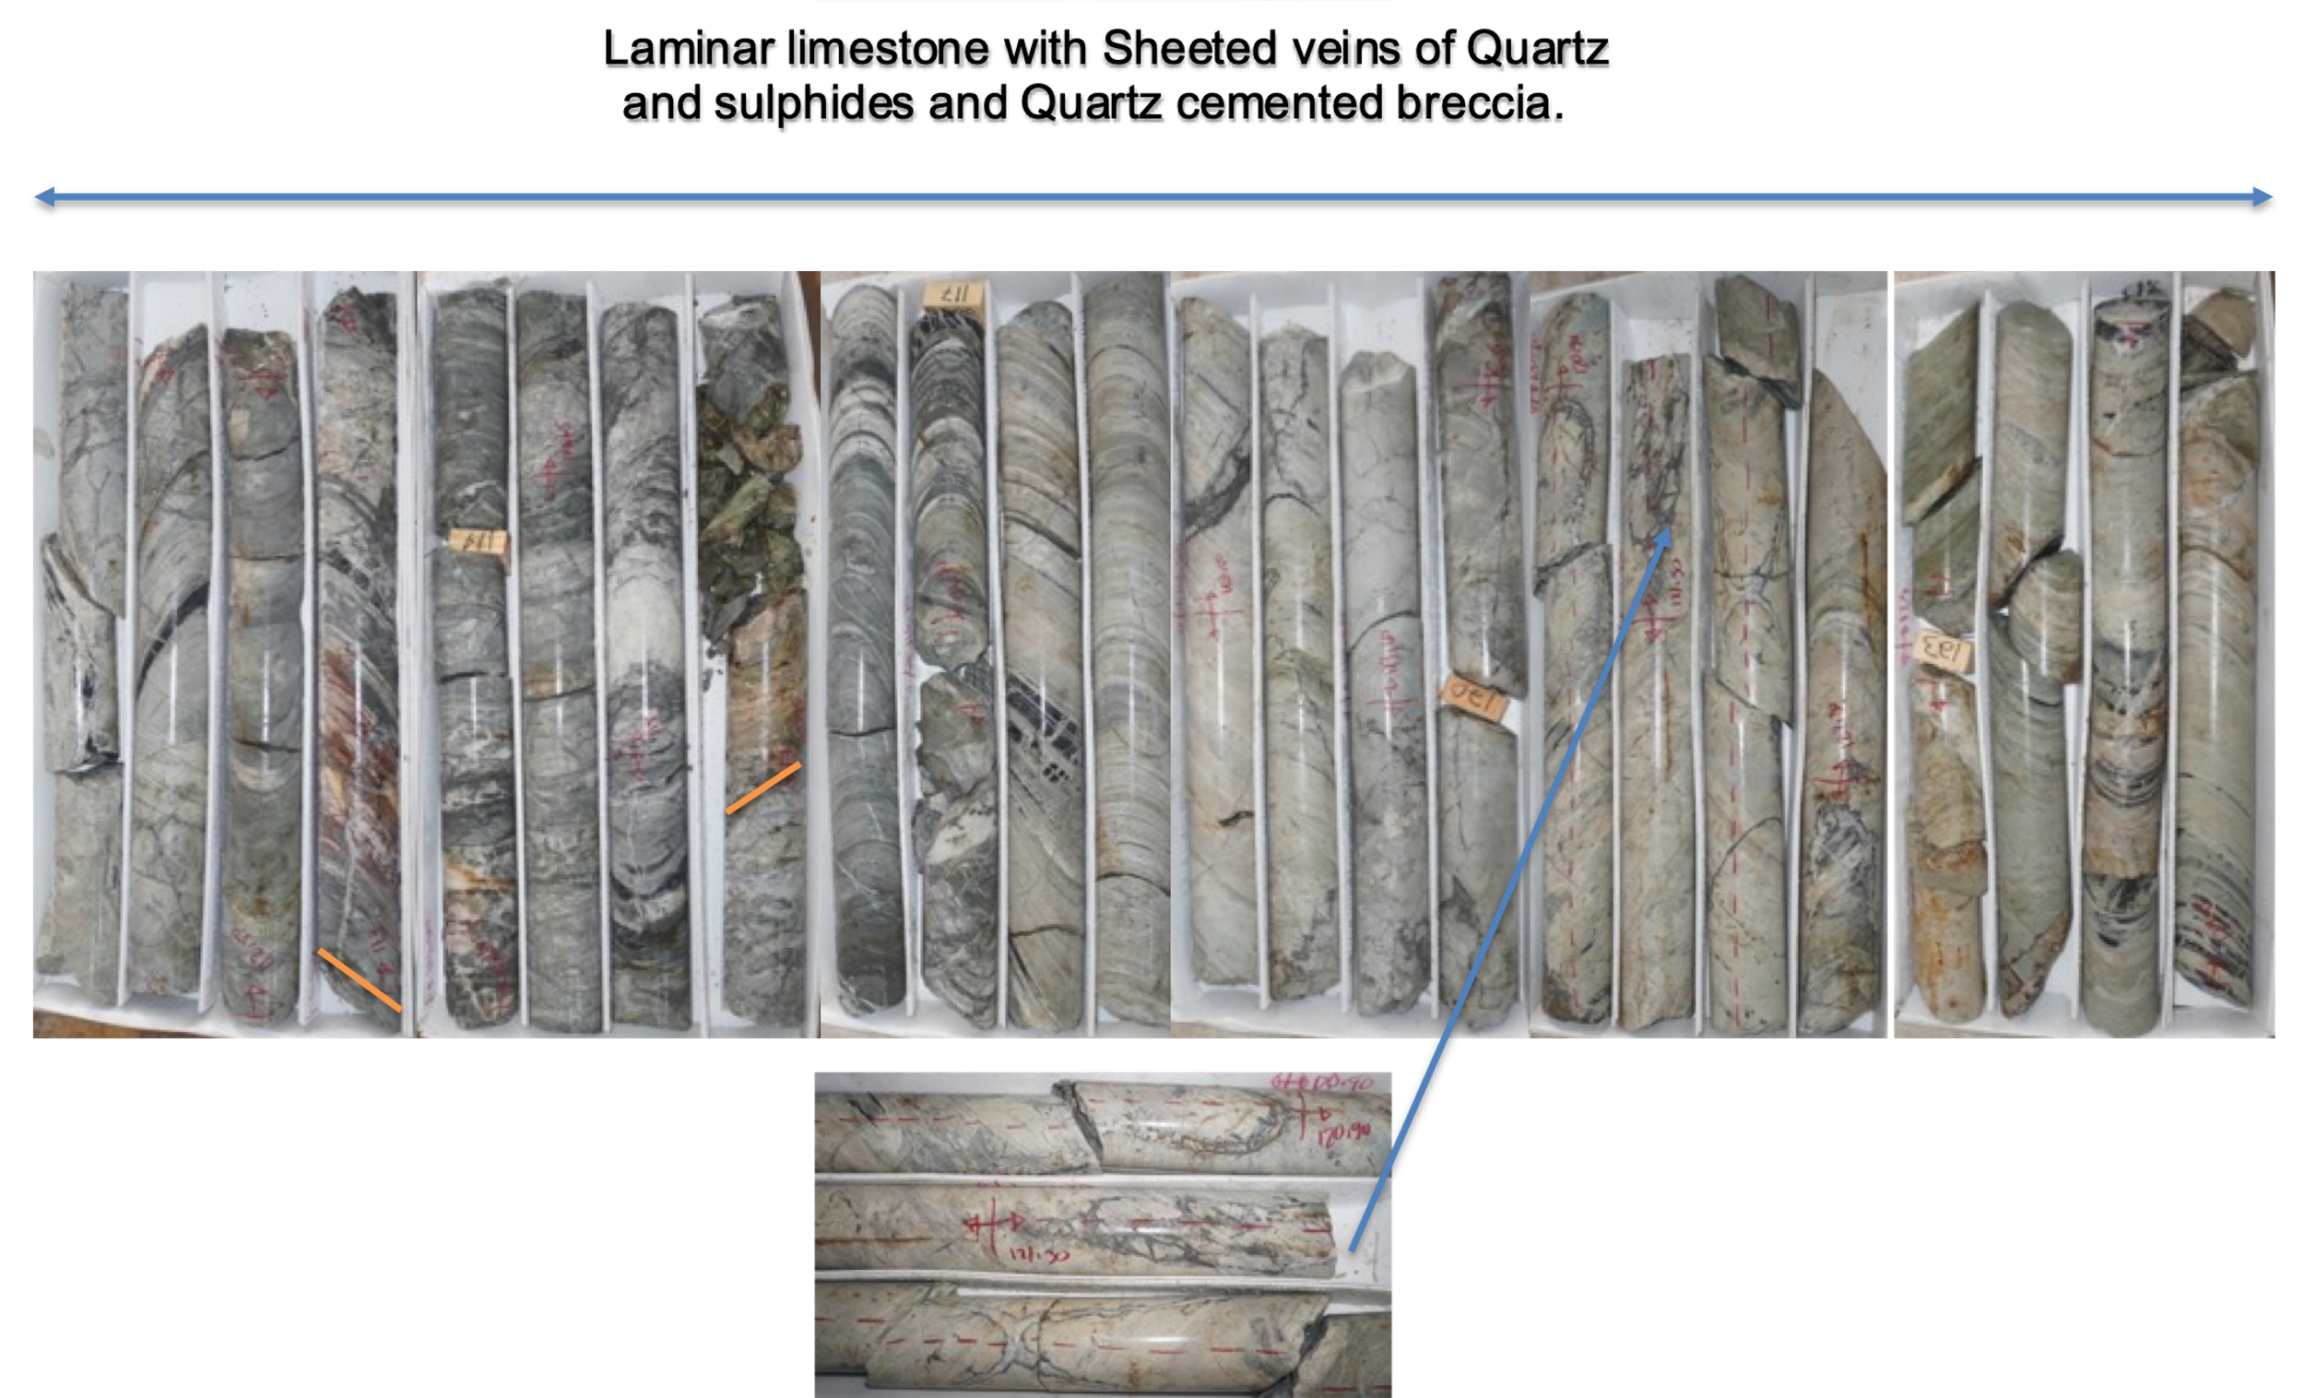

Figure 4 – Cross Section for Drill Hole SM20-29
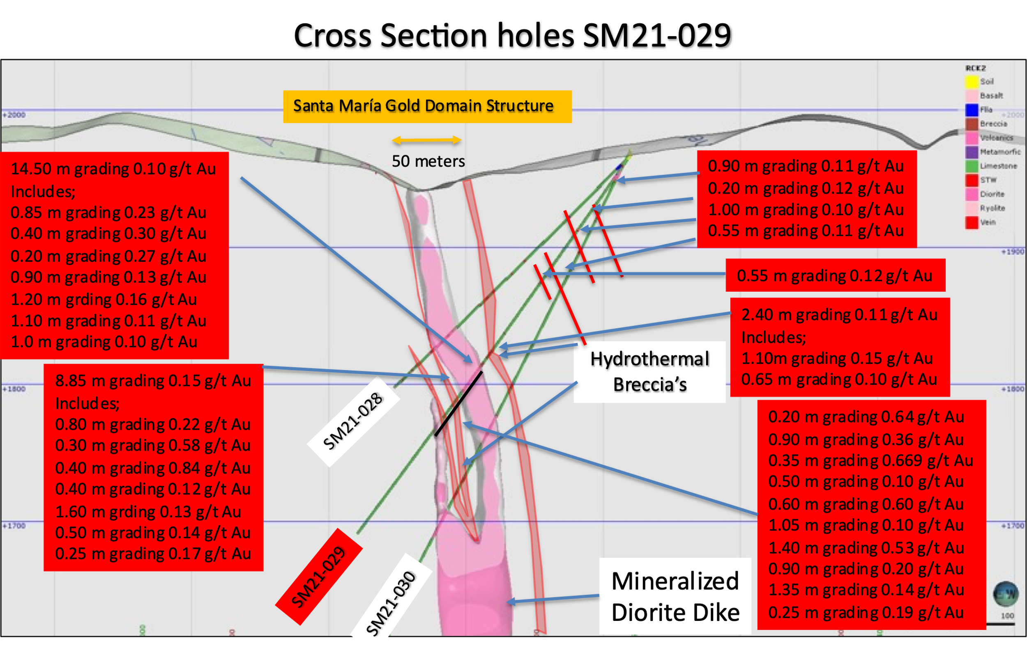

SM20-30

Surface diamond drill hole SM20-30 was drilled underneath hole 29 at -60 degrees to target an intercept at -200 meters and was again was successful.

Increased intensity in the sheeted veins in silicified limestone, gray in color, laminar with calcite – carbonate veinlets with sulphide halos was seen to approximately 220 meters, followed by 20 meters of oxidized diorite dike with sulphide bearing quartz veinlets as sheets followed by 18 meters of cemented hydrothermal breccia with replacement features, pyrite and sphalerite content increasing, then followed by 68 meters of silicified limestone breccia’s with hydrothermal quartz filling matrix and fine pyrite.

Note the increase in intensity at depth and increase gold content, with over 22 intercepts in the hole greater than 0.10 g/t gold. Also intersected was the base metal feeder type mineralization seen in hole 29 and reported an increased grade of 1.57 g/t Au with 202.76 g/t Ag Eq, 3.68% Pb, 14.30% Zn and 0.14% Cu.

See Table 3, Photos 3, 4, 5 and Figure 5 below.

Table 3- Drill hole SM20-30 Assay Results
Drill Hole | From m | To m | Width m | Au g/t | Ag g/t | Ag Eq* g/t | Pb % | Zn % | Cu %
SM20-30 | 7.80 | 10.10 | 2.30 | 0.14 | 4.42 | 11.62 | 0.03 | 0.10 | 0.01
 | 12.80 | 15.00 | 2.20 | 0.14 | 8.94 | 16.14 | 0.03 | 0.11 | 0.01
 | 26.60 | 27.20 | 0.60 | 0.17 | 6.10 | 14.84 | 0.04 | 0.08 | 0.00
 | 43.80 | 47.70 | 3.90 | 0.11 | 3.88 | 9.54 | 0.05 | 0.10 | 0.01
Including | 43.80 | 44.10 | 0.30 | 0.19 | 2.90 | 12.67 | 0.01 | 0.02 | 0.00
 | 56.40 | 59.20 | 2.80 | 0.15 | 4.43 | 12.15 | 0.04 | 0.17 | 0.01
Including | 58.60 | 59.20 | 0.60 | 0.26 | 2.20 | 15.57 | 0.02 | 0.06 | 0.00
 | 70.50 | 72.00 | 1.50 | 0.14 | 2.40 | 9.60 | 0.01 | 0.03 | 0.01
 | 76.50 | 78.00 | 1.50 | 0.13 | 6.80 | 13.49 | 0.25 | 0.37 | 0.02
 | 99.90 | 108.80 | 2.90 | 0.12 | 2.50 | 8.47 | 0.15 | 0.01 | 0.00
 | 118.50 | 120.00 | 1.50 | 0.11 | 1.70 | 7.36 | 0.00 | 0.00 | 0.00
 | 122.10 | 122.80 | 0.70 | 1.57 | 122.00 | 202.76 | 3.68 | 14.30 | 0.14
 | 163.00 | 164.70 | 1.70 | 0.10 | 4.60 | 9.74 | 0.05 | 0.71 | 0.02
 | 214.40 | 214.70 | 0.30 | 0.10 | 1.40 | 6.54 | 0.01 | 0.03 | 0.00
 | 216.10 | 217.00 | 0.90 | 0.19 | 5.50 | 15.27 | 0.05 | 0.13 | 0.01
 | 222.30 | 222.60 | 0.30 | 0.10 | 4.80 | 9.94 | 0.01 | 0.00 | 0.00
 | 231.00 | 232.50 | 1.50 | 0.14 | 6.70 | 13.90 | 0.11 | 0.47 | 0.10
 | 268.00 | 268.50 | 0.50 | 0.23 | 14.90 | 26.73 | 0.43 | 1.28 | 0.07
 | 280.20 | 291.80 | 11.60 | 0.45 | 12.87 | 36.02 | 0.80 | 0.78 | 0.03
Including | 280.20 | 281.30 | 1.10 | 0.14 | 15.40 | 22.60 | 0.54 | 0.97 | 0.04
Including | 282.50 | 283.00 | 0.50 | 0.52 | 17.40 | 44.15 | 0.41 | 1.02 | 0.04
Including | 284.20 | 285.10 | 0.90 | 2.60 | 40.40 | 174.14 | 0.58 | 2.27 | 0.13
Including | 284.20 | 284.80 | 0.60 | 1.79 | 35.00 | 127.08 | 0.69 | 2.55 | 0.09
Including | 284.80 | 285.10 | 0.30 | 4.22 | 51.20 | 268.28 | 0.36 | 1.70 | 0.21
Including | 285.10 | 285.40 | 0.30 | 0.30 | 12.50 | 27.93 | 0.23 | 0.33 | 0.03
Including | 286.20 | 286.70 | 0.50 | 0.42 | 9.70 | 31.30 | 0.16 | 0.63 | 0.02
Including | 288.90 | 289.60 | 0.70 | 1.28 | 43.40 | 109.24 | 0.77 | 4.31 | 0.12
 | 295.00 | 295.60 | 0.60 | 0.10 | 5.90 | 11.04 | 0.04 | 0.10 | 0.01
 | 314.70 | 316.00 | 1.30 | 0.10 | 6.60 | 11.74 | 0.06 | 0.14 | 0.01
- ** Ag Equivalent (“Ag Eq”) grade is calculated using $20 per ounce Ag and $1,600 Au

Photo 3- Hole SM20-30; Base Metal Feeder Mineralization
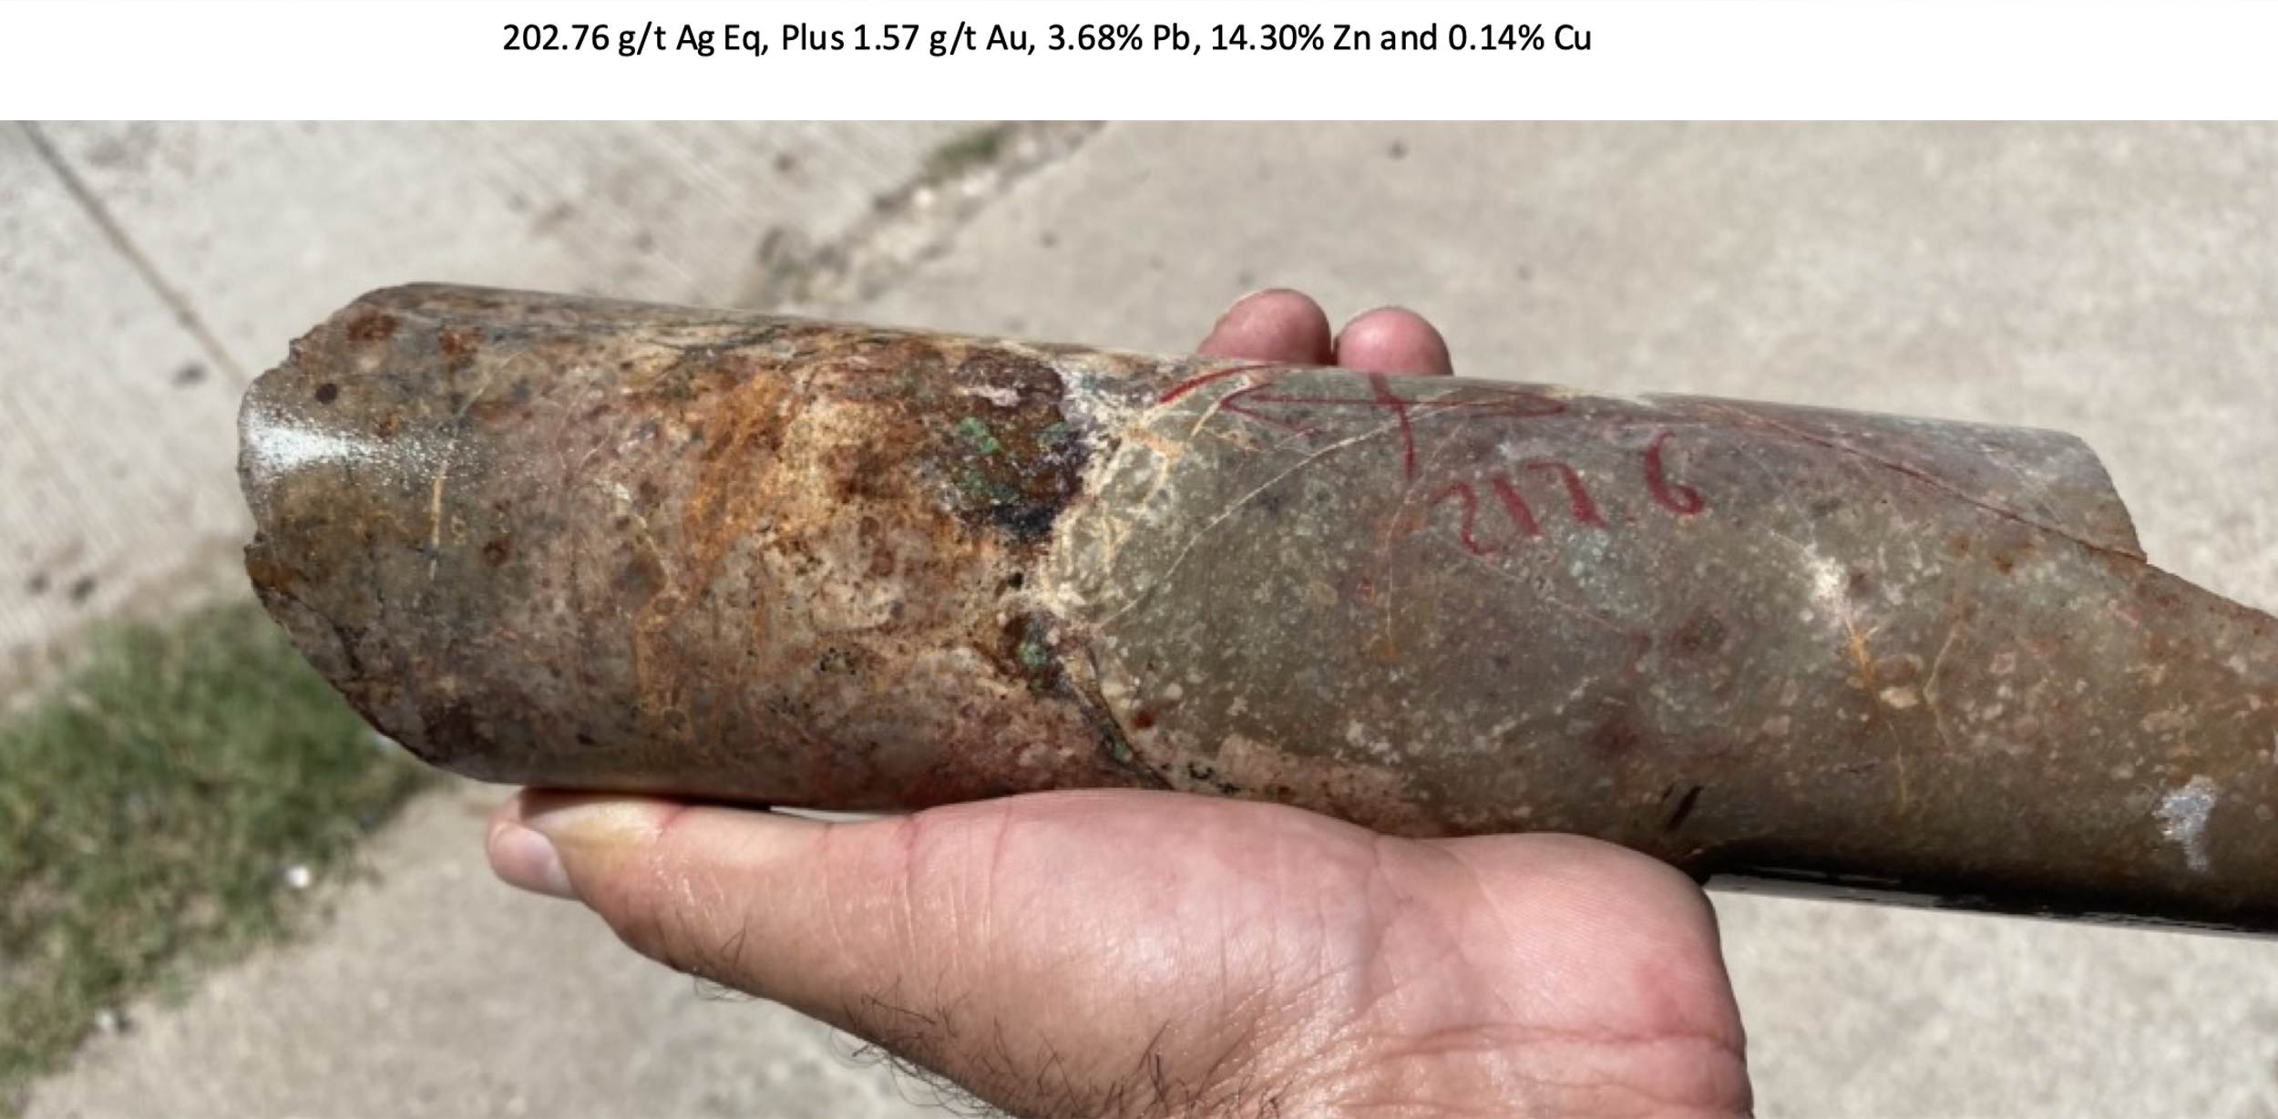

Photo 4- Hole SM20-30; Silicified Limestone, Quartz Breccia
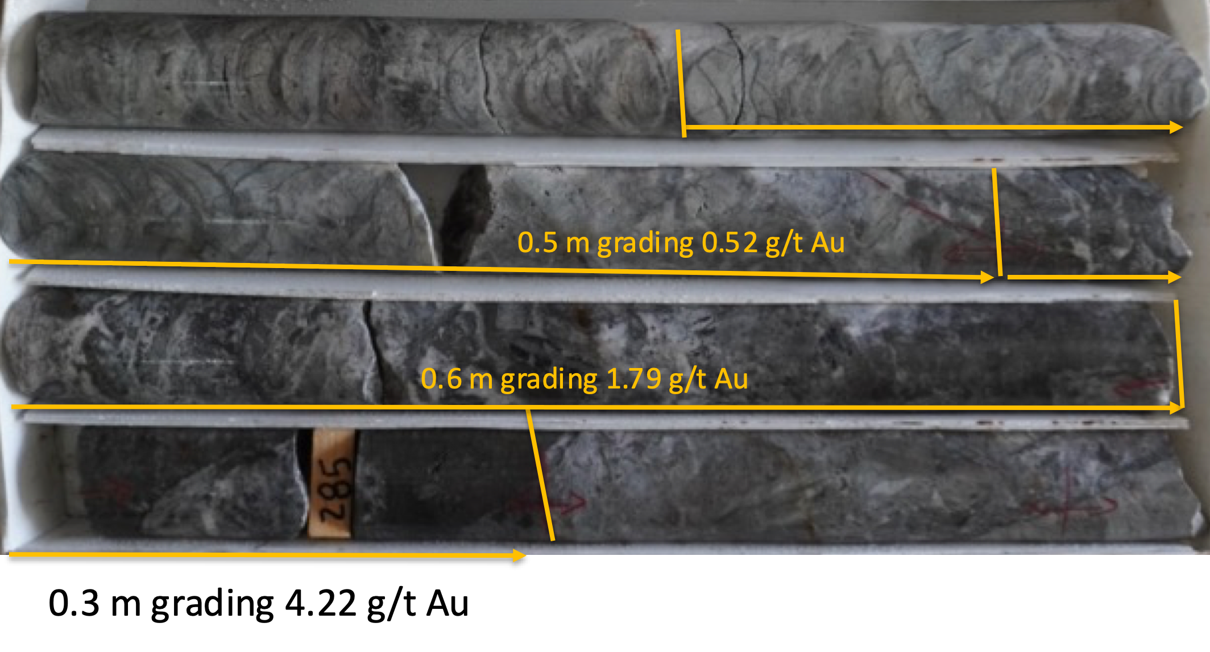

Photo 5 – Hole SM20-30; Silicified Hydrothermal Breccia With Fine Pyrite
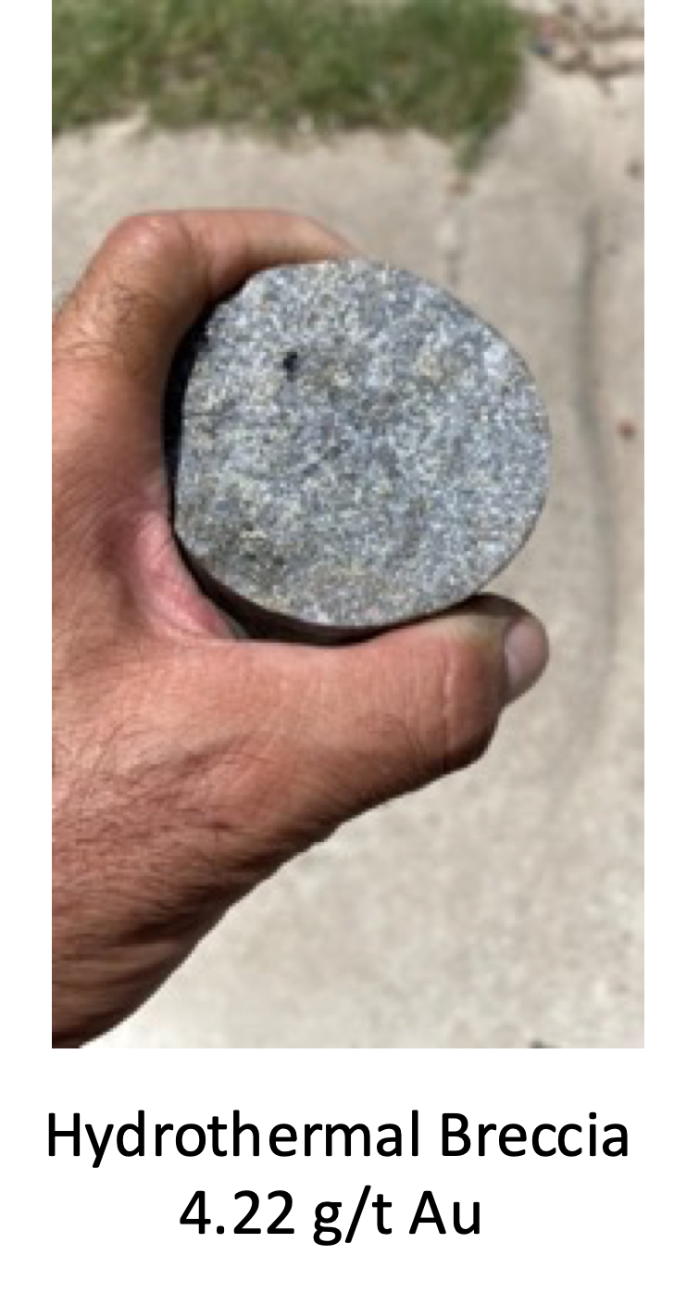

Figure 5 – Cross Section for Drill Hole SM20-30
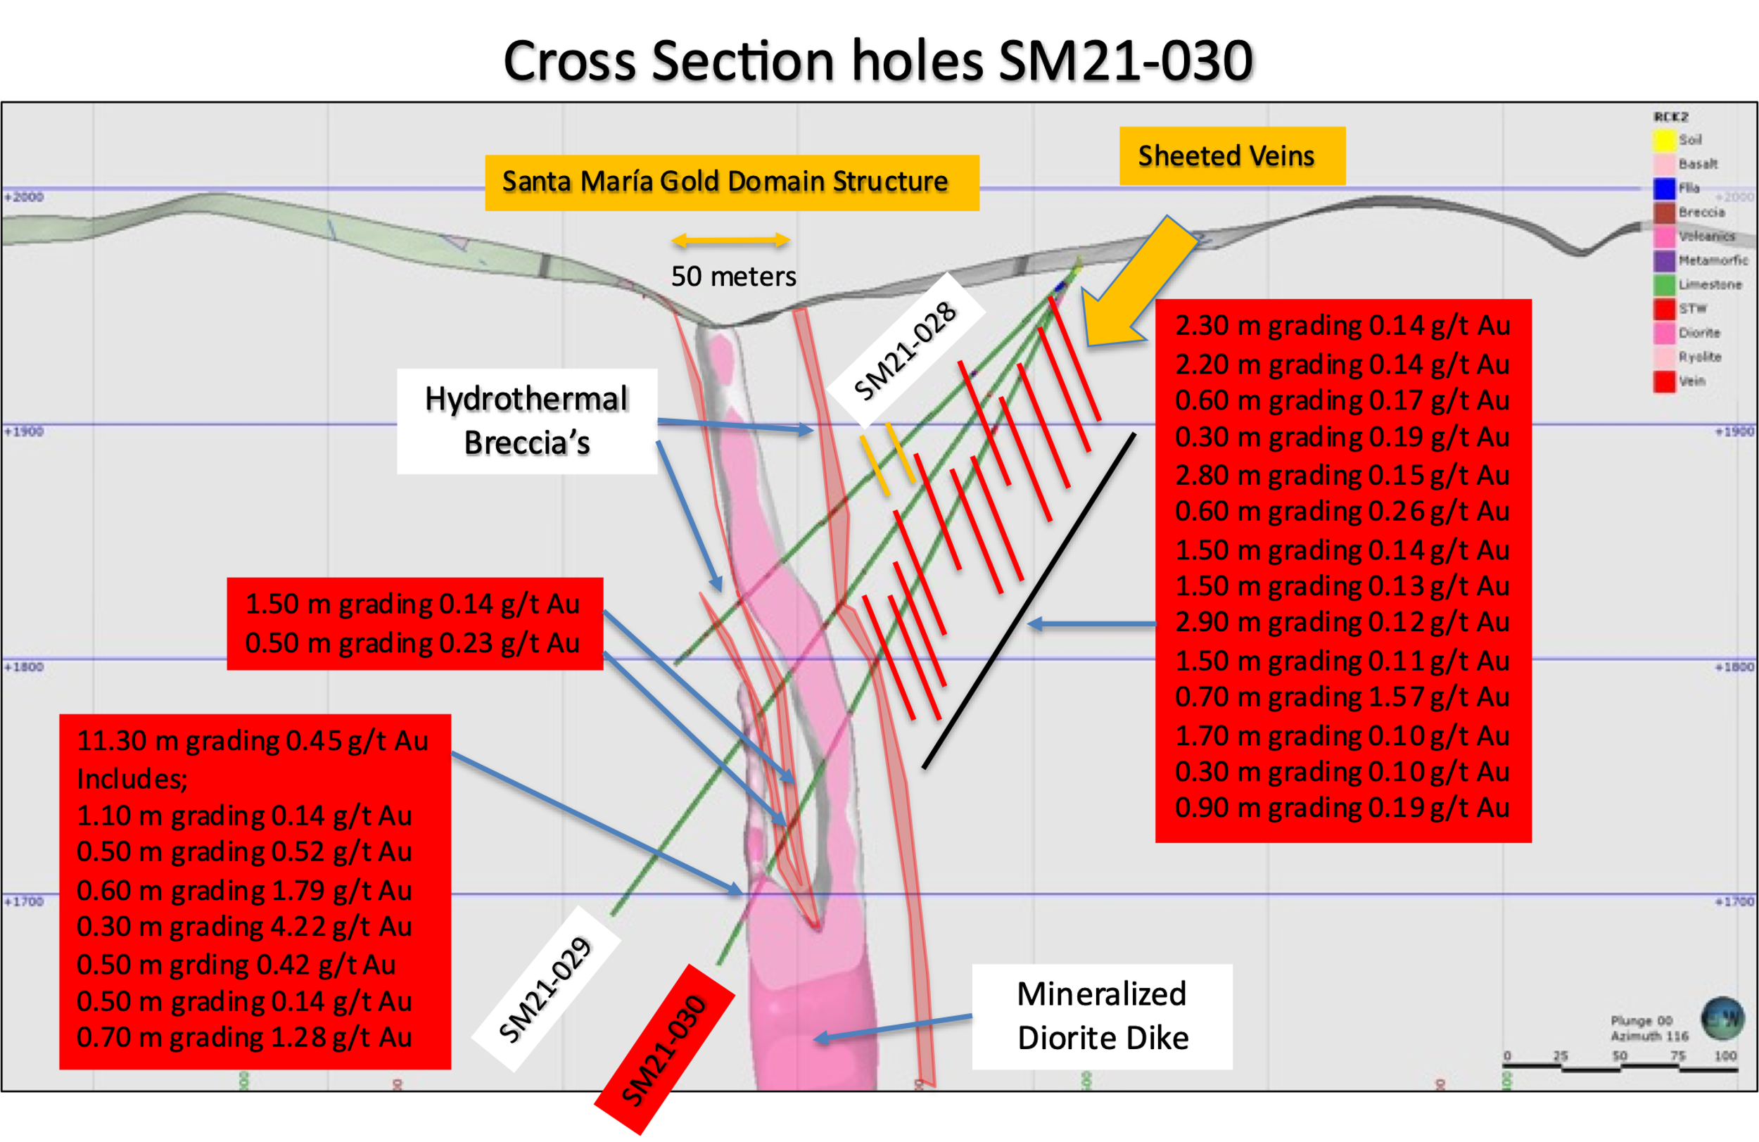

Discussion
It now is the belief, that the mineralized diorite dike being encountered in present drilling or re-logged in past historical drilling is the direct cause of the hydrothermal gold domain system and increases with mineralization at depth. The emplacement of the dike caused breccias and sheeted veins to the sides of the walls over considerable widths. The sheeted veins may have been shatter veins replaced with quartz, carbonate and mineralization. See Figure 6 below of modeled diorite dike looking east and north. Modelling is ongoing.
Figure 6 – Mineralized Diorite Dike Model
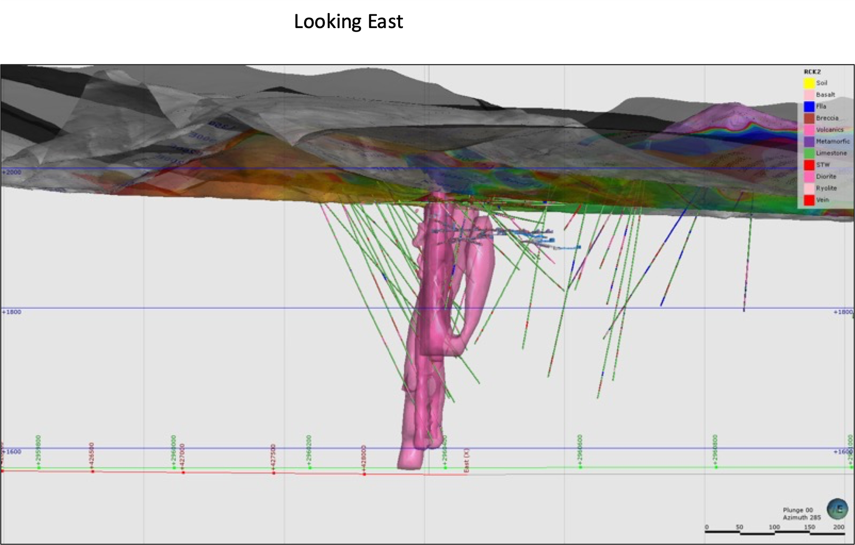
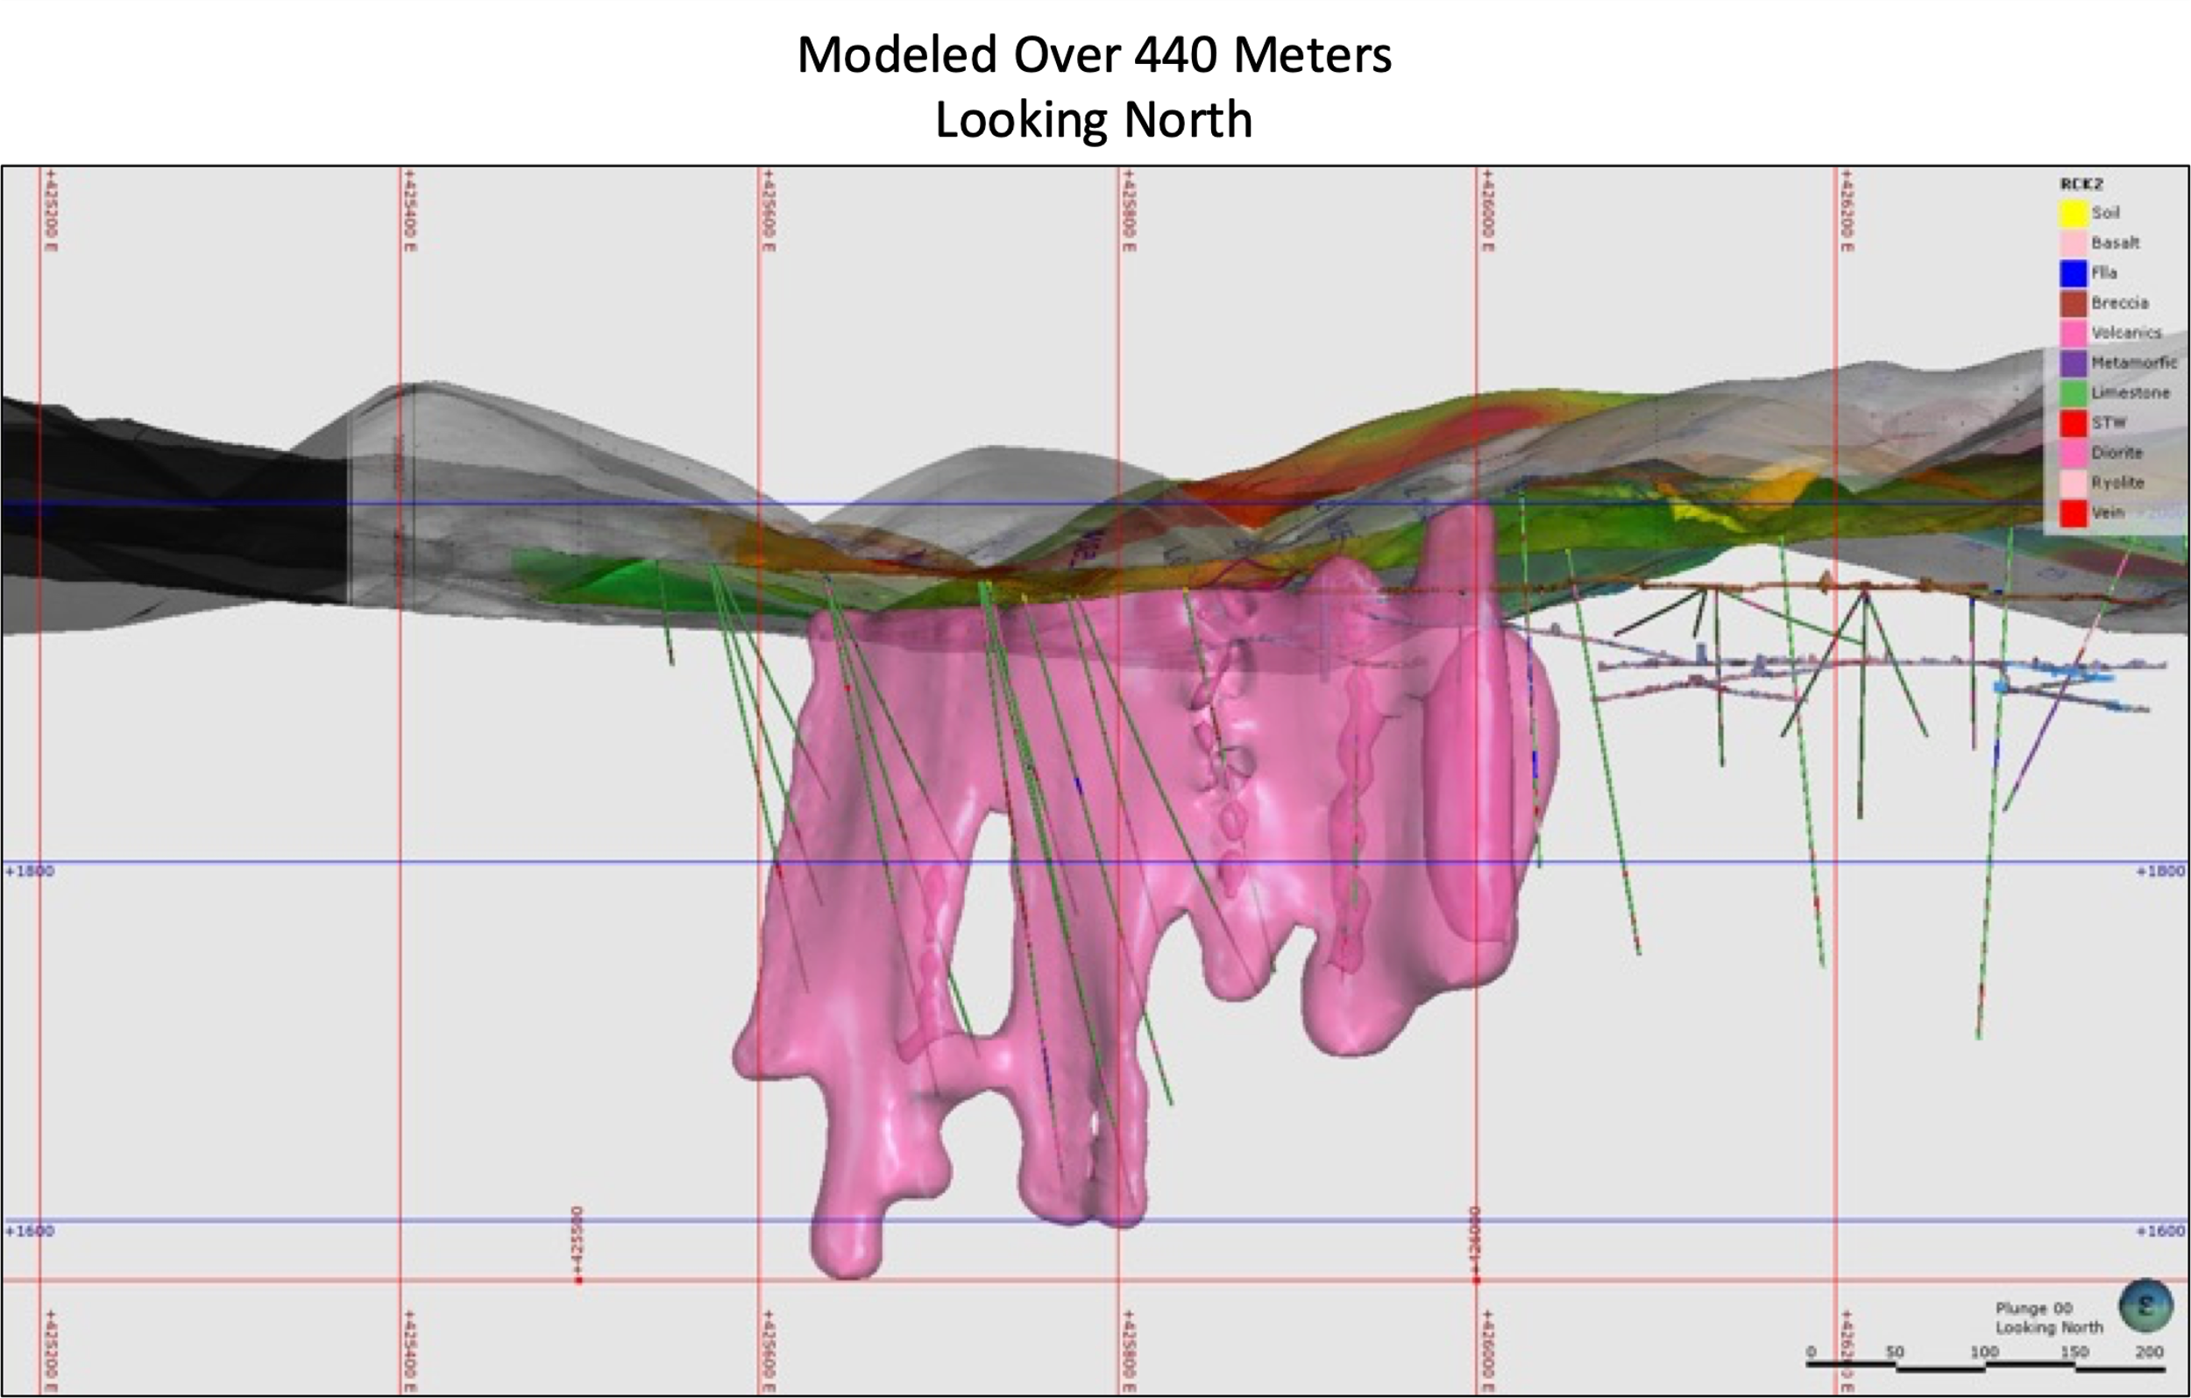

FUTURE DRILLING UPDATE
The fence of drill holes SM20-31, 32 and 33 are located another 75 meters to the west of drill collars SM20-28, 29 and 30 and were designed to again tighten up the interpretation or boundaries of the new Santa Maria gold structure, see Figure 1 above.
Holes SM20-34,35,36 are the last fence of holes near our western boundary and located 150 meters west of drill set up 28, 29 and 30.
Drill holes SM20-31 – 36 have been completed and submitted for assay. Hole SM20-37 is in progress and sites for other holes are being planned, subject to assays results and structural / dike interpretation.

QA QC Procedure

Analytical results of sampling reported by Fabled Silver Gold represent core samples that have been sawn in half with half of the core sampled and submitted by Fabled Silver Gold staff directly to ALS Chemex, Chihuahua, Chihuahua, Mexico. Samples were crushed, split, and pulverized as per ALS Chemex method PREP-31, then analyzed for ME-ICP61 33 element package by four acid digestion with ICP-AES Finish. ME-GRA21 method for Au and Ag by fire assay and gravimetric finish, 30g nominal sample weight.

Over Limit Methods
For samples triggering precious metal over-limit thresholds of 10 g/t Au or 100 g/t Ag, the following is being used:
Au-GRA21 Au by fire assay and gravimetric finish with 30 g sample.
Ag-GRA21 Ag by fire assay and gravimetric finish.
Fabled Silver Gold monitors QA/QC using commercially sourced standards and locally sourced blank materials inserted within the sample sequence at regular intervals.

About Fabled Silver Gold Corp.

Fabled is focused on acquiring, exploring and operating properties that yield near-term metal production. The Company has an experienced management team with multiple years of involvement in mining and exploration in Mexico. The Company's mandate is to focus on acquiring precious metal properties in Mexico with blue-sky exploration potential.

The Company has entered into an agreement with Golden Minerals Company (NYSE American and TSX: AUMN) to acquire the Santa Maria Property, a high-grade silver-gold property situated in the center of the Mexican epithermal silver-gold belt. The belt has been recognized as a significant metallogenic province, which has reportedly produced more silver than any other equivalent area in the world.

Mr. Peter J. Hawley, President and C.E.O.
Fabled Silver Gold Corp.
Phone: (819) 316-0919
peter@fabledfco.com

For further information please contact:

info@fabledfco.com

The technical information contained in this news release has been approved by Peter J. Hawley, P.Geo. President and C.E.O. of Fabled, who is a Qualified Person as defined in National Instrument 43-101 - Standards of Disclosure for Mineral Projects.

Neither the TSX Venture Exchange nor its Regulations Service Provider (as that term is defined in the policies of the TSX Venture Exchange) does accept responsibility for the adequacy or accuracy of this news release.

Certain statements contained in this news release constitute "forward-looking information" as such term is used in applicable Canadian securities laws. Forward-looking information is based on plans, expectations and estimates of management at the date the information is provided and is subject to certain factors and assumptions, including, that the Company's financial condition and development plans do not change as a result of unforeseen events and that the Company obtains any required regulatory approvals.

Forward-looking information is subject to a variety of risks and uncertainties and other factors that could cause plans, estimates and actual results to vary materially from those projected in such forward-looking information. Some of the risks and other factors that could cause results to differ materially from those expressed in the forward-looking statements include, but are not limited to: impacts from the coronavirus or other epidemics, general economic conditions in Canada, the United States and globally; industry conditions, including fluctuations in commodity prices; governmental regulation of the mining industry, including environmental regulation; geological, technical and drilling problems; unanticipated operating events; competition for and/or inability to retain drilling rigs and other services; the availability of capital
on acceptable terms; the need to obtain required approvals from regulatory authorities; stock market volatility; volatility in market prices for commodities; liabilities inherent in mining operations; changes in tax laws and incentive programs relating to the mining industry; as well as the other risks and uncertainties applicable to the Company as set forth in the Company's continuous disclosure filings filed under the Company's profile at www.sedar.com. The Company undertakes no obligation to update these forward-looking statements, other than as required by applicable law.

