August 23, 2021 | TSX-V: FCO

Fabled Intercepts Gold Bearing Sheeted Vein Structure
Over A True Width of 150 Meters.

Vancouver, British Columbia – Fabled Silver Gold Corp. (“Fabled” or the “Company”) (TSXV: FCO; OTCQB: FBSGF, and FSE: 7NQ) is pleased to announce an update to the results of diamond drilling from the upgraded 14,200 meter drill program on the “Santa Maria” Property in Parral, Mexico.

Peter J. Hawley, CEO and President, remarks, “We are pleased to announce drill assay results for surface diamond drill holes SM20-25, SM20-26 and SM20-27, please see Figure 1 below.”

Mr. Hawley continues: “From hitting a lower feeder zone 75 meters to the east, and now hitting a sheeted vein structure with a true width of 150 meters, adds to our understanding of the robust multi-phase plumbing system that is the driver of the Santa Maria mineralization.”

Preamble
A sheeted vein structure is a hydrothermal, intrusive related set of parallel quartz sulphide veins spatially associated with a near by intrusive. They are closely spaced, distinct parallel fractures or veins filled with mineralization and separated from one another by thin screens or areas of barren country rock. Typically, they become closer and closer together, mineralized and an increase in silification will be seen as the drilling approaches the intrusive body, which is the source of the mineralization.

Given these new assay results displaying this sheeted gold domain system, we once again find ourselves refining the interpretation of structural controls as seen in Figure 1, which is an isopac contour of gold grade multiplied by thickness.

Figure 1 – Longitudinal View of Area of Current Drilling
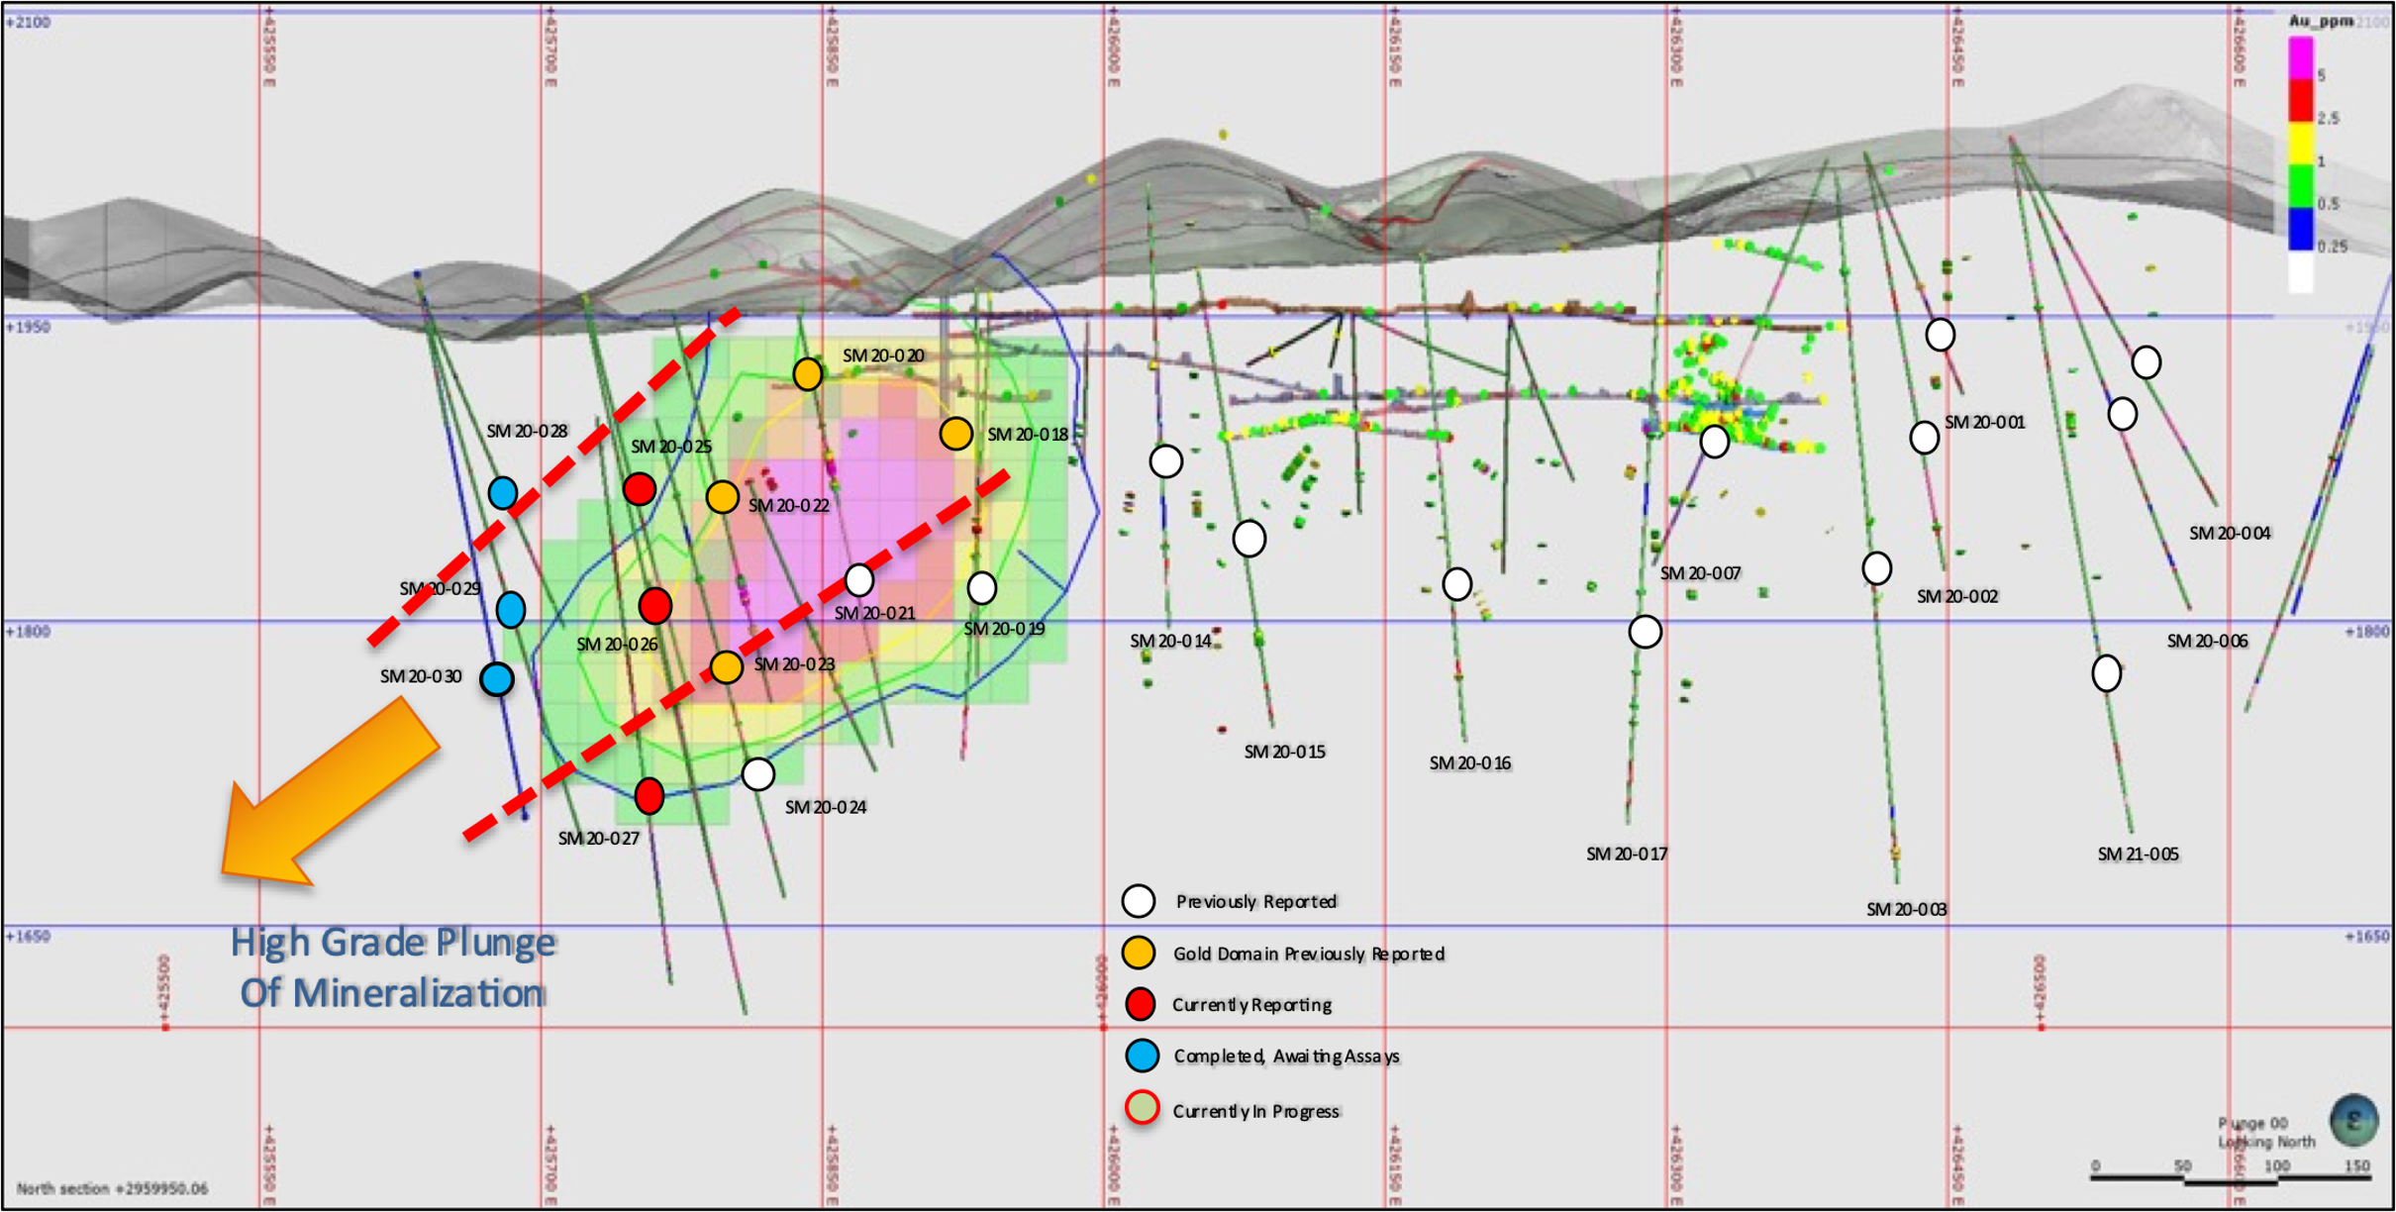
The fence of drill holes SM20-25, 26 and 27 are located 75 meters to the west of drill collars SM20-22, 23, 24 and were designed to once again tighten up the interpretation of the boundaries of the new Santa Maria gold structure with respect to the lower feeder intercept in hole SM 20-23, which reported 18.64 oz silver Eq per tonne, 437.8 lb. of lead per tonne, 113.96 lb. of zinc per tonne and 28.38 lb. copper per tonne over a width of 0.80 meters.

The drill holes were targeted to intercept the structure at vertical depths of -170, -225, and -290 meters, respectively. The interpreted mineral / structural thesis, which includes gold mineralization, is plunging 45 degrees to the west, has thickened to a true width of 150 meters, and continues to validate our prior interpretation. The gold domain system remains open in all directions.

SM20 – 25

Any vein sheet, whether micro or macro in size, grading greater than 0.50 g/t gold is highly anomalous in this type of system and must be paid attention. As seen in Table 1, a total of 12 gold bearing sheeted veins were intercepted that graded greater than 0.50 g/t gold. An intensely silicified breccia zone was encountered in the middle of the sheeted vein structure.

Table 1- Drill hole SM20-25 Assay Results
Drill Hole | From m | To m | Width m | Au g/t | Ag g/t | AgEq* g/t | Pb % | Zn % | Cu %
SM20-25 | 35.70 | 36.60 | 0.90 | 0.93 | 20.43 | 68.27 | 0.21 | 0.23 | 0.02
Includes | 36.30 | 36.60 | 0.30 | 2.22 | 30.90 | 145.10 | 0.35 | 0.24 | 0.03
 | 52.80 | 53.20 | 0.40 | 0.78 | 38.40 | 78.52 | 0.88 | 0.55 | 0.03
 | 80.40 | 80.60 | 0.20 | 2.94 | 6.10 | 157.33 | 0.04 | 0.11 | 0.01
 | 86.00 | 86.40 | 0.40 | 0.51 | 24.40 | 50.63 | 0.08 | 0.28 | 0.08
 | 115.00 | 119.30 | 4.30 | 0.14 | 27.51 | 34.71 | 0.32 | 0.73 | 0.02
Includes | 118.30 | 118.60 | 0.30 | 0.61 | 142.00 | 173.38 | 1.36 | 5.43 | 0.16
 | 125.30 | 137.90 | 12.60 | 0.49 | 28.31 | 53.32 | 0.24 | 0.23 | 0.04
Includes | 126.40 | 129.80 | 3.40 | 1.29 | 73.87 | 140.32 | 0.47 | 0.33 | 0.13
Includes | 126.40 | 127.50 | 1.10 | 1.85 | 23.10 | 118.26 | 0.20 | 0.25 | 0.03
Includes | 127.50 | 129.00 | 1.50 | 1.11 | 88.10 | 145.20 | 0.60 | 0.33 | 0.09
 | 184.50 | 189.00 | 4.50 | 0.45 | 12.50 | 35.65 | 0.18 | 0.42 | 0.02
Includes | 187.30 | 188.25 | 0.95 | 1.37 | 20.93 | 91.40 | 0.29 | 0.97 | 0.04
Includes | 187.60 | 188.10 | 0.50 | 1.76 | 17.60 | 108.13 | 0.16 | 0.98 | 0.04
Includes | 188.10 | 188.25 | 0.15 | 1.13 | 50.10 | 108.23 | 0.90 | 2.02 | 0.06
- ** Ag Equivalent (“Ag Eq”) grade is calculated using $20 per ounce Ag and $1,600 Au

Photo 1 – SM20-25 SHEETED VEIN SYSTEM
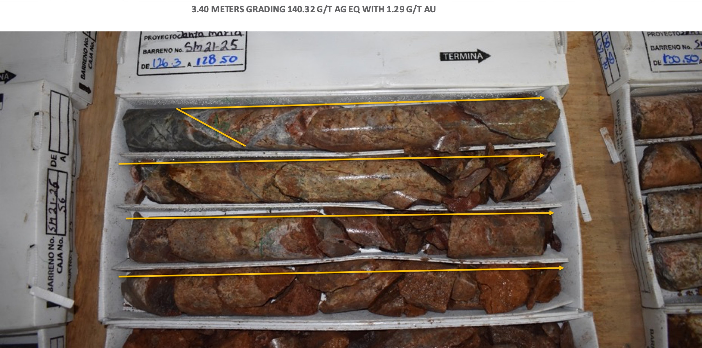
Figure 2 – Cross Section for Drill Hole SM20-25, 26, 27
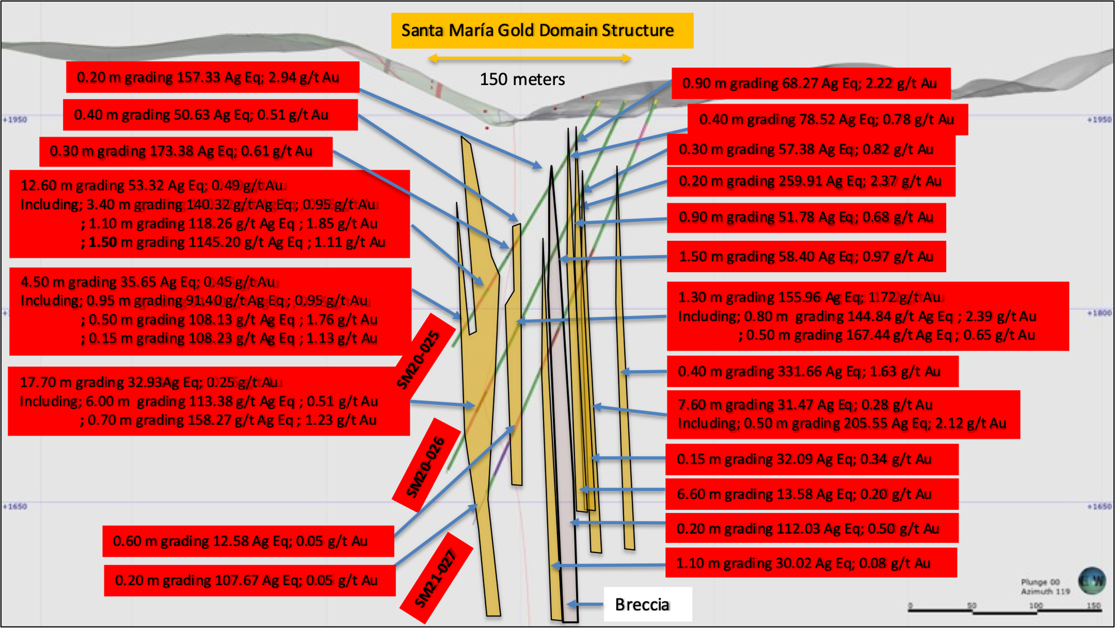

SM20-26

In the case of drill hole SM20-26, a total of 9 gold bearing veins and veinlets that graded greater than 0.50 g/t gold were intercepted. The intensely silicified breccia zone continued to be encountered in the middle of the sheeted vein structure. See Figure 2 above.

Table 2- Drill hole SM20-26 Assay Results
Drill Hole | From m | To m | Width m | Au g/t | Ag g/t | Ag Eq* g/t | Pb % | Zn % | Cu %
SM20-26 | 56.40 | 56.70 | 0.30 | 0.82 | 15.20 | 57.38 | 0.06 | 0.23 | 0.00
 | 68.30 | 68.50 | 0.20 | 2.37 | 138.00 | 259.91 | 0.20 | 1.05 | 0.03
 | 80.00 | 80.90 | 0.90 | 0.68 | 16.80 | 51.78 | 0.20 | 0.23 | 0.01
 | 90.00 | 91.50 | 1.50 | 0.97 | 8.50 | 58.40 | 0.09 | 0.05 | 0.02
 | 132.60 | 133.90 | 1.30 | 1.72 | 67.48 | 155.96 | 1.53 | 1.71 | 0.12
Includes | 132.60 | 133.40 | 0.80 | 2.39 | 25.90 | 148.84 | 0.19 | 0.69 | 0.06
 | 133.40 | 133.90 | 0.50 | 0.65 | 134.00 | 167.44 | 3.68 | 3.34 | 0.23
 | 253.50 | 271.20 | 17.70 | 0.25 | 20.07 | 32.93 | 0.31 | 0.91 | 0.07
 | 261.60 | 267.60 | 6.00 | 0.51 | 87.15 | 113.38 | 0.76 | 2.26 | 0.07
 | 266.90 | 267.60 | 0.70 | 1.23 | 95.00 | 158.27 | 2.60 | 7.01 | 0.18
- ** Ag Equivalent (“Ag Eq”) grade is calculated using $20 per ounce Ag and $1,600 Au

Photo 2- Hole SM20-26 Sheeted Vein System
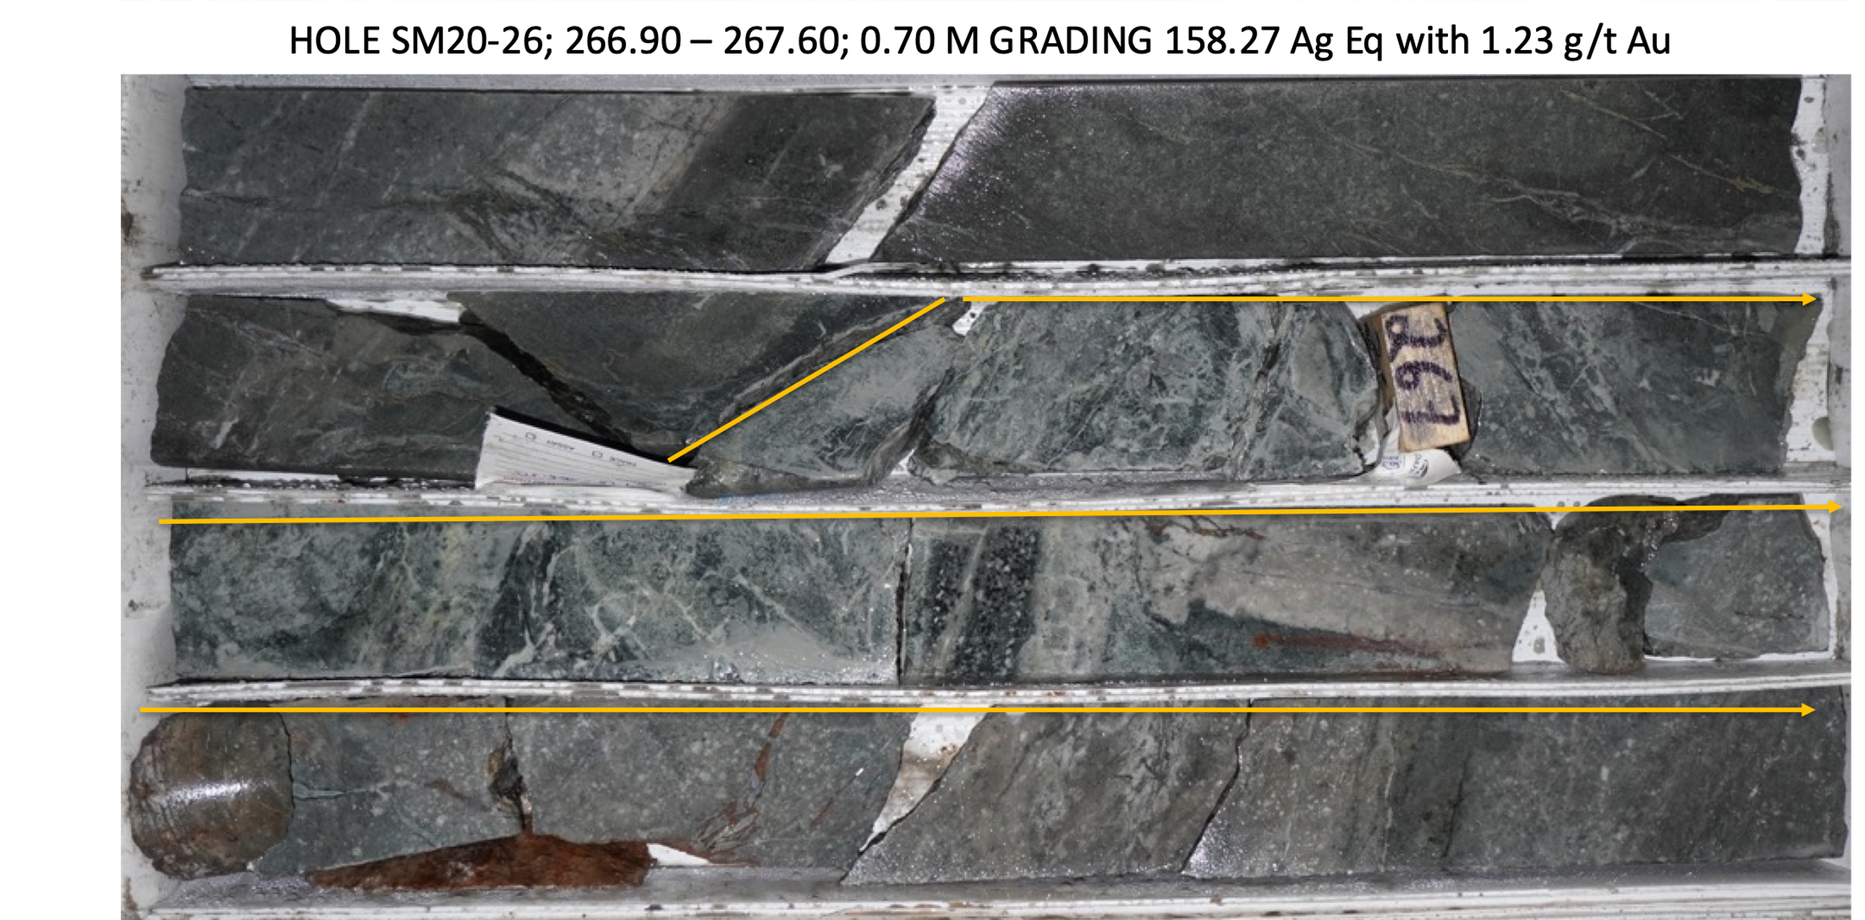

SM20-27

In the case of drill hole SM20-27, the density of gold bearing veins and veinlets decreased to 3 which graded greater than 0.50 g/t gold. The intensely silicified breccia zone continued to be encountered in the middle of the sheeted vein structure. See Figure 2 above.

Table 3- Drill hole SM20-27 Assay Results
Drill Hole | From m | To m | Width m | Au g/t | Ag g/t | Ag Eq* g/t | Pb % | Zn % | Cu %
SM20-27 | 49.60 | 50.00 | 0.40 | 1.63 | 248.00 | 331.66 | 0.34 | 2.10 | 0.05
 | 55.60 | 63.20 | 7.60 | 0.28 | 17.07 | 31.47 | 0.04 | 0.15 | 0.01
Includes | 59.00 | 59.50 | 0.50 | 2.12 | 96.50 | 205.55 | 0.18 | 0.21 | 0.01
 | 88.45 | 86.60 | 0.15 | 0.34 | 14.60 | 32.09 | 0.02 | 0.06 | 0.01
 | 120.00 | 126.60 | 6.60 | 0.20 | 3.29 | 13.58 | 0.02 | 0.06 | 0.01
 | 154.80 | 155.00 | 0.20 | 0.50 | 86.10 | 112.03 | 1.86 | 3.53 | 0.10
 | 213.00 | 215.90 | 2.90 | 0.06 | 15.62 | 18.71 | 0.33 | 0.68 | 0.02
Includes | 213.00 | 214.10 | 1.10 | 0.08 | 25.90 | 30.02 | 0.52 | 0.90 | 0.03
 | 249.70 | 250.30 | 0.60 | 0.05 | 9.80 | 12.58 | 0.13 | 2.87 | 0.04
 | 338.50 | 338.70 | 0.20 | 0.05 | 105.00 | 107.67 | 3.66 | 4.35 | 0.09
- ** Ag Equivalent (“Ag Eq”) grade is calculated using $20 per ounce Ag and $1,600 Au

Photo 3- Hole SM20-27 Sheeted Vein System
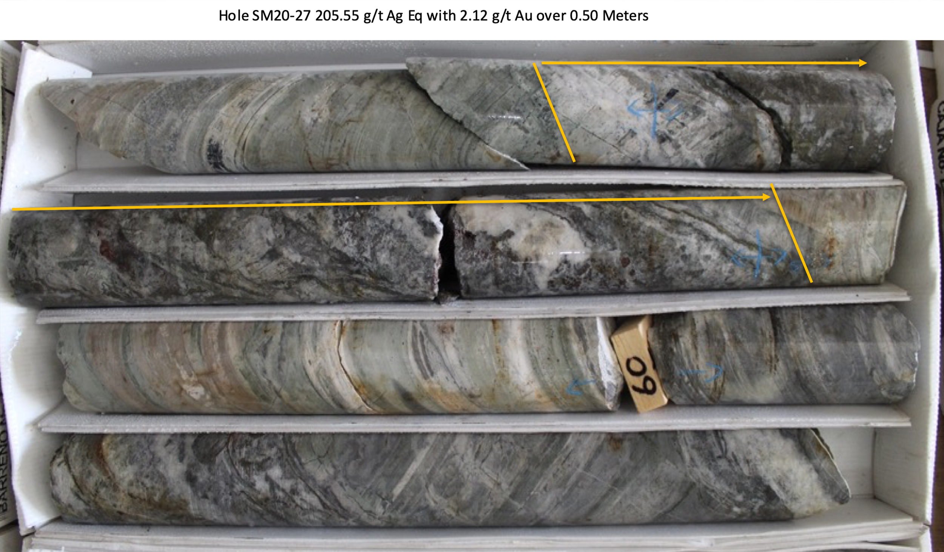
FUTURE DRILLING UPDATE
The fence of drill holes SM20-28, 29 and 30 are located another 75 meters to the west of drill collars SM20-25, 26 and 27 and have been designed to again tighten up the interpretation and lower gold domain boundary of the new Santa Maria gold structure, see Figure 1 above.
Drill holes SM20-25 – 29 have been completed and submitted for assay. Hole SM20-30 is in progress and sites for holes SM20-31 to 36 are planned, subject to future assays results, and revisions to the structural interpretation.

QA QC Procedure

Analytical results of sampling reported by Fabled Silver Gold represent core samples that have been sawn in half with half of the core sampled and submitted by Fabled Silver Gold staff directly to ALS Chemex, Chihuahua, Chihuahua, Mexico. Samples were crushed, split, and pulverized as per ALS Chemex method PREP-31, then analyzed for ME-ICP61 33 element package by four acid digestions with ICP-AES Finish. ME-GRA21 method for Au and Ag by fire assay and gravimetric finish, 30g nominal sample weight.
Over Limit Methods
For samples triggering precious metal over-limit thresholds of 10 g/t Au or 100 g/t Ag, the following is being used:
Au-GRA21 Au by fire assay and gravimetric finish with 30 g sample.
Ag-GRA21 Ag by fire assay and gravimetric finish.
Fabled Silver Gold monitors QA/QC using commercially sourced standards and locally sourced blank materials inserted within the sample sequence at regular intervals.
About Fabled Silver Gold Corp.

Fabled is focused on acquiring, exploring and operating properties that yield near-term metal production. The Company has an experienced management team with multiple years of involvement in mining and exploration in Mexico. The Company's mandate is to focus on acquiring precious metal properties in Mexico with blue-sky exploration potential.

The Company has entered into an agreement with Golden Minerals Company (NYSE American and TSX: AUMN) to acquire the Santa Maria Property, a high-grade silver-gold property situated in the center of the Mexican epithermal silver-gold belt. The belt has been recognized as a significant metallogenic province, which has reportedly produced more silver than any other equivalent area in the world.

Mr. Peter J. Hawley, President and C.E.O.
Fabled Silver Gold Corp.
Phone: (819) 316-0919
peter@fabledfco.com

For further information please contact:

info@fabledfco.com

The technical information contained in this news release has been approved by Peter J. Hawley, P.Geo. President and C.E.O. of Fabled, who is a Qualified Person as defined in National Instrument 43-101 - Standards of Disclosure for Mineral Projects.

Neither the TSX Venture Exchange nor its Regulations Service Provider (as that term is defined in the policies of the TSX Venture Exchange) does accept responsibility for the adequacy or accuracy of this news release.

Certain statements contained in this news release constitute "forward-looking information" as such term is used in applicable Canadian securities laws. Forward-looking information is based on plans, expectations and estimates of management at the date the information is provided and is subject to certain factors and assumptions, including, that the Company's financial condition and development plans do not change as a result of unforeseen events and that the Company obtains any required regulatory approvals.

Forward-looking information is subject to a variety of risks and uncertainties and other factors that could cause plans, estimates and actual results to vary materially from those projected in such forward-looking information. Some of the risks and other factors that could cause results to differ materially from those expressed in the forward-looking statements include, but are not limited to: impacts from the coronavirus or other epidemics, general economic conditions in Canada, the United States and globally; industry conditions, including fluctuations in commodity prices; governmental regulation of the mining industry, including environmental regulation; geological, technical and drilling problems; unanticipated operating events; competition for and/or inability to retain drilling rigs and other services; the availability of capital
on acceptable terms; the need to obtain required approvals from regulatory authorities; stock market volatility; volatility in market prices for commodities; liabilities inherent in mining operations; changes in tax laws and incentive programs relating to the mining industry; as well as the other risks and uncertainties applicable to the Company as set forth in the Company's continuous disclosure filings filed under the Company's profile at www.sedar.com. The Company undertakes no obligation to update these forward-looking statements, other than as required by applicable law.

