July 12, 2021 | TSX-V: FCO

Fabled Discovers New High Grade Gold System
With Values Intercepted Up To 10.85 g/t Au
Within 30.7 Meter Structure Grading 161.09 Ag Eq.

Vancouver, British Columbia – Fabled Silver Gold Corp. (“Fabled” or the “Company”) (TSXV: FCO; OTCQB: FBSGF, and FSE: 7NQ) is pleased to announce updates of the results of diamond drilling from the upgraded 9,200 meter drill program on the “Santa Maria” Property in Parral, Mexico.

Peter J. Hawley, CEO and President, remarks, “We are pleased to announce drill assay results for surface diamond drill holes SM20-19 and 20, see Figure 1.

Figure 1 – Longitudinal View of Area of Current Drilling

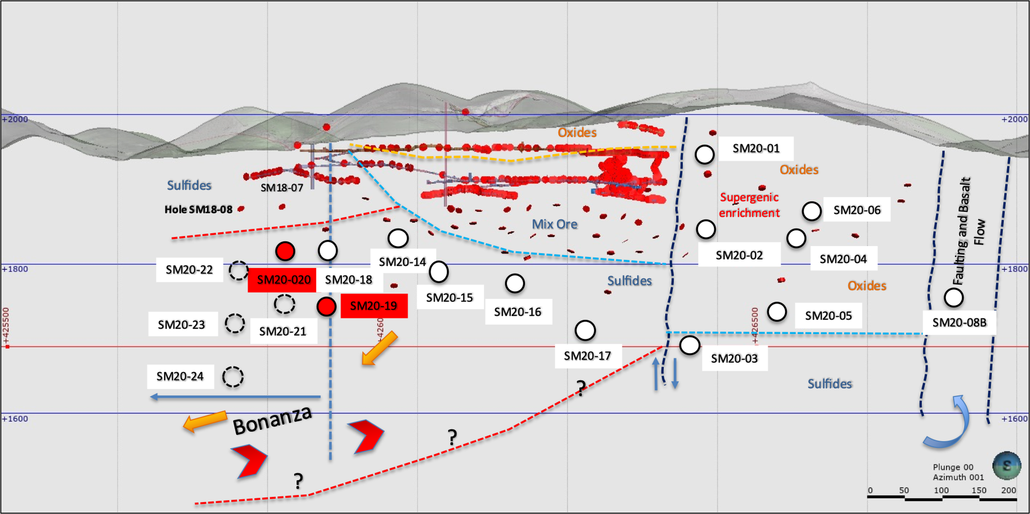

SM20 – 19.

This is the deepest hole in this area at -225 meters vertically.

Drill hole SM20-19, which was drilled below hole SM20-18, was designed to test the Santa Maria structure at a vertical depth of -225 meters, which is approximately -125 meters below historical drill hole SM16-22 which reported 15.34 meters grading 113.14 g/t Ag eq and included 0.64 meters grading 844.72 g/t Ag eq.

As previously reported, hole SM20-18 intersected 19.65 meters grading 74.67 g/t Ag Eq with numerous higher grade intervals such as 7.90 meters grading 142.48 g/t Ag Eq 75 meters above.

Unfortunately, Hole SM20-19 only intercepted a broad zone of low-grade silver. At this time, it is believed that the fence of holes SM20-18 and SM20-19 define the true western edge of the complete sulphide mineralization without the oxide and super-gene mineral package, and represent a down drop of the eastern portion of the mineralization. On the western side of the up thrust fault the entire sulphide only mineral package is intact as seen in Figure 5 below. This intercept continues to be revalued in our structural interpretation versus mineral controls as drill hole data continues to be obtained.

Table 1- Drill hole SM20-19 Assay Results

Drill Hole | From m | To m | Width m | Au g/t | Ag g/t | AgEq* g/t | Pb % | Zn % | Cu %
SM20-19 | 218.50 | 231.65 | 13.15 | 0.15 | 14.70 | 22.42 | 0.03 | 0.07 | 0.04
- ** Ag Equivalent (“Ag Eq”) grade is calculated using $20 per ounce Ag and $1,600 Au

Figure 2 – Cross Section for Drill Hole SM20-19
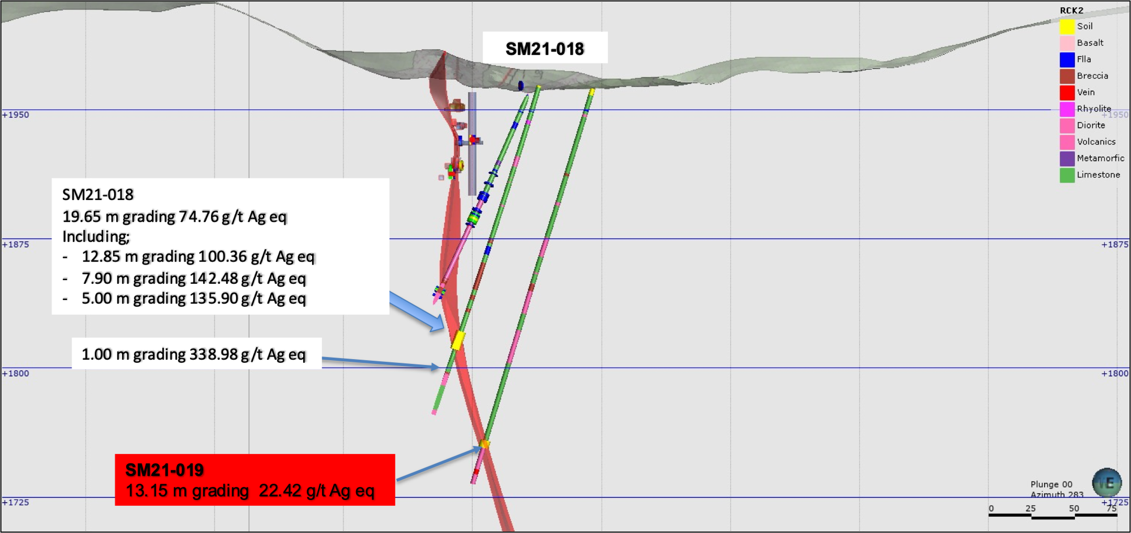

SM20-20

The next fence of holes SM20- 20 to SM20-21 is located 75 meters to the west of drill collars SM20-18 and SM20-19 and are designed to intercept the Santa Maria structure at a vertical depth of -200 meters and -260 meters, respectively, using a newly interpreted mineral / structural thesis which includes new gold mineralization plunging 45 degrees to the west and remains open in all directions.

Peter J. Hawley, CEO, President states, “To support this interpretation, we refer to previous drilling by other operators on the eastern section of the property which has only intersected 5 intervals of what is considered high grade gold for the Santa Maria silver domain property. Two are reported from surface and three from underground drilling, as shown below in Tables 2 and 3.

As seen in Tables 2 and 3 there is a direct correlation between high gold values, narrow widths, and high silver values in 4 of the 5 intercepts.

Table 2- Historical High Grade Gold Surface Drilling Intercepts
Drill Hole | From m | To m | Width m | Au g/t | Ag g/t | Ag Eq* g/t | Pb % | Zn % | Cu %
SM18-03 | 139.81 | 140.50 | 0.69 | 30.20 | 6,860.00 | *N/C | 0.75 | 0.64 | 0.05
SM14-08 | 196.14 | 196.62 | 0.48 | 11.30 | 85.00 | *N/C | 1.13 | 3.94 | 0.09
*N/C: Not Calculated Previously
Table 3- Historical High Grade Gold Underground Drilling Intercepts
Drill Hole | From m | To m | Width m | Au g/t | Ag g/t | Ag Eq* g/t | Pb % | Zn % | Cu %
SM16-15 | 24.33 | 25.22 | 0.89 | 9.97 | 1,760.00 | *N/C | 0.39 | 0.65 | 0.02
SM16-13 | 1.05 | 2.56 | 1.51 | 9.04 | 275.00 | *N/C | 0.26 | 3.54 | 0.02
SM16-08 | 56.63 | 58.86 | 0.23 | 7.51 | 831.00 | *N/C | 1.50 | 4.08 | 0.12
*N/C: Not Calculated Previously
Peter J. Hawley continues; “These above narrow high-grade intercepts were common to the property. As seen below in Table 4 and Photo 1, we have found a new, never discovered high grade gold mineral domain system, with silver credits, over consistent widths in an area never explored, and which remains open to the west and at depth, plunging 45 degrees to the west and open in all directions for expansion.

Table 4- Drill hole SM20-20 Compilation Assay Results

Drill Hole | From m | To m | Width m | Au g/t | Ag g/t | Ag Eq* g/t | Pb % | Zn % | Cu %
SM20-20 | 58.70 | 62.00 | 3.30 | 0.26 | 25.18 | 38.55 | 0.07 | 0.24 | 0.01
 | 66.00 | 96.70 | 30.7 | 2.50 | 32.49 | 161.09 | 0.58 | 0.49 | 0.03
Includes | 74.00 | 96.70 | 22.70 | 3.33 | 41.22 | 212.52 | 0.77 | 0.53 | 0.04
Includes | 76.30 | 87.90 | 11.60 | 5.61 | 64.25 | 352.83 | 1.42 | 0.89 | 0.06
Includes | 79.50 | 87.90 | 8.40 | 7.24 | 80.20 | 452.63 | 1.86 | 1.09 | 0.07
- ** Ag Equivalent (“Ag Eq”) grade is calculated using $20 per ounce Ag and $1,600 Au

Table 5- Drill hole SM20-20 Individual Assay Results
Drill Hole | From m | To  m | Width m | Au g/t | Ag g/t | Ag Eq* g/t | Pb % | Zn % | Cu %
SM20-20 | 74.00 | 76.30 | 2.30 | 0.34 | 14.50 | 31.78 | 0.10 | 0.16 | 0.01
 | 76.30 | 78.70 | 2.40 | 1.29 | 17.50 | 83.60 | 0.15 | 0.20 | 0.02
 | 78.70 | 79.50 | 0.80 | 1.58 | 37.00 | 118.02 | 0.72 | 0.86 | 0.07
 | 79.50 | 81.00 | 1.50 | 4.77 | 52.90 | 298.27 | 0.95 | 0.00 | 0.04
 | 81.00 | 82.50 | 1.50 | 7.47 | 92.00 | 476.26 | 1.79 | 1.86 | 0.08
 | 82.50 | 84.00 | 1.50 | 10.85 | 129.00 | 687.12 | 2.73 | 1.58 | 0.10
 | 84.00 | 85.50 | 1.50 | 4.93 | 129.00 | 382.60 | 4.49 | 1.79 | 0.03
 | 85.50 | 87.90 | 2.40 | 7.81 | 28.90 | 430.65 | 0.28 | 0.55 | 0.01
 | 87.90 | 91.70 | 3.80 | 0.18 | 14.80 | 23.90 | 0.10 | 0.19 | 0.01
 | 91.70 | 92.10 | 0.40 | 0.08 | 4.60 | 8.51 | 0.13 | 0.16 | 0.01
 | 92.10 | 93.50 | 1.40 | 1.46 | 23.40 | 98.25 | 0.11 | 0.07 | 0.05
 | 93.50 | 94.10 | 0.60 | 9.14 | 37.60 | 507.76 | 0.07 | 0.07 | 0.02
 | 94.10 | 96.40 | 2.30 | 0.55 | 17.50 | 45.79 | 0.07 | 0.13 | 0.02
 | 96.40 | 96.70 | 0.30 | 0.35 | 11.40 | 29.92 | 0.03 | 0.11 | 0.02
- ** Ag Equivalent (“Ag Eq”) grade is calculated using $20 per ounce Ag and $1,600 Au

Photo 1 – SM20-20 Gold Intercept
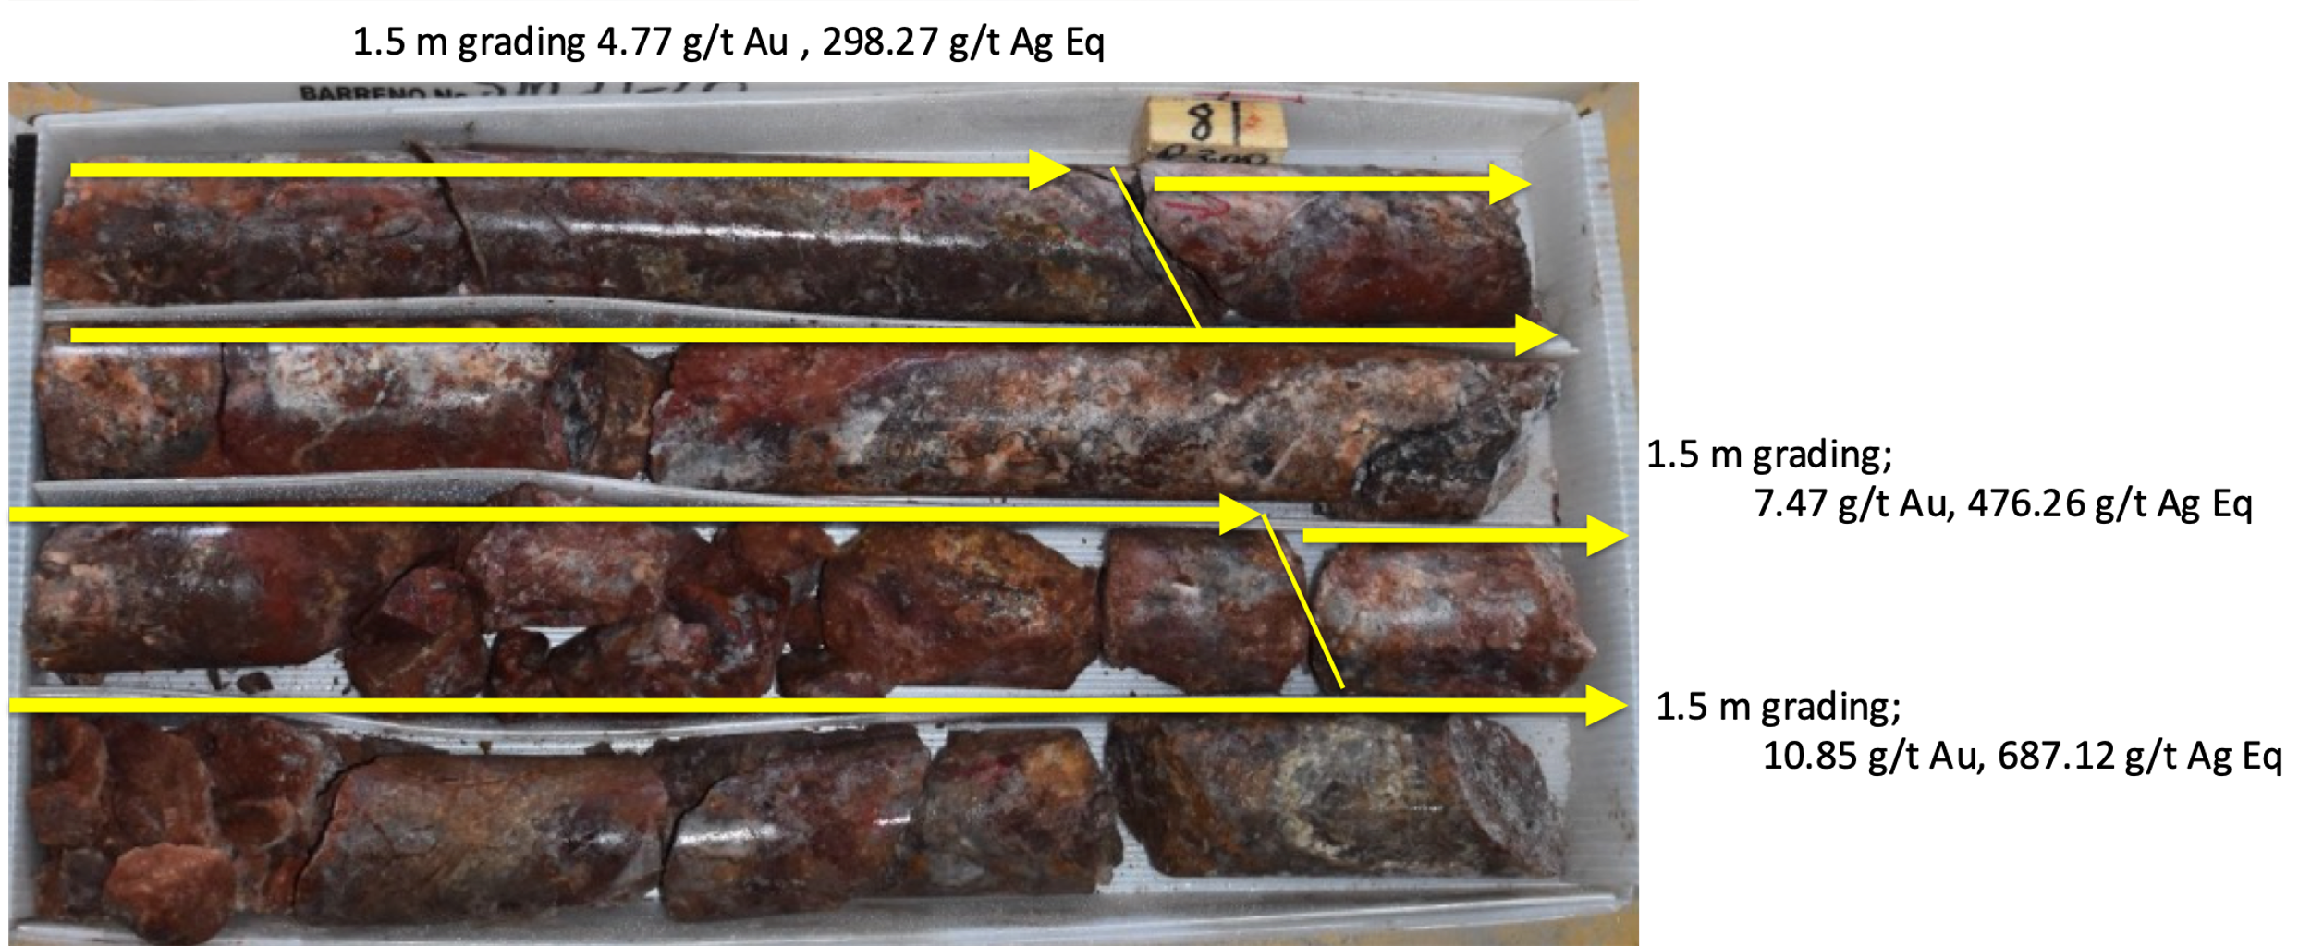

Figure 3 – Cross Section for Drill Hole SM20-20
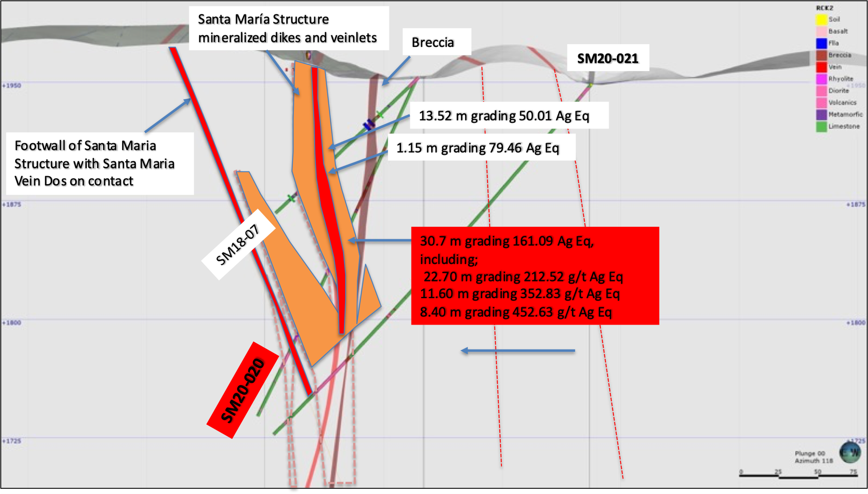

Conclusions.

Mr. Hawley states “We are looking for structure on structure as we continue our “Exploration Program” which is aimed at allowing us to determine areas to follow up on in the future.

We are following the three “E” discipline in our approach. We are using our “Expertise” to discover and deliver new zones and results; we have increased the “Exploration” program to 9,200 meters continue to deliver and finally, and most importantly we believe we have “Executed” on increasing the potential of the property with the discovery of this gold enriched trend, open in all directions.

We will continue to try and inform our shareholders and the public of our results and interpretations in the most transparent manner through the issuance of news releases, graphics, video’s and various interviews on social platforms.

Figure 5 - Longitudinal Section of New Interpretation
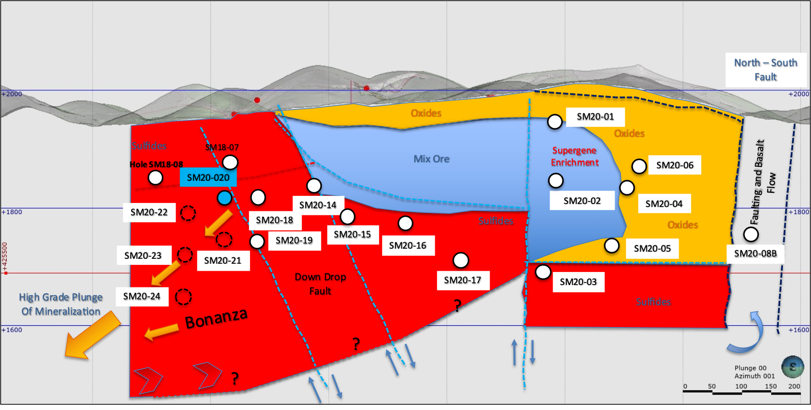

FUTURE DRILLING UPDATE

The Company has now completed drill holes SM20-01 to SM20-24 for a total of approximately 6,500 meters of the increased 9,200 meter drill program drilled to date. Hole SM20-25 is currently in progress.

Drill hole samples of SM20-21 to SM20-24 have submitted for analyses.

QA QC Procedure

Analytical results of sampling reported by Fabled Silver Gold represent core samples that have been sawn in half with half of the core sampled and submitted by Fabled Silver Gold staff directly to ALS Chemex, Chihuahua, Chihuahua, Mexico. Samples were crushed, split, and pulverized as per ALS Chemex method PREP-31, then analyzed for ME-ICP61 33 element package by four acid digestion with ICP-AES Finish. ME-GRA21 method for Au and Ag by fire assay and gravimetric finish, 30g nominal sample weight.
Over Limit Methods
For samples triggering precious metal over-limit thresholds of 10 g/t Au or 100 g/t Ag, the following is being used:
Au-GRA21 Au by fire assay and gravimetric finish with 30 g sample.
Ag-GRA21 Ag by fire assay and gravimetric finish.

Fabled Silver Gold monitors QA/QC using commercially sourced standards and locally sourced blank materials inserted within the sample sequence at regular intervals.
About Fabled Silver Gold Corp.

Fabled is focused on acquiring, exploring and operating properties that yield near-term metal production. The Company has an experienced management team with multiple years of involvement in mining and exploration in Mexico. The Company's mandate is to focus on acquiring precious metal properties in Mexico with blue-sky exploration potential.

The Company has entered into an agreement with Golden Minerals Company (NYSE American and TSX: AUMN) to acquire the Santa Maria Property, a high-grade silver-gold property situated in the center of the Mexican epithermal silver-gold belt. The belt has been recognized as a significant metallogenic province, which has reportedly produced more silver than any other equivalent area in the world.

Mr. Peter J. Hawley, President and C.E.O.
Fabled Silver Gold Corp.
Phone: (819) 316-0919
peter@fabledfco.com

For further information please contact:

info@fabledfco.com

The technical information contained in this news release has been approved by Peter J. Hawley, P.Geo. President and C.E.O. of Fabled, who is a Qualified Person as defined in National Instrument 43-101 - Standards of Disclosure for Mineral Projects.

Neither the TSX Venture Exchange nor its Regulations Service Provider (as that term is defined in the policies of the TSX Venture Exchange) does accept responsibility for the adequacy or accuracy of this news release.

Certain statements contained in this news release constitute "forward-looking information" as such term is used in applicable Canadian securities laws. Forward-looking information is based on plans, expectations and estimates of management at the date the information is provided and is subject to certain factors and assumptions, including, that the Company's financial condition and development plans do not change as a result of unforeseen events and that the Company obtains any required regulatory approvals.

Forward-looking information is subject to a variety of risks and uncertainties and other factors that could cause plans, estimates and actual results to vary materially from those projected in such forward-looking information. Some of the risks and other factors that could cause results to differ materially from those expressed in the forward-looking statements include, but are not limited to: impacts from the coronavirus or other epidemics, general economic conditions in Canada, the United States and globally; industry conditions, including fluctuations in commodity prices; governmental regulation of the mining industry, including environmental regulation; geological, technical and drilling problems; unanticipated operating events; competition for and/or inability to retain drilling rigs and other services; the availability of capital
on acceptable terms; the need to obtain required approvals from regulatory authorities; stock market volatility; volatility in market prices for commodities; liabilities inherent in mining operations; changes in tax laws and incentive programs relating to the mining industry; as well as the other risks and uncertainties applicable to the Company as set forth in the Company's continuous disclosure filings filed under the Company's profile at www.sedar.com. The Company undertakes no obligation to update these forward-looking statements, other than as required by applicable law.

