July 8, 2021 | TSX-V: FCO

Fabled Underground Diamond Drilling Intercepts 4 Zones of Silver Mineralization
Including; 314.35 g/t Ag Eq over 0.80 meters

Vancouver, British Columbia – Fabled Silver Gold Corp. (“Fabled” or the “Company”) (TSXV: FCO; OTCQB: FBSGF, and FSE: 7NQ) is pleased to announce the first results of underground diamond drilling from the 1,200 meter underground drill program on the “Santa Maria” Property in Parral, Mexico.

Preamble

Underground drilling is currently taking place from drill stations in the ramp, or in mined out areas, where previous bulk samples were taken by previous property holders. Unfortunately, the ramp was centered down the Santa Maria vein in order to access mineralized material as they advanced the ramp. This has resulted in the higher-grade portion of the Santa Maria Vein being absent from the beginning of the majority of the drill holes. This begs the question that, if this is the case, what is the purpose of drilling? We know from previous holes drilled in this program, that the Santa Maria vein and Santa Maria Dos veins are the footwall and hanging wall of a mineralized structure and the purpose of the program is to determine the widths of this structure. As the ramp is restrictive, useful available drill locations will become sparser, and therefore the Company is planning to establish new “proper” drill bays for future holes, see Figures 1,2.

Figure 1 – Plan View of Area of Current Underground Drilling
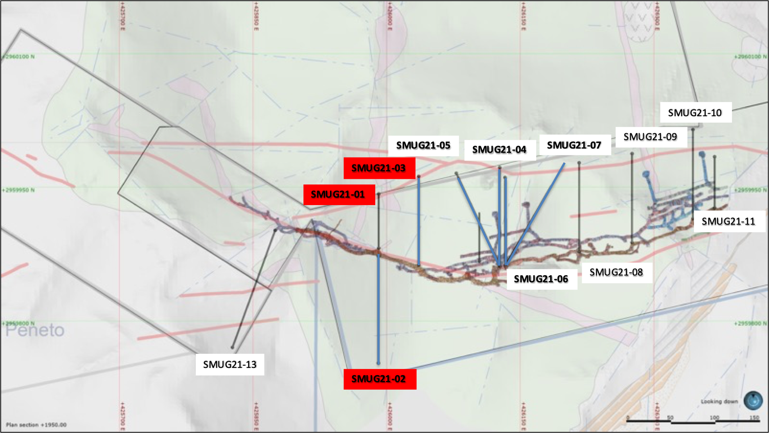

Figure 2 – Longitudinal View of Area of Current Underground Drilling
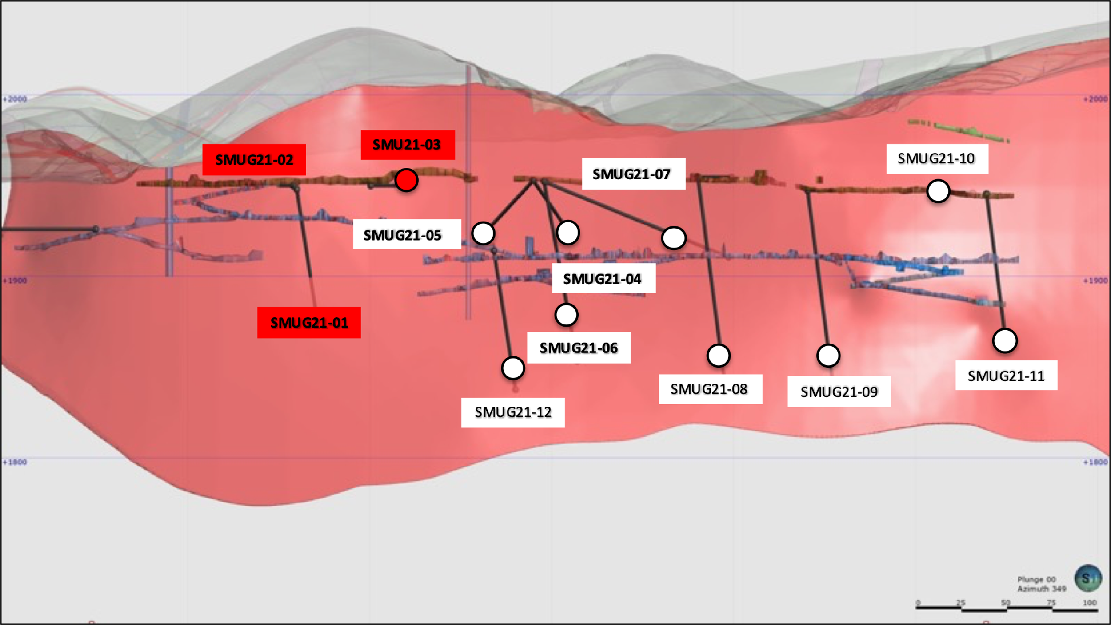

Drill hole SMUG21-01 was designed to test the extent of the Santa Maria Dos footwall mineralization near the contact and was successful in intercepting 9.90 meters grading 21.62 g/t Ag Eq.

Drill hole SMUG21-02 was drilled at 180 degrees from hole 01 to try an exploration test to see if anything exists outside of the hanging wall structure. As expected, no values or widths of interest were found.

Table 1- Drill hole SMUG 21- 01 Assay Results
Drill Hole | From m | To  m | Width m | Au g/t | Ag g/t | AgEq* g/t | Pb % | Zn % | Cu %
SMUG21-01 | 58.20 | 68.10 | 9.90 | 0.08 | 17.50 | 21.62 | 0.02 | 0.04 | 0.02
Including | 58.20 | 62.80 | 4.60 | 0.12 | 20.50 | 26.67 | 0.03 | 0.06 | 0.04
- ** Ag Equivalent (“Ag Eq”) grade is calculated using $20 per ounce Ag and $1,600 Au

Table 2- Drill hole SMUG 21- 02 Assay Results
Drill Hole | From m | To  m | Width m | Au g/t | Ag g/t | AgEq* g/t | Pb % | Zn % | Cu %
SMUG21-02 | 88.10 | 89.30 | 1.20 | 0.08 | 13.10 | 17.22 | 0.02 | 0.03 | 0.01
- ** Ag Equivalent (“Ag Eq”) grade is calculated using $20 per ounce Ag and $1,600 Au

Figure 3 – Cross Section for Drill Holes SMUG21-01, 02
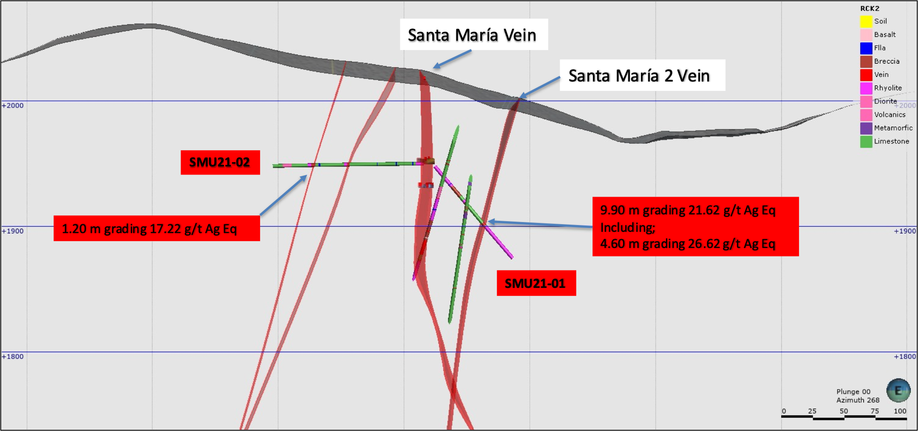

Peter J. Hawley, CEO and President, remarks, “SMUG21-03 has revealed what we have been targeting. Excluding the mined Santa Maria vein, we have hit four zones of silver mineralization in the Santa Maria Structure. The first 18 meters would have been part of the mined zone. Of interest is not only the widths but grades and the 314.35 g/t Ag Eq over 0.80 meters is certainly something to pay attention to.”

As the ramp increases with depth, we expect the near surface lower grade oxide component to decrease and start to see some supergene enrichment at the contact between oxides and sulphides.

Table 3- Drill hole SMUG21-03 Assay Results
Drill Hole | From m | To  m | Width m | Au  g/t | Ag  g/t | AgEq* g/t | Pb  % | Zn  % | Cu  %
SMUG21-03 | 0.00 | 18.00 | 18.00 | 0.24 | 20.00 | 32.35 | 0.01 | 0.06 | 0.00
 | 77.00 | 79.40 | 2.40 | 0.06 | 36.00 | 39.09 | 0.03 | 0.07 | 0.00
 | 89.80 | 90.60 | 0.80 | 0.24 | 302.00 | 314.35 | 0.10 | 0.25 | 0.01
 | 96.00 | 102.80 | 6.30 | 0.04 | 17.00 | 19.06 | 0.02 | 0.06 | 0.00

Figure 4 – Cross Section for Drill Hole SMUG21-03
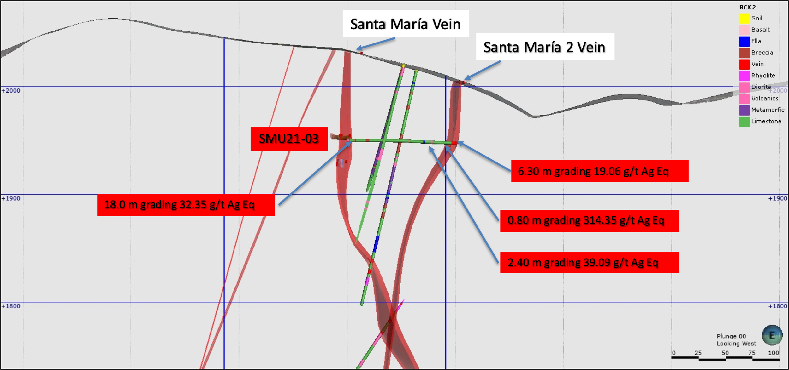
- ** Ag Equivalent (“Ag Eq”) grade is calculated using $20 per ounce Ag and $1,600 Au

FUTURE UNDERGROUND DRILLING UPDATE

The Company has now completed drill holes SMUG21-01 – 07 with Hole SMUG21-08 in progress.

Underground drilling continues to progress and drill holes SMUG-04 – 07 have been submitted for assay.
SM21-008B finalized
SM21-009
SM21-010
Fault

QA QC Procedure

Analytical results of sampling reported by Fabled Silver Gold represent core samples that have been sawn in half with half of the core sampled and submitted by Fabled Silver Gold staff directly to ALS Chemex, Chihuahua, Chihuahua, Mexico. Samples were crushed, split, and pulverized as per ALS Chemex method PREP-31, then analyzed for ME-ICP61 33 element package by four acid digestion with ICP-AES Finish. ME-GRA21 method for Au and Ag by fire assay and gravimetric finish, 30g nominal sample weight.
Over Limit Methods
For samples triggering precious metal over-limit thresholds of 10 g/t Au or 100 g/t Ag, the following is being used:
Au-GRA21 Au by fire assay and gravimetric finish with 30 g sample.
Ag-GRA21 Ag by fire assay and gravimetric finish.

Fabled Silver Gold monitors QA/QC using commercially sourced standards and locally sourced blank materials inserted within the sample sequence at regular intervals.
About Fabled Silver Gold Corp.

Fabled is focused on acquiring, exploring and operating properties that yield near-term metal production. The Company has an experienced management team with multiple years of involvement in mining and exploration in Mexico. The Company's mandate is to focus on acquiring precious metal properties in Mexico with blue-sky exploration potential.

The Company has entered into an agreement with Golden Minerals Company (NYSE American and TSX: AUMN) to acquire the Santa Maria Property, a high-grade silver-gold property situated in the center of the Mexican epithermal silver-gold belt. The belt has been recognized as a significant metallogenic province, which has reportedly produced more silver than any other equivalent area in the world.

Mr. Peter J. Hawley, President and C.E.O.
Fabled Silver Gold Corp.
Phone: (819) 316-0919
peter@fabledfco.com

For further information please contact:

info@fabledfco.com

The technical information contained in this news release has been approved by Peter J. Hawley, P.Geo. President and C.E.O. of Fabled, who is a Qualified Person as defined in National Instrument 43-101 - Standards of Disclosure for Mineral Projects.

Neither the TSX Venture Exchange nor its Regulations Service Provider (as that term is defined in the policies of the TSX Venture Exchange) does accept responsibility for the adequacy or accuracy of this news release.

Certain statements contained in this news release constitute "forward-looking information" as such term is used in applicable Canadian securities laws. Forward-looking information is based on plans, expectations and estimates of management at the date the information is provided and is subject to certain factors and assumptions, including, that the Company's financial condition and development plans do not change as a result of unforeseen events and that the Company obtains any required regulatory approvals.

Forward-looking information is subject to a variety of risks and uncertainties and other factors that could cause plans, estimates and actual results to vary materially from those projected in such forward-looking information. Some of the risks and other factors that could cause results to differ materially from those expressed in the forward-looking statements include, but are not limited to: impacts from the coronavirus or other epidemics, general economic conditions in Canada, the United States and globally; industry conditions, including fluctuations in commodity prices; governmental regulation of the mining industry, including environmental regulation; geological, technical and drilling problems; unanticipated operating events; competition for and/or inability to retain drilling rigs and other services; the availability of capital on acceptable terms; the need to obtain required approvals from regulatory authorities; stock market volatility; volatility in market prices for commodities; liabilities inherent in mining operations; changes in tax laws and incentive programs relating to the mining industry; as well as the other risks and uncertainties applicable to the Company as set forth in the Company's continuous disclosure filings filed under the Company's profile at www.sedar.com. The Company undertakes no obligation to update these forward-looking statements, other than as required by applicable law.

