September 07, 2021 | TSX-V: FCO

Fabled Hits Supergene Quartz Breccia Over 1.35 Meters Grading 689.56 g/t Ag Eq

Vancouver, British Columbia – Fabled Silver Gold Corp. (“Fabled” or the “Company”) (TSXV: FCO; OTCQB: FBSGF, and FSE: 7NQ) is pleased to announce additional results from underground diamond drilling of the 1,200 meter underground drill program at the “Santa Maria” Property in Parral, Mexico, see Figure 1.

Figure 1 – Longitudinal View of Area of Current Underground Drilling
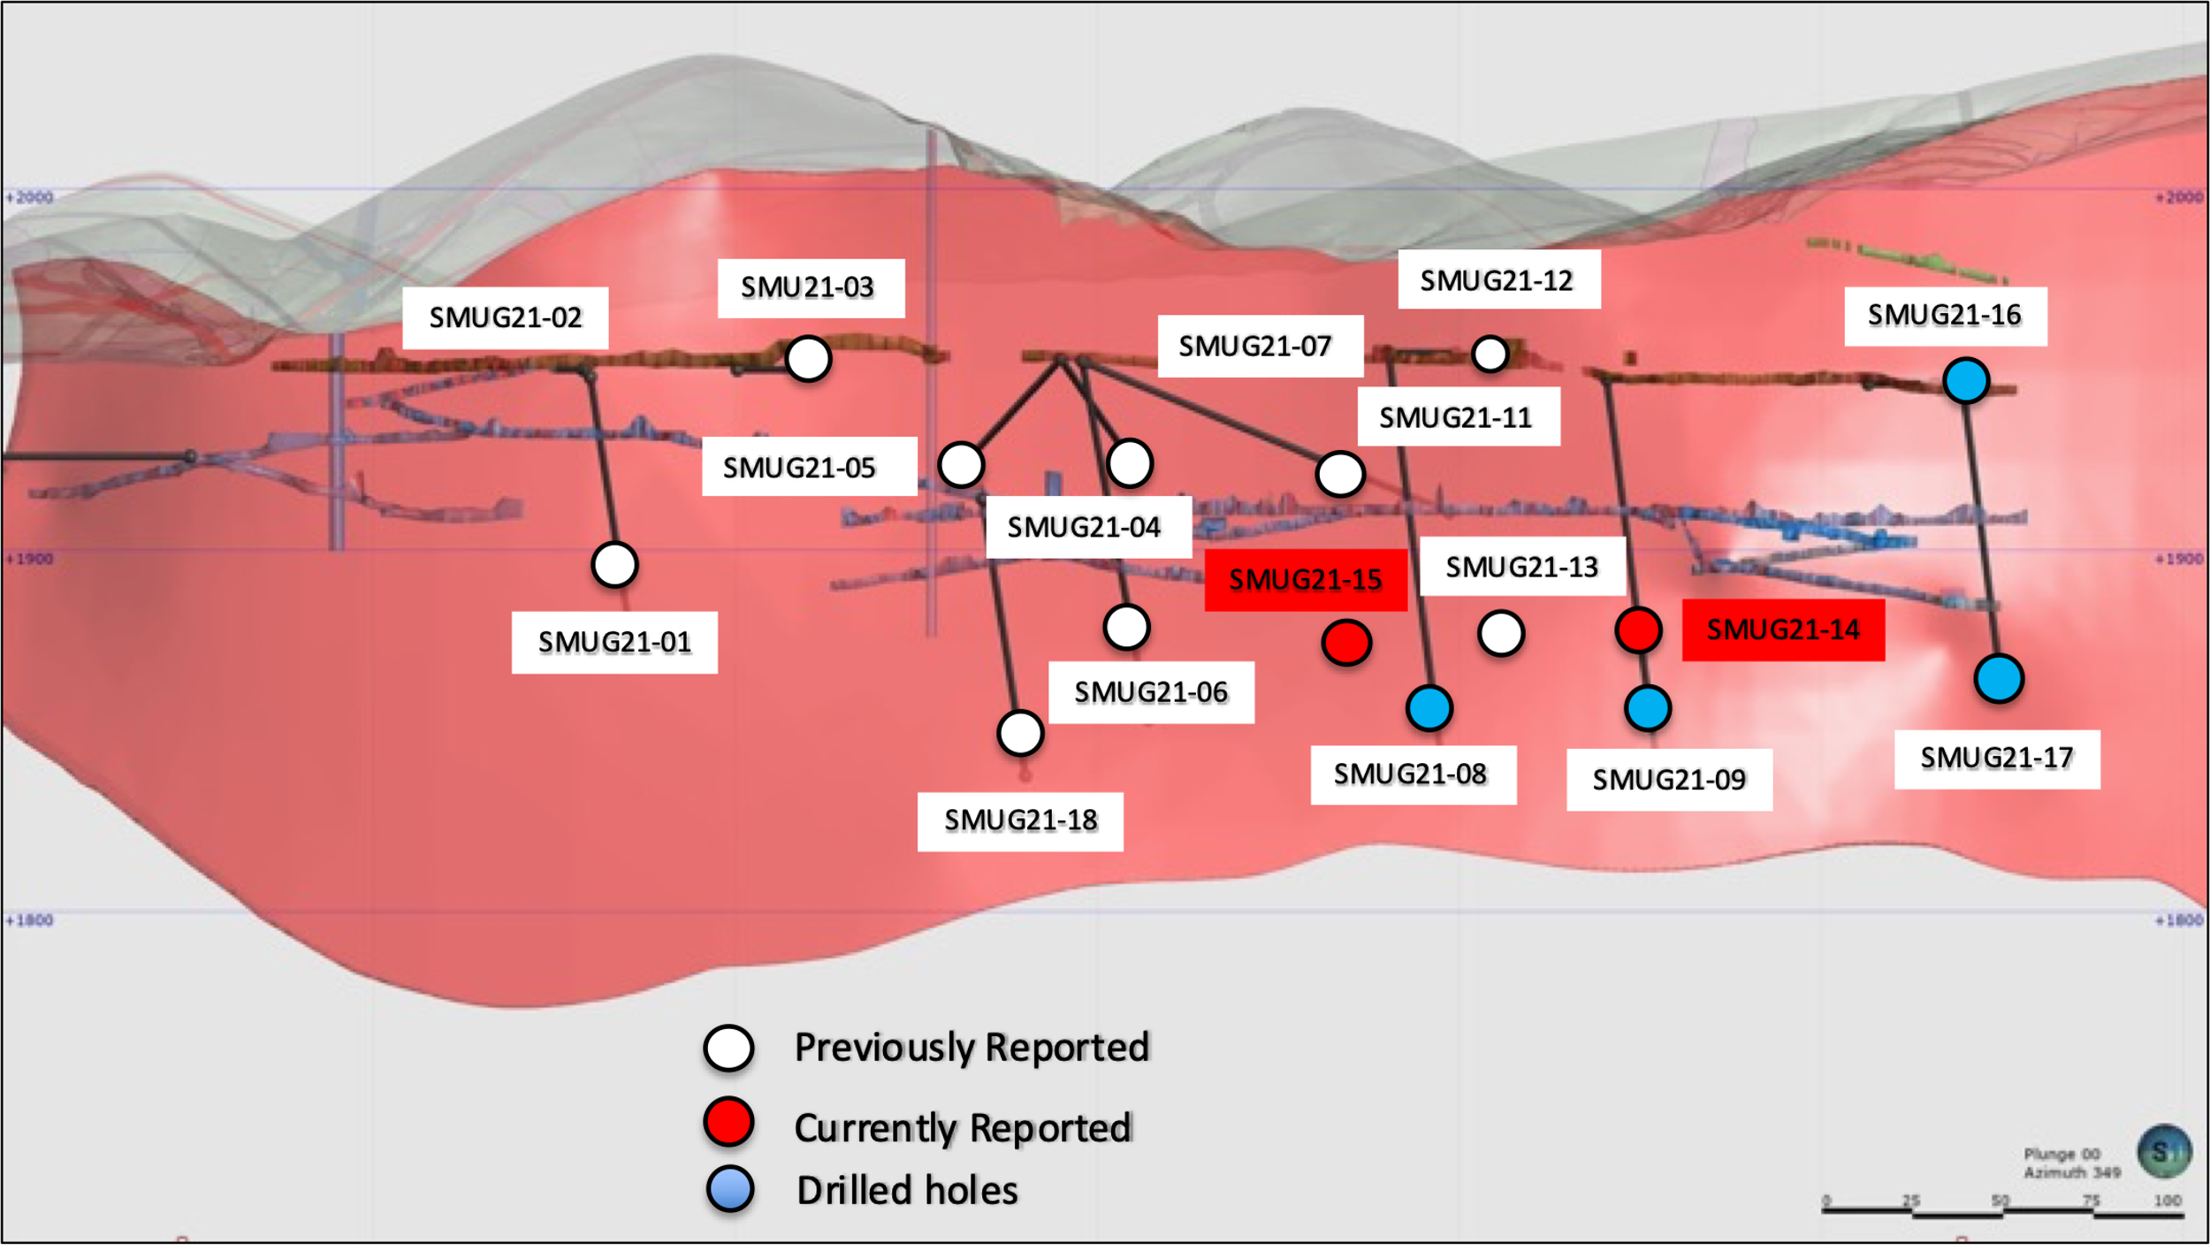

Drill hole SMUG21- 14 was drilled approximately 50 meters east of drill hole SMUG21- 13, which reported 541.49 g/t Ag Eq, while drill hole SMUG21- 15 was drilled approximately 50 meters west of hole 13. Each hole was designed to hit the hole 13 mineralization at the same vertical elevation underground of -125 meters.
Drill Hole SMUG21-14
SMUG21-14 was drilled at a dip of -45 degrees and was successful in the interception of the Santa Maria footwall wall structure, a low-grade hydrothermal breccia, and a mineralized diorite dike with quartz veining at the hanging wall structure.

The collar, or the beginning, of hole SMUG21-14 reported 7.20 meters grading 93.19 g/t Ag Eq, including 2.15 meters located in the footwall of the Santa Maria structure and reporting 168.21 g/t Ag Eq.
Adjacent to the hanging wall zone, a mineralized diorite was encountered with a supergene enriched quartz vein breccia on the lower contact. The diorite dike interval of 6.7 meters assayed 193.98 g/t Ag Eq, including the contact with the lower vein breccia, which graded 313.26 g/t Ag Eq over 3.85 meters, and the supergene quartz breccia reporting 1.35 meters of 689.56 g/t Ag Eq. See Figure 2 below and Photos 1 of foot wall mineralization and photo 2 of the hanging wall mineralization.
Figure 2- Cross Section of Underground Drill Hole SMUG21- 14
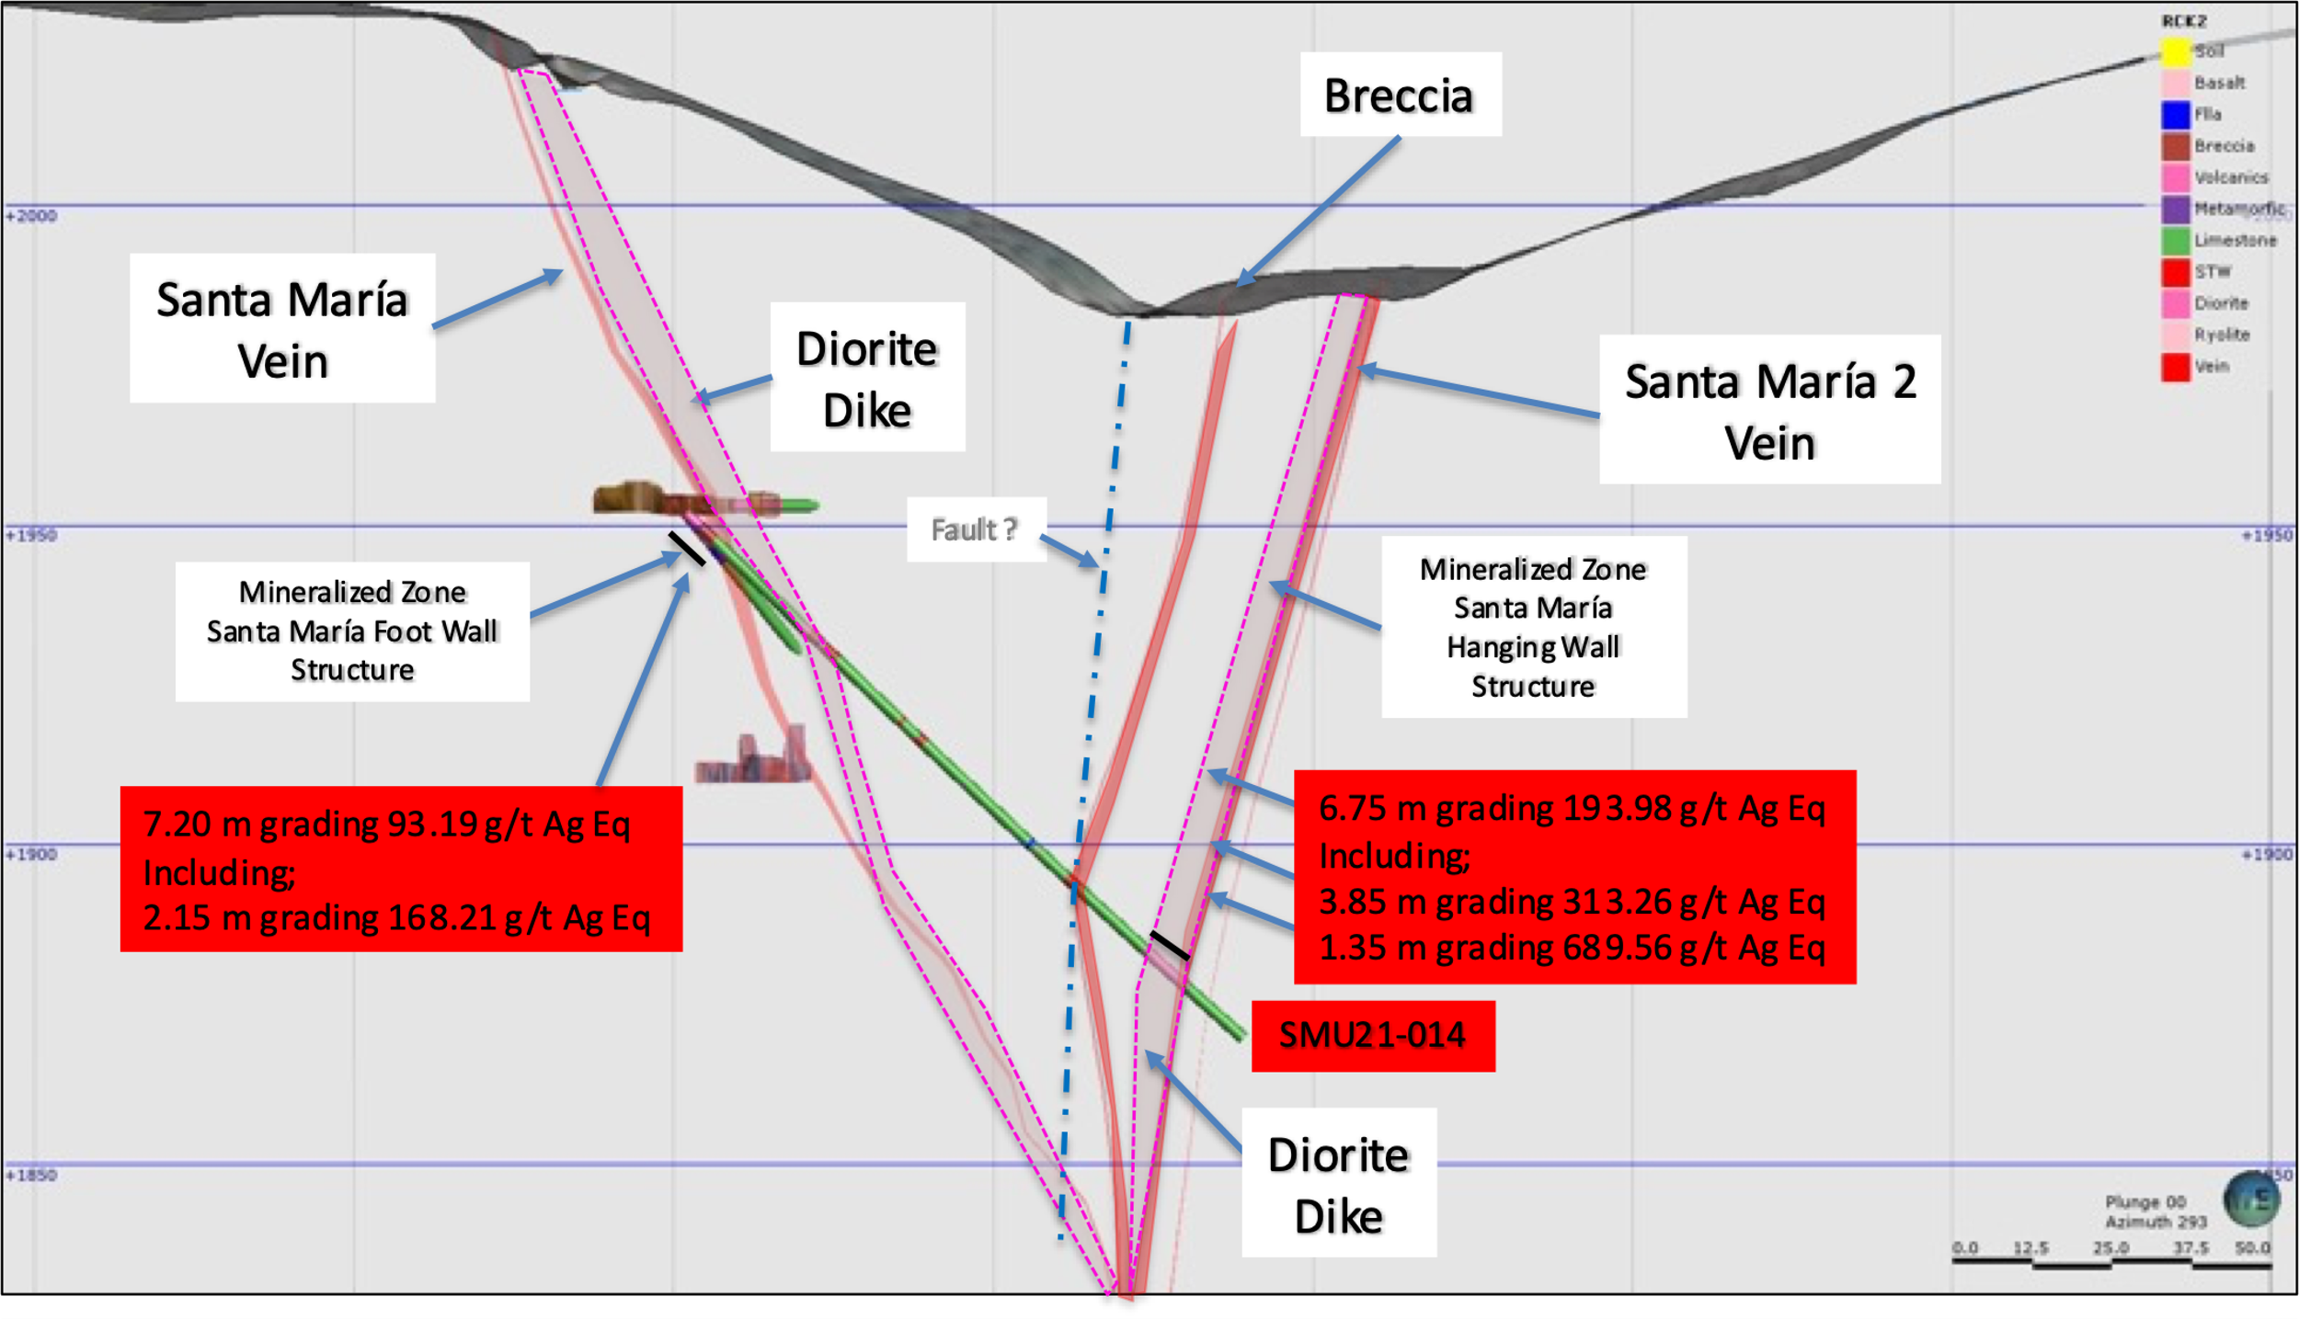

Table 1- Drill hole SMUG 21- 14 Assay Results
Drill Hole | From m | To  m | Width m | Au g/t | Ag g/t | AgEq* g/t | Pb % | Zn % | Cu %
SMUG21-14 | 0.00 | 7.20 | 7.20 | 0.23 | 81.36 | 93.19 | 0.07 | 0.13 | 0.01
Including | 4.00 | 6.15 | 2.15 | 0.49 | 143.00 | 168.21 | 0.15 | 0.27 | 0.01
 | 99.15 | 105.90 | 6.75 | 0.33 | 177.00 | 193.98 | 0.10 | 0.36 | 0.01
Including | 99.15 | 103.00 | 3.85 | 0.53 | 286.00 | 313.26 | 0.16 | 0.57 | 0.01
Including | 99.15 | 100.50 | 1.35 | 1.08 | 634.00 | 689.56 | 0.29 | 0.88 | 0.02
- ** Ag Equivalent (“Ag Eq”) grade is calculated using $20 per ounce Ag and $1,600 Au

Photo 1- Drill hole SMUG 21- 14 Foot Wall Oxidized Vein and Diorite Dike
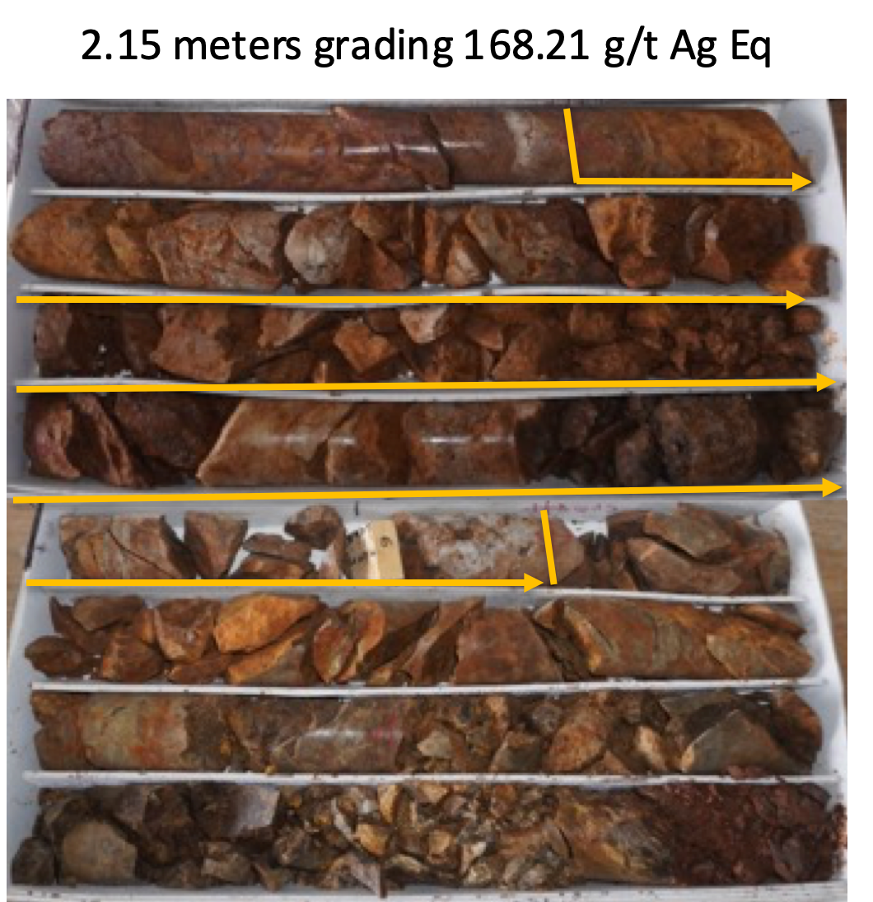

Photo 2- Drill hole SMUG 21- 14 Hanging Wall, Highly Fractured, Oxide Mineralized Diorite Dike
Supergene Enrichment Over 1.35 Meters on The Lower Contact
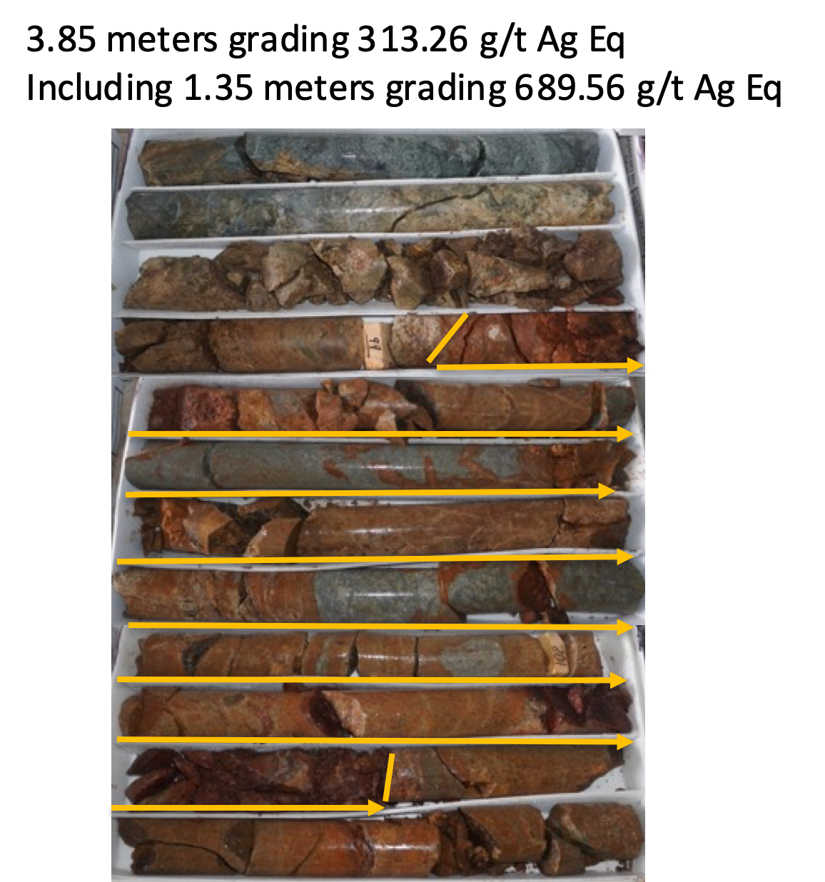

Drill Hole SMUG21-15

Underground drill hole SMUG21- 15 was drilled in the same plane as SMUG21- 14 but collared 50 meters to the west of hole SMUG21-13.

SMUG21-15 was drilled at -45 degrees and was again successful in intercepting the mineralized foot wall structure, followed by a hydrothermal breccia and the hanging wall Santa Maria structure the at a vertical depth of -125 meters.

From the beginning, or the collar, of hole SMUG21-15, and as in the case of holes SMUG21- 13 and 14, the footwall of the Santa Maria structure was intercepted over a distance of 7.90 meters grading 67.50 g/t Ag Eq, which includes 2 intercepts of 1.50 meters which graded 134.11 and 135.58 g/t Ag Eq.
A 1.20 meters intercept of hydrothermal breccia assayed 67.35 g/t Ag Eq which was followed by the hanging wall zone of 1.80 meters, of which 0.20 meters reported 495.50 g/t Ag Eq at the bottom contact of the structure. See Figure 3 below and photos 3 of the Santa Maria foot wall zone and photo 4 of the lower contact of the hanging wall.
Figure 3- Cross Section of Underground Drill Hole SMUG21- 15
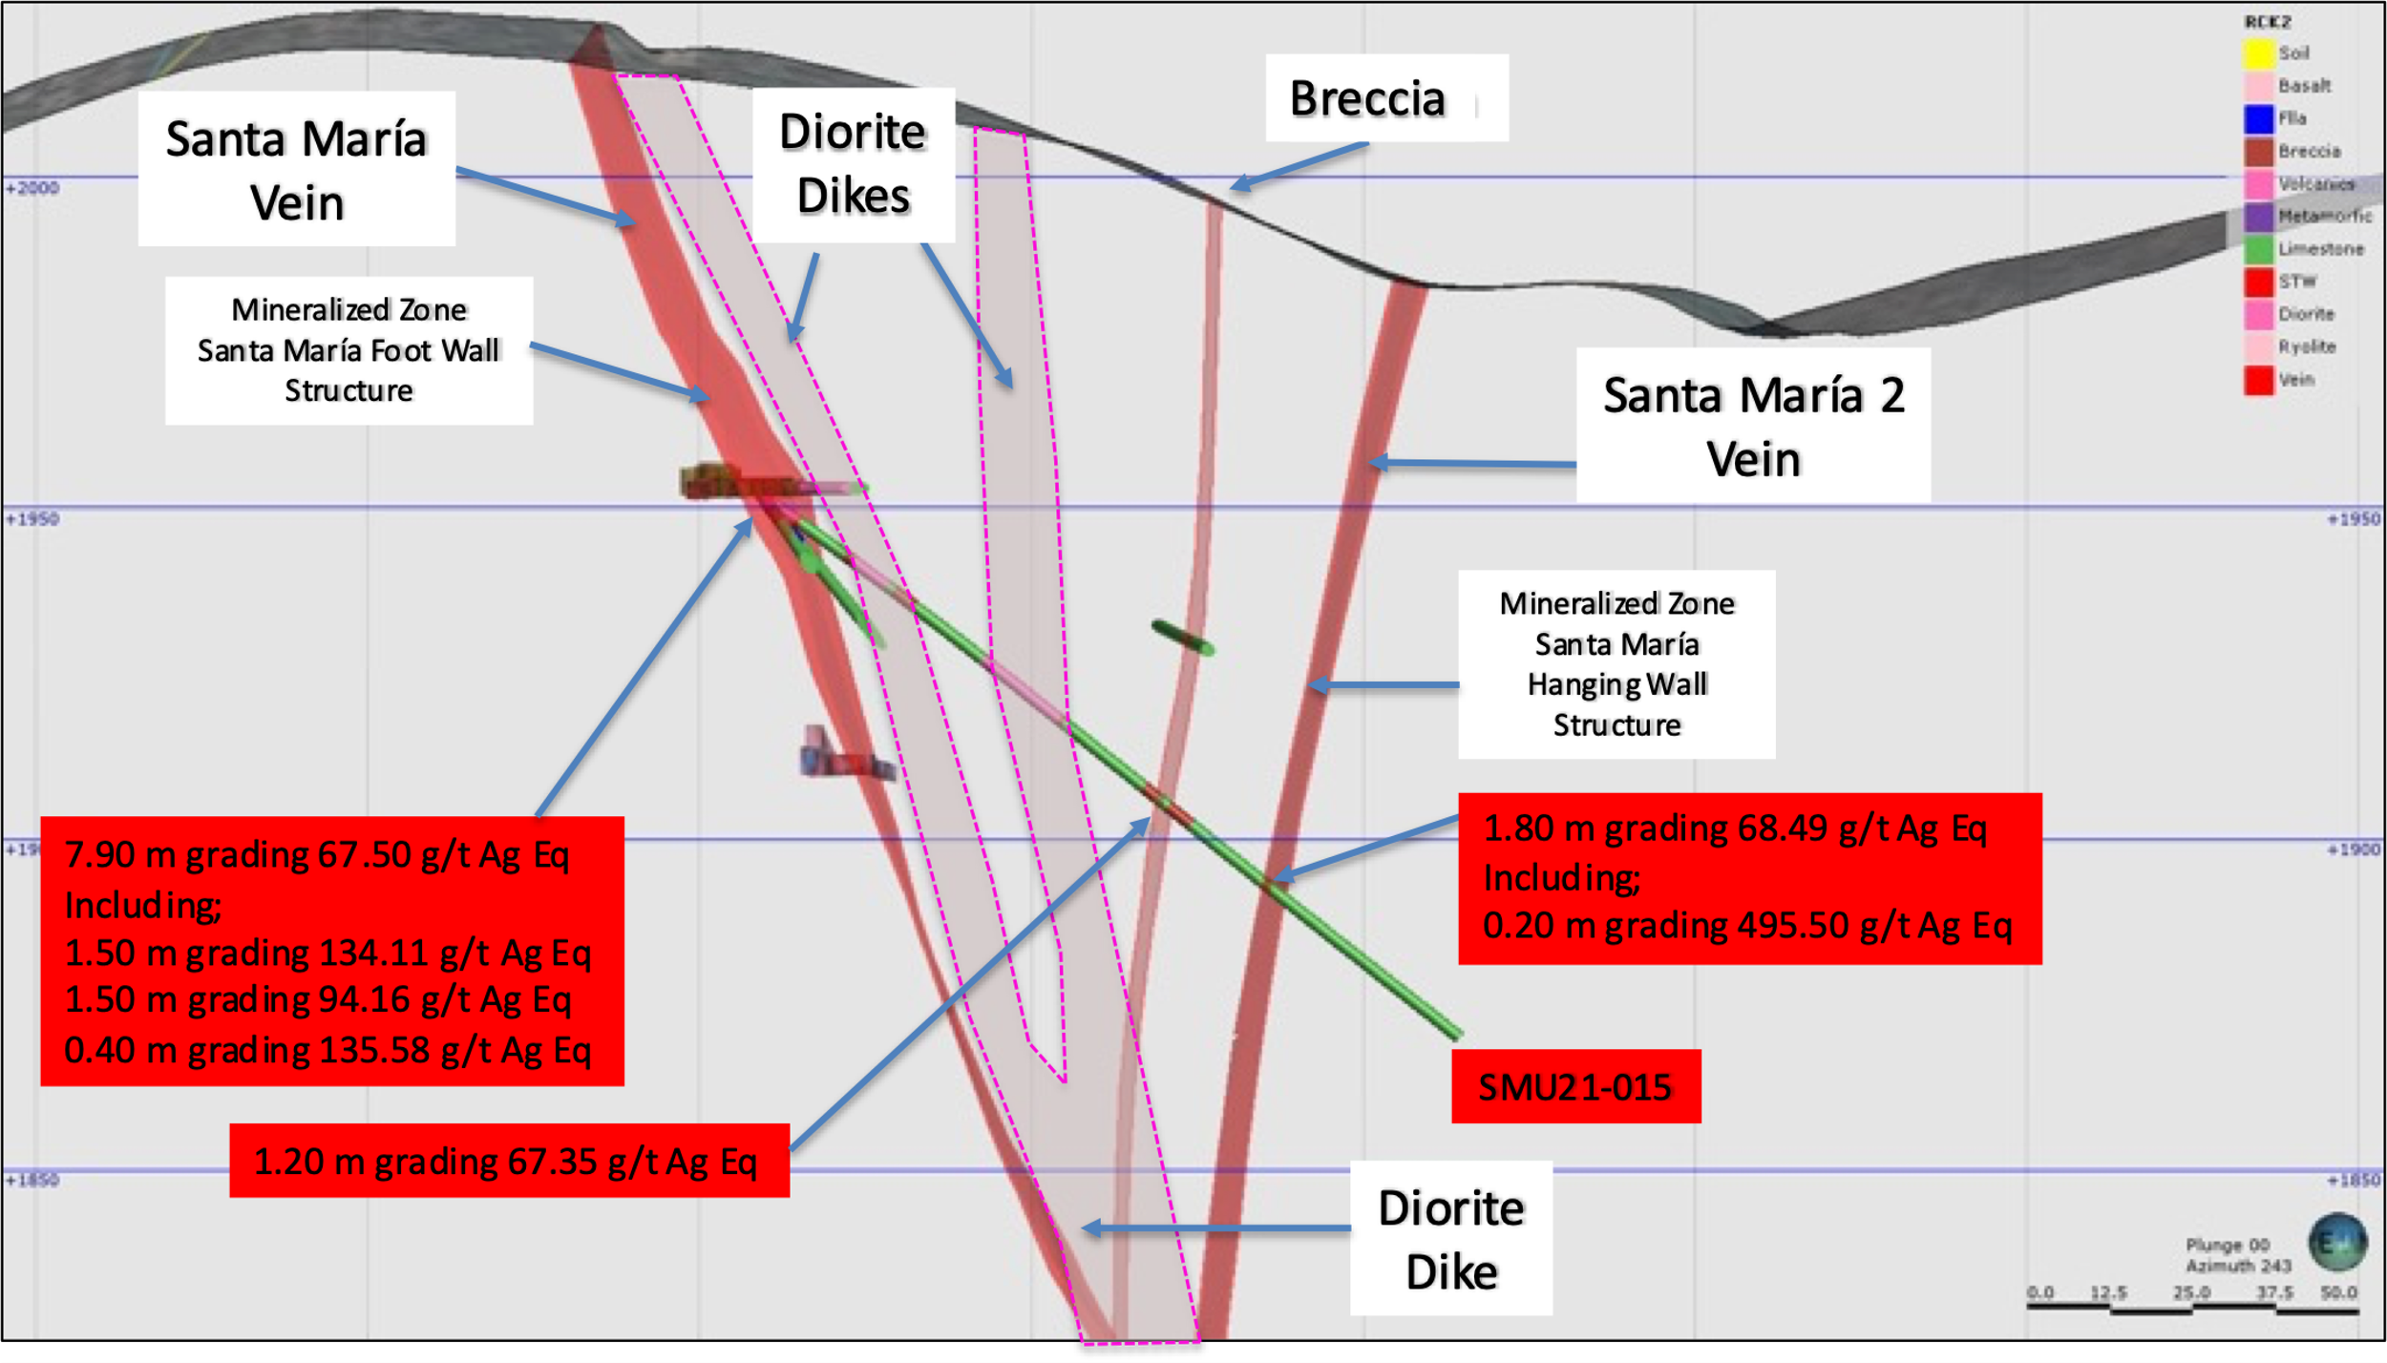

Table 2- Drill hole SMUG21-15 Assay Results
Drill Hole | From m | To  m | Width m | Au  g/t | Ag  g/t | AgEq* g/t | Pb  % | Zn  % | Cu  %
SMUG21- 15 | 0.00 | 7.90 | 7.90 | 0.09 | 62.87 | 67.50 | 0.09 | 0.14 | 0.01
Including | 0.00 | 1.50 | 1.50 | 0.04 | 132.00 | 134.11 | 0.04 | 0.05 | 0.00
Including | 1.50 | 3.00 | 1.50 | 0.08 | 90.30 | 94.16 | 0.04 | 0.06 | 0.00
Including | 6.60 | 7.00 | 0.40 | 0.44 | 113.00 | 135.58 | 0.15 | 0.15 | 0.01
 | 79.80 | 81.00 | 1.20 | 0.11 | 61.90 | 67.35 | 0.00 | 0.03 | 0.00
 | 87.75 | 89.60 | 1.80 | 0.09 | 63.86 | 68.49 | 0.04 | 0.09 | 0.00
Including | 89.40 | 89.60 | 0.20 | 0.38 | 495.50 | 495.50 | 0.26 | 0.72 | 0.01
- ** Ag Equivalent (“Ag Eq”) grade is calculated using $20 per ounce Ag63.86 and $1,600 Au

Photo 3,4 – SMUG21-15 Oxidized Diorite Dike at Santa Maria Footwall
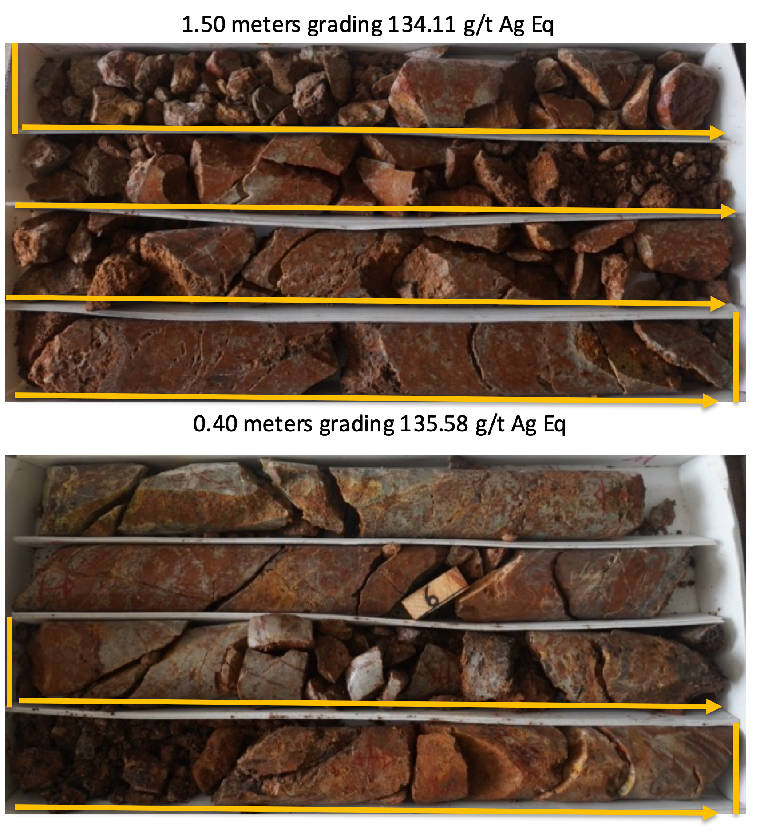

Photo 5 – SMUG21-15; Santa Maria Hanging Wall Vein.
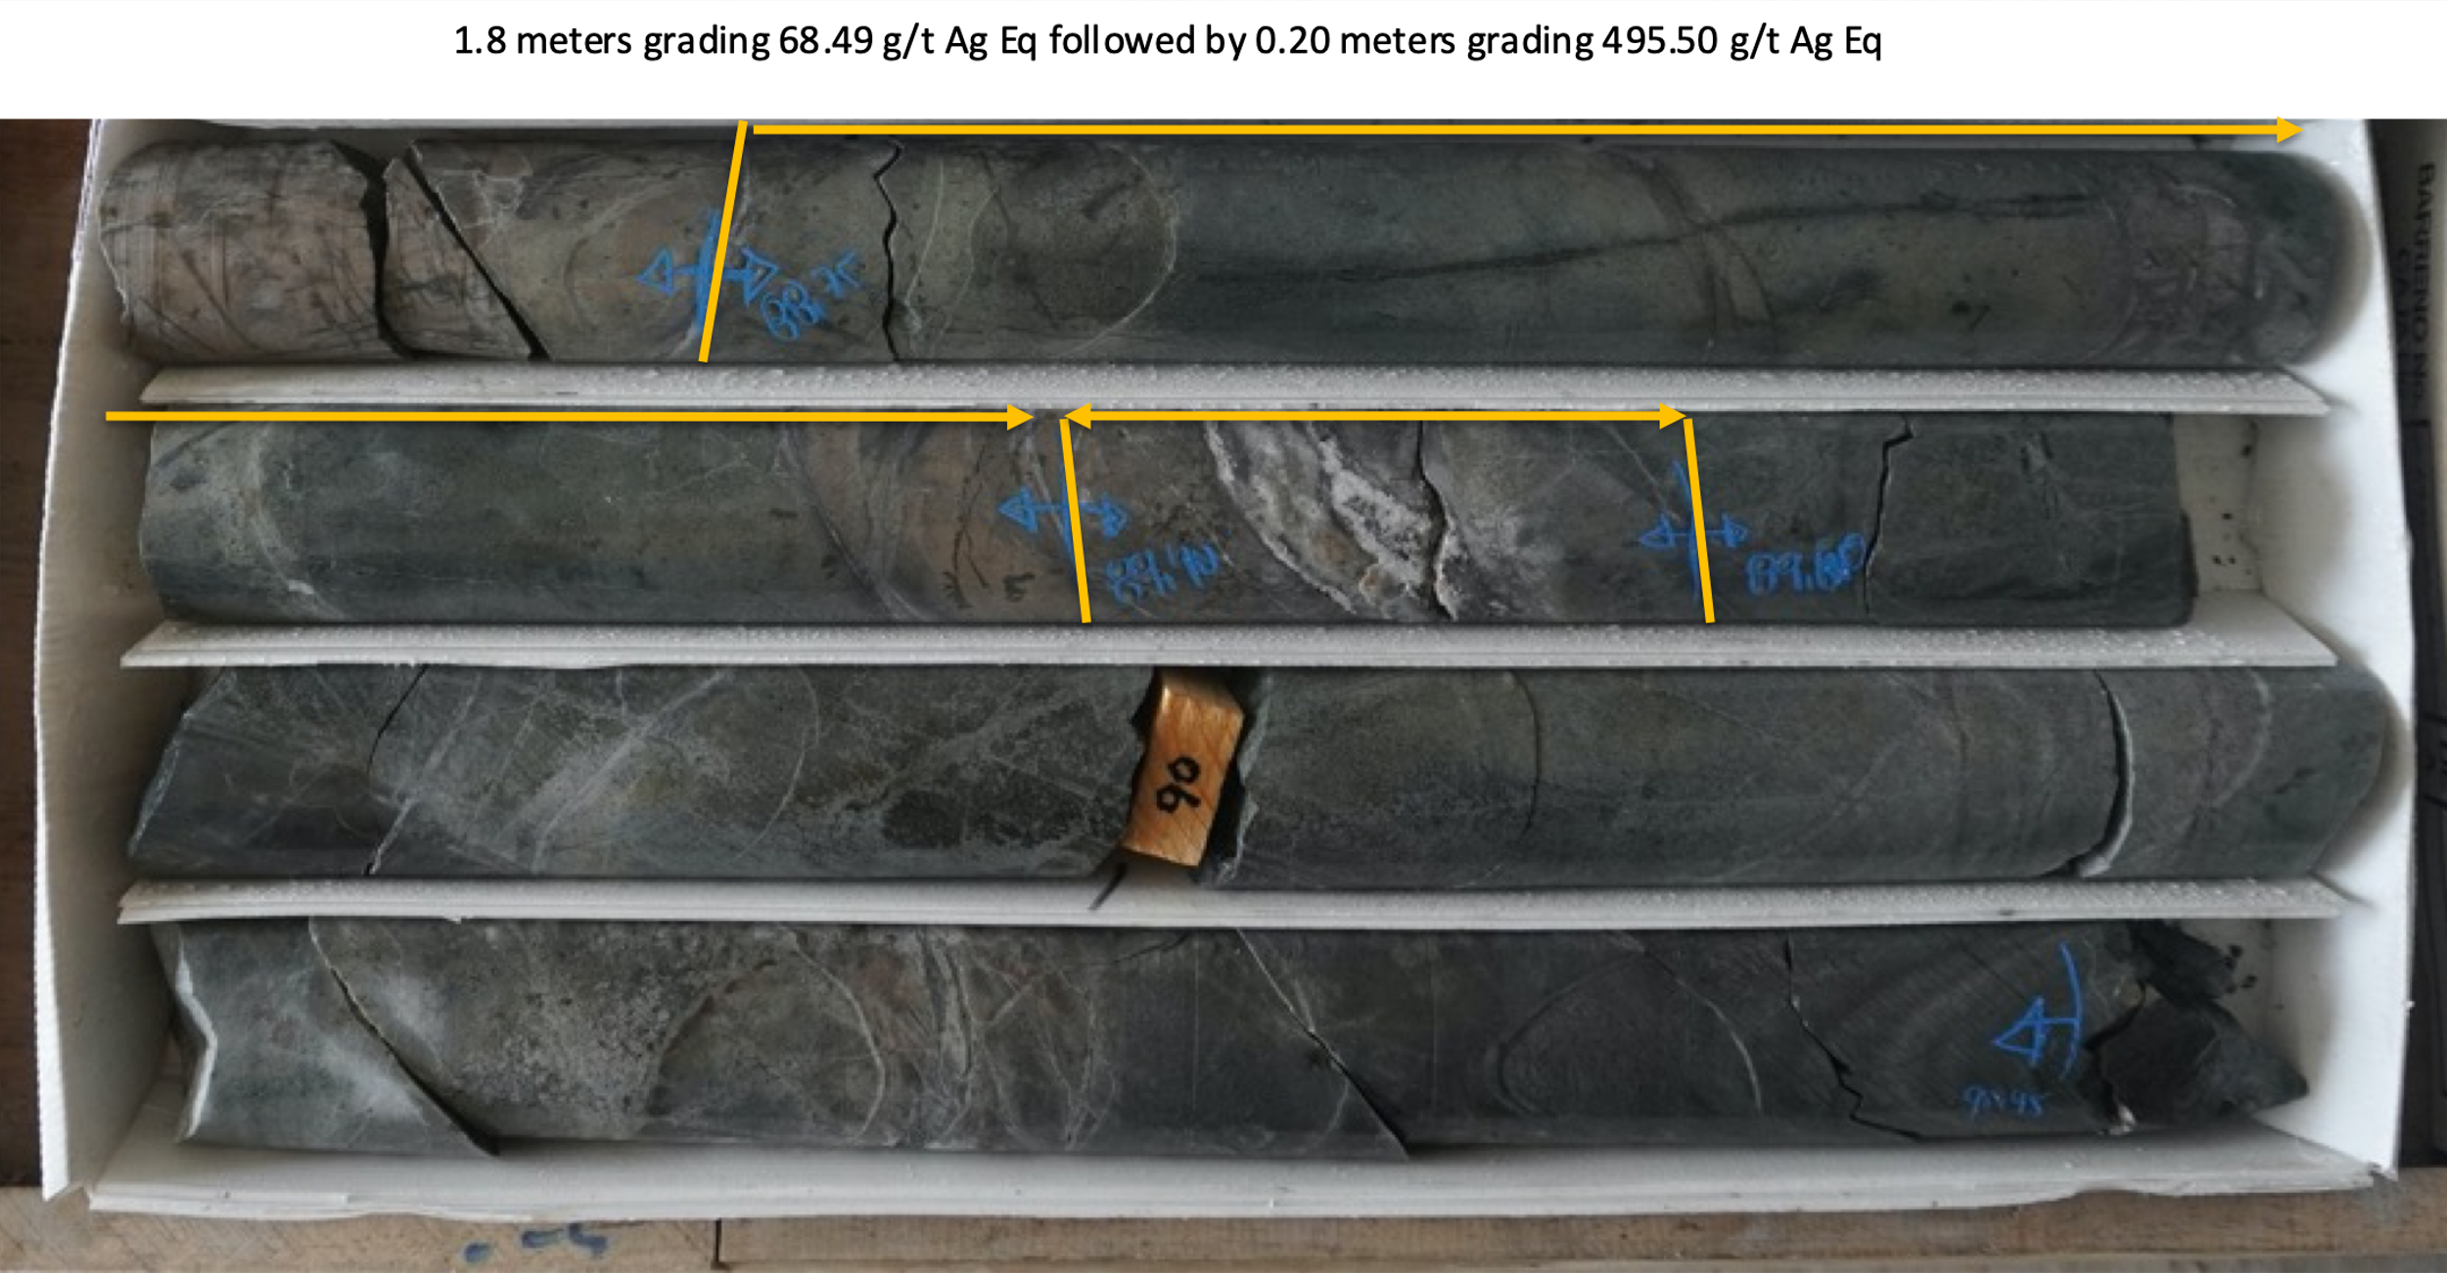

FUTURE UNDERGROUND DRILLING UPDATE

Holes SMUG21- 16, 17 and 18 have been completed and submitted for assay. Hole SMUG21- 18 is the last hole drilled for the underground drill campaign.

QA QC Procedure

Analytical results of sampling reported by Fabled Silver Gold represent core samples that have been sawn in half with half of the core sampled and submitted by Fabled Silver Gold staff directly to ALS Chemex, Chihuahua, Chihuahua, Mexico. Samples were crushed, split, and pulverized as per ALS Chemex method PREP-31, then analyzed for ME-ICP61 33 element package by four acid digestions with ICP-AES Finish. ME-GRA21 method for Au and Ag by fire assay and gravimetric finish, 30g nominal sample weight.
Over Limit Methods
For samples triggering precious metal over-limit thresholds of 10 g/t Au or 100 g/t Ag, the following is being used:
Au-GRA21 Au by fire assay and gravimetric finish with 30 g sample.
Ag-GRA21 Ag by fire assay and gravimetric finish.
Fabled Silver Gold monitors QA/QC using commercially sourced standards and locally sourced blank materials inserted within the sample sequence at regular intervals.

About Fabled Silver Gold Corp.

Fabled is focused on acquiring, exploring and operating properties that yield near-term metal production. The Company has an experienced management team with multiple years of involvement in mining and exploration in Mexico. The Company's mandate is to focus on acquiring precious metal properties in Mexico with blue-sky exploration potential.

The Company has entered into an agreement with Golden Minerals Company (NYSE American and TSX: AUMN) to acquire the Santa Maria Property, a high-grade silver-gold property situated in the center of the Mexican epithermal silver-gold belt. The belt has been recognized as a significant metallogenic province, which has reportedly produced more silver than any other equivalent area in the world.

Mr. Peter J. Hawley, President and C.E.O.
Fabled Silver Gold Corp.
Phone: (819) 316-0919
peter@fabledfco.com

For further information please contact:

info@fabledfco.com

The technical information contained in this news release has been approved by Peter J. Hawley, P.Geo. President and C.E.O. of Fabled, who is a Qualified Person as defined in National Instrument 43-101 - Standards of Disclosure for Mineral Projects.

Neither the TSX Venture Exchange nor its Regulations Service Provider (as that term is defined in the policies of the TSX Venture Exchange) does accept responsibility for the adequacy or accuracy of this news release.

Certain statements contained in this news release constitute "forward-looking information" as such term is used in applicable Canadian securities laws. Forward-looking information is based on plans, expectations and estimates of management at the date the information is provided and is subject to certain factors and assumptions, including, that the Company's financial condition and development plans do not change as a result of unforeseen events and that the Company obtains any required regulatory approvals.

Forward-looking information is subject to a variety of risks and uncertainties and other factors that could cause plans, estimates and actual results to vary materially from those projected in such forward-looking information. Some of the risks and other factors that could cause results to differ materially from those expressed in the forward-looking statements include, but are not limited to: impacts from the coronavirus or other epidemics, general economic conditions in Canada, the United States and globally; industry conditions, including fluctuations in commodity prices; governmental regulation of the mining industry, including environmental regulation; geological, technical and drilling problems; unanticipated operating events; competition for and/or inability to retain drilling rigs and other services; the availability of capital on acceptable terms; the need to obtain required approvals from regulatory authorities; stock market volatility; volatility in market prices for commodities; liabilities inherent in mining operations; changes in tax laws and incentive programs relating to the mining industry; as well as the other risks and uncertainties applicable to
the Company as set forth in the Company's continuous disclosure filings filed under the Company's profile at www.sedar.com. The Company undertakes no obligation to update these forward-looking statements, other than as required by applicable law.

