March 31, 202 | TSX-V: FCO

Fabled Reports on Drill Holes SM20 – 07 - 11

Vancouver, British Columbia – Fabled Silver Gold Corp. (“Fabled” or the “Company”) (TSXV: FCO; OTCQB: FBSGF, and FSE: 7NQ) is pleased to announce updates of diamond drill holes SM20-07 - 11 from the on-going 8,000 meter drill program on the “Santa Maria” Property in Parral, Mexico.

Peter J. Hawley, CEO and President, remarks, “We are heading into areas never explored before, with new ideas to test our structure-on-structure theory over the Property. Hole SM20-07 intercepted two broad zones of northwest trending, never seen before, semi-massive marcasite, (pyrite) in hornfels, and to the east 225 meters, we tried to cross the major C1 regional north – south fault in the center of the Property.”

Hole SM20-07 was drilled at -50 degrees and 246.0 meters in length from same drill station as hole SM20-03 at an angle of 210 degree azimuth and designed to test the tail end of two northwest trending IP anomalies labeled IPSM-08. Northwest trending anomalies or structures have not been seen previously on the Property.

Drill results clearly demonstrate the cause of the two conductive zones, with a 19.90 meter intersection from 145.50 – 165.30 meters and a second 78 meter interval from 167 – 245 meters of greenish hornfels, (a metamorphic rock formed by the contact between a mudstone / shale (clay rich rock) and a hot igneous body, usually at shallow depths), with strong chlorite / sericite alteration with 25-30% marcasite, (white iron pyrite, FeS2 ). See Plan View of Drill Hole Locations below.

Drill hole SM20-08 was collared approximately 225 meters east of the drill station for holes SM20-4, 5, and 6. See drill plan below as designed to drill thru the interpreted main north – south structure at an oblique angle and hit the Santa Maria structure.

The hole was drilled with NQ size core, 1 7/8th inches at -50 degrees for a premature total depth of 64.18 meters where the hole was terminated by major faulting and could not be advanced further.

Drill hole SM20-08B was a re-entry into hole SM20-08 with larger PQ size drill core, 3.36 inches in diameter, to compensate for the massive broken structure, which allowed the hole to be drilled to a final depth of 234 meters and was successful in reaching its target. Currently all sampled drill core of interest is being tested. See Cross Section View below.

Drill hole SM20-09 was drilled with PQ size core from the collar, in anticipation of bad ground conditions, at -60 degrees for a targeted depth of -250 meters to hit the Santa Maria structure, as encountered in hole 8B and was terminated prematurely at 231 meters where not only did the hole collapse due to the fault but jammed the drill rods and a section of the drill string and bit was left in the hole.

Drill hole SM20-10 was designed to follow up on the hole SM20-8B targeted intercept but also to replace the loss of hole SM20-09.

HoleSM20-10 was drilled with PQ size core from the collar, in anticipation of bad ground conditions as seen previously, at -70 degrees for a targeted depth of -220 meters to hit the Santa Maria structure, as encountered in hole SM20-08B. The hole was successful in its objective and as such stopped at a total depth of 227.5 meters. Currently all sampled drill core of interest is being tested. See Cross Section View below.

Drill hole SM20-11 is located approximately 125 meters northeast of drill hole station 4 for holes SM20-08, 8B, 9, and 10. See Plan View of Drill Stations below.

The hole was drilled due west, 270 degrees, at -60 degrees targeting the intercept of the major north – south C1 regional structure at the right angle, 90 degree. The hole was successfully completed and drilled to a total depth of 258 meters.

New roads and drill pads have been completed and the drill is currently being moved to drill station 6 for hole SM20- 12. See Plan View of Drill Stations below.

Peter Hawley continues, “We are systematically taking what was previously thought of as simple E-W high grade structure and re-evaluating, with numerous successes to date, in order to develop our new concept which is seen below in the “Plan View of Drill Station Locations over IP Anomalies”. Over the next few drill holes to test blue sky potential in the north of the Property should add to the new data base as we start to dial in the focus of the remaining drill program. With the Company well funded we will continue to explore all targets as they present themselves.”

The Company has completed drill holes SM20-01 – 11 for a total of approximately 2,600 meters of the ongoing 8,000 meter drill program completed to date. Holes SM20-8B and SM20-10 have been sampled and submitted to ALS Chihuahua Laboratory for analysis. Hole SM20-11 is currently being logged and sampled and expected to be sent to the laboratory later this week.

Plan View of Drill Station Locations over IP Anomalies
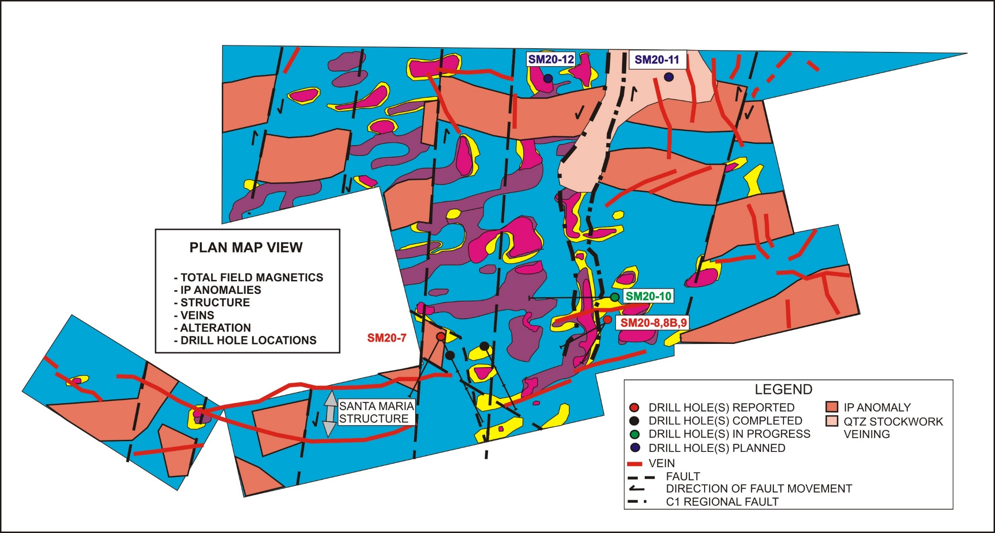

Cross Section View of Drill Hole 8, 9, 10

SM21-010

QA QC Procedure

Analytical results of sampling reported by Fabled Silver Gold represent core samples that have been sawn in half with half of the core sampled and submitted by Fabled Silver Gold staff directly to ALS Chemex, Chihuahua, Chihuahua, Mexico. Samples were crushed, split, and pulverized as per ALS Chemex method PREP-31, then analyzed for ME-ICP61 33 element package by four acid digestion with ICP-AES Finish. ME-GRA21 method for Au and Ag by fire assay and gravimetric finish, 30g nominal sample weight.
Over Limit Methods
For samples triggering precious metal over-limit thresholds of 10 g/t Au or 100 g/t Ag, the following is being used:
Au-GRA21 Au by fire assay and gravimetric finish with 30 g sample.
Ag-GRA21 Ag by fire assay and gravimetric finish.
Fabled Silver Gold monitors QA/QC using commercially sourced standards and locally sourced blank materials inserted within the sample sequence at regular intervals.
About Fabled Silver Gold Corp.

Fabled is focused on acquiring, exploring and operating properties that yield near-term metal production. The Company has an experienced management team with multiple years of involvement in mining and exploration in Mexico. The Company's mandate is to focus on acquiring precious metal properties in Mexico with blue-sky exploration potential.

The Company has entered into an agreement with Golden Minerals Company (NYSE American and TSX: AUMN) to acquire the Santa Maria Property, a high-grade silver-gold property situated in the center of the Mexican epithermal silver-gold belt. The belt has been recognized as a significant metallogenic province, which has reportedly produced more silver than any other equivalent area in the world.

Mr. Peter J. Hawley, President and C.E.O.
Fabled Silver Gold Corp.
Phone: (819) 316-0919
peter@fabledfco.com

For further information please contact:

info@fabledfco.com

The technical information contained in this news release has been approved by Peter J. Hawley, P.Geo. President and C.E.O. of Fabled, who is a Qualified Person as defined in National Instrument 43-101 - Standards of Disclosure for Mineral Projects.

Neither the TSX Venture Exchange nor its Regulations Service Provider (as that term is defined in the policies of the TSX Venture Exchange) does accept responsibility for the adequacy or accuracy of this news release.

Certain statements contained in this news release constitute "forward-looking information" as such term is used in applicable Canadian securities laws. Forward-looking information is based on plans, expectations and estimates of management at the date the information is provided and is subject to certain factors and assumptions, including, that the Company's financial condition and development plans do not change as a result of unforeseen events and that the Company obtains any required regulatory approvals.

Forward-looking information is subject to a variety of risks and uncertainties and other factors that could cause plans, estimates and actual results to vary materially from those projected in such forward-looking information. Some of the risks and other factors that could cause results to differ materially from those expressed in the forward-looking statements include, but are not limited to: impacts from the coronavirus or other epidemics, general economic conditions in Canada, the United States and globally; industry conditions, including fluctuations in commodity prices; governmental regulation of the mining industry, including environmental regulation; geological, technical and drilling problems; unanticipated operating events; competition for and/or inability to retain drilling rigs and other services; the availability of capital on acceptable terms; the need to obtain required approvals from regulatory authorities; stock market volatility; volatility in market prices for commodities; liabilities inherent in mining operations; changes in tax laws and incentive programs relating to the mining industry; as well as the other risks and uncertainties applicable to the Company as set forth in the Company's continuous disclosure filings filed under the Company's profile at www.sedar.com. The Company undertakes no obligation to update these forward-looking statements, other than as required by applicable law.

