NOT FOR DISTRIBUTION TO U.S. NEWS WIRE SERVICES OR DISSEMINATION IN THE U.S.
March 22, 2021 | TSX-V: FCO

Fabled DDH SM20-06 Intercepts Six Silver Bearing Structures Including 5 New Mineralized
North – South Structures Identified

Vancouver, British Columbia – Fabled Silver Gold Corp. (“Fabled” or the “Company”) (TSXV:FCO; OTC:QB:FBSGF, and FSE: 7NQ) is pleased to announce assay results of diamond drill hole 6 from the on-going 8,000 meter drill program on the Santa Maria Property in Parral, Mexico.

Peter J. Hawley, CEO and President, remarks, “This completes the results of the fence of drill holes 4,5 and 6 which are located approximately 125 meters to the east of the previous fence of holes 1, 2 and 3 which have been reported.

Hole SM20-06 was drilled at -50 degrees and 232.0 meters in length and designed to test the various structures in the brittle oxide zone.

Drill results demonstrate, while we are traversing eastwards the edge of a broad secondary north – south structure trend is starting to be encountered with intermittent silver mineralization within the structural fabric. As shown below in Table 1, five silver bearing north – south structures were intercepted before intersecting the targeted East – West Santa Maria structure which intersected 14.7 meters grading 44.92 g/t Ag Eq at -150 meters.

Drill hole SM20-04 which was drilled at -60 below hole SM20-06 intercepted a north – south trending fault which displaced the Santa Maria Structure slightly to the south. This displacement is also quite evident in the first priority east to west northern IP anomaly IPSM-04 which has the same offset as we have encountered.

Further evidence of the north – south trend is found in hole SM20-05 which has not only intersected the edge of Santa Maria structure but has also intersected three additional north – south trending mineralized structures reporting up to 232.08 g/t Ag Eq over 2.20 meters, 162.64 g/t Ag Eq over 0.55 meters and 1.6 meters grading 46.62 g/t Ag Eq before hitting the edge of the displaced Santa Maria structure at -300 meters vertically reporting 53.21 g/t Ag Eq over 7.2 meters.

These intercepts add weight to the proposed theory that not only do the north – south structures slightly off set the east to west structures but they are more importantly mineralized.

Re-logging of previously drilled hole SM-17-10 shows it intersected the north – south structures between hole SM20-04 and 05 at right angles to the structure not along the structure and returned1.40 g/t Au, 862 g/t Ag, 934.02 g/t Ag Eq.

The two fences of drill holes 125 meters apart completes this drill section and adds new structural details to the interpretation on the newly interpreted East – West Santa Maria structure which is clearly defined from surface down to -350 meters vertically, which is the deepest hole ever drilled on the property. The structure remains very conformable and intersected exactly where predicted, which bodes very well for the expansion of Santa Maria and increasing the present NI 43-101 resources on the property with only 5 drill holes drilled to date.

We expect to see the effect of the North – South structural fabric to become more intense as we move to the next fence of holes a further 200 meters to the east and expected to be in the middle of what is interpreted to be the center of the broad North – South structure intersecting the Santa Maria Structure. If this is the case this will set the stage for further investigation of this area.”

Table 1: Drill Hole Intercepts

Hole No | From (meters) | To  (meters) | Width (meters) | Au g/t | Ag g/t | Ag Eq g/t**
SM20-06 | 56.05 | 63.45 | 7.40 | 0.09 | 28.04 | 32.44*
 | 64.95 | 66.00 | 1.05 | 0.06 | 38.10 | 41.39*
 | 96.30 | 96.70 | 0.40 | 0.06 | 49.40 | 52.59*
 | 105.50 | 110.90 | 5.40 | 0.15 | 44.95 | 52.79*
 | 129.00 | 134.30 | 5.30 | 0.10 | 43.23 | 48.38*
 | 216.00 | 230.70 | 14.70 | 0.15 | 37.40 | 44.92
Includes | 223.20 | 226.20 | 3.00 | 0.19 | 54.90 | 64.79
Includes | 223.20 | 224.10 | 0.90 | 0.20 | 79.00 | 89.19
- * North – South Structure
- ** Ag Equivalent (“Ag Eq”) grade is calculated using $20 per ounce Ag and $1,600 Au

Peter Hawley continues, “The data being obtained from this fence of drill holes with the mineralized north – south structures now evident should not only help target adding silver ounces to the overall resource but also allow us to interpret and model the behavior of this robust mineralized system for future drilling as we expand outwards from the present resource. We now have two mineralized plumbing systems starting to intersect which bodes well for the future drilling”

The Company has completed drill holes SM20-07 – 09 for a total of 2,134 meters of the on going 8,000 meter drilled program completed to date. Holes SM20-07 - 09 have been sampled and submitted to ALS Chihuahua Laboratory for analysis. Hole SM 20-10 is in progress.

Plan View of Drill Station Locations over IP Anomalies

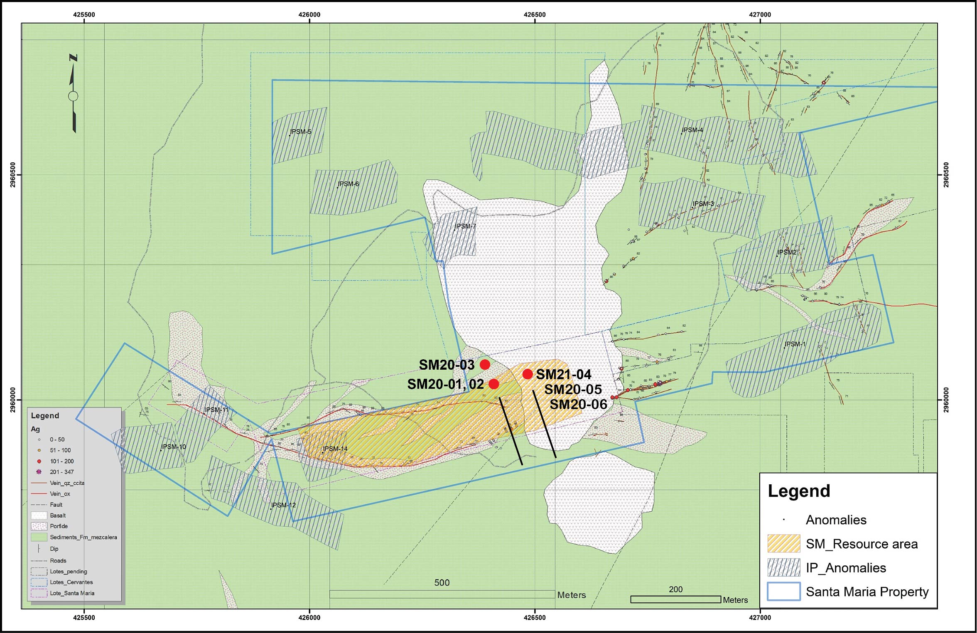

Cross Section View of Drill Hole Intercepts

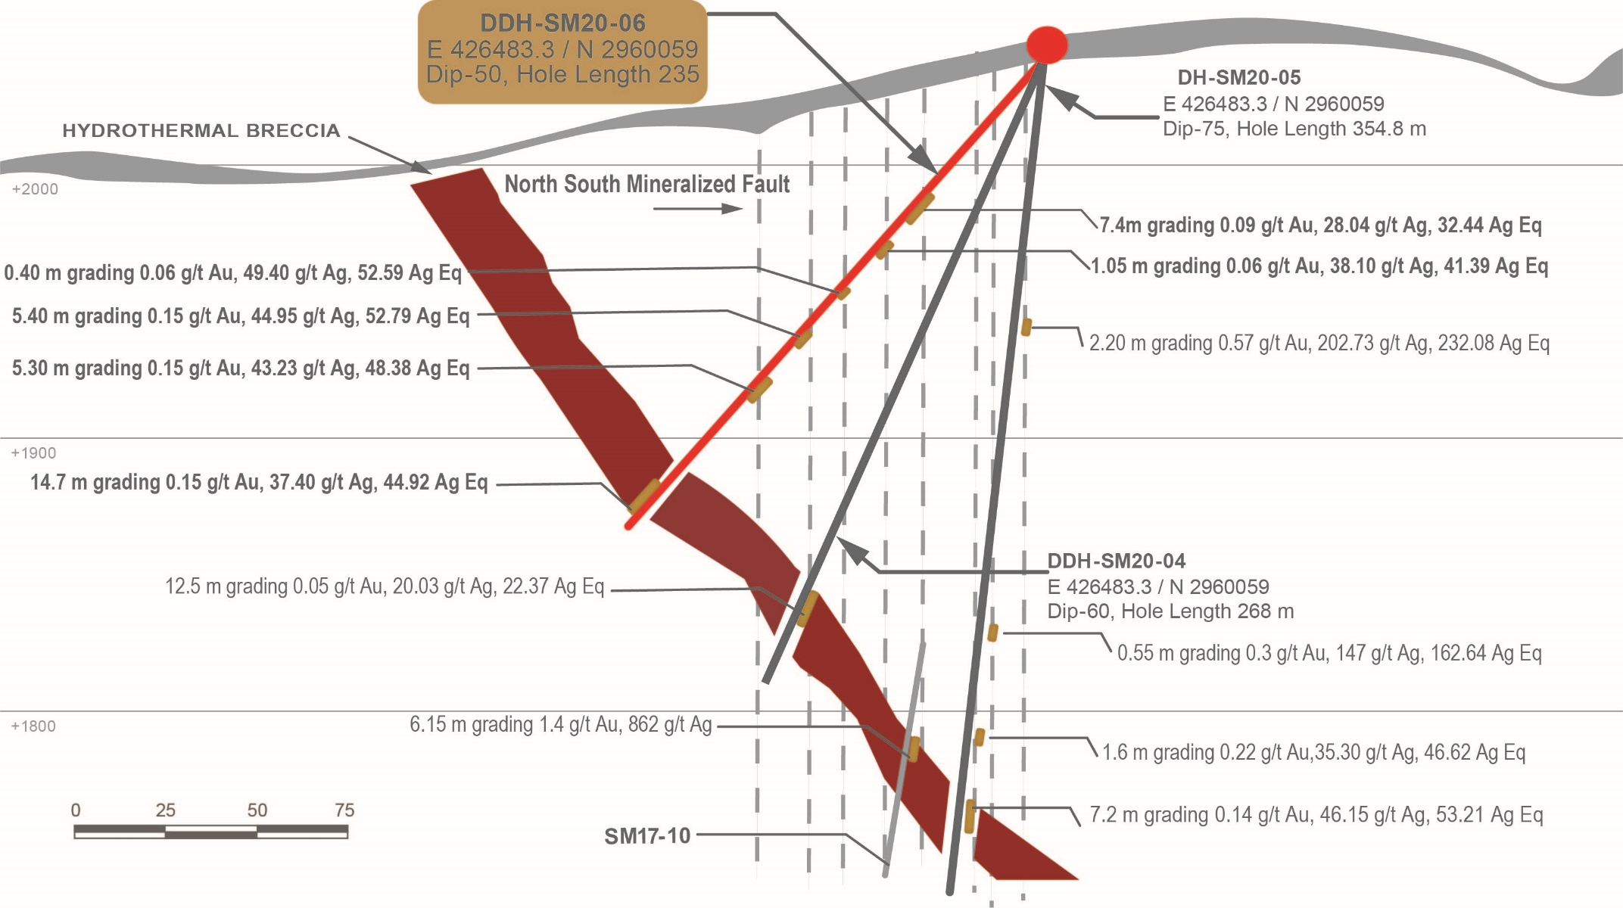

QA QC Procedure

Analytical results of sampling reported by Fabled Silver Gold represent core samples that have been sawn in half with half of the core sampled and submitted by Fabled Silver Gold staff directly to ALS Chemex, Chihuahua, Chihuahua, Mexico. Samples were crushed, split, and pulverized as per ALS Chemex method PREP-31, then analyzed for ME-ICP61 33 element package by four acid digestion with ICP-AES Finish. ME-GRA21 method for Au and Ag by fire assay and gravimetric finish, 30g nominal sample weight.
Over Limit Methods
For samples triggering precious metal over-limit thresholds of 10 g/t Au or 100 g/t Ag, the following is being used:
Au-GRA21 Au by fire assay and gravimetric finish with 30 g sample.
Ag-GRA21 Ag by fire assay and gravimetric finish.
Fabled Silver Gold monitors QA/QC using commercially sourced standards and locally sourced blank materials inserted within the sample sequence at regular intervals.

About Fabled Silver Gold Corp.

Fabled is focused on acquiring, exploring and operating properties that yield near-term metal production. The Company has an experienced management team with multiple years of involvement in mining and exploration in Mexico. The Company's mandate is to focus on acquiring precious metal properties in Mexico with blue-sky exploration potential.

The Company has entered into an agreement with Golden Minerals Company (NYSE American and TSX: AUMN) to acquire the Santa Maria project, a high-grade silver-gold property situated in the center of the Mexican epithermal silver-gold belt. The belt has been recognized as a significant metallogenic province, which has reportedly produced more silver than any other equivalent area in the world.

Mr. Peter J. Hawley, President and C.E.O.
Fabled Silver Gold Corp.
Phone: (819) 316-0919
peter@fabledfco.com

For further information please contact:

info@fabledfco.com

The technical information contained in this news release has been approved by Peter J. Hawley, P.Geo. President and C.E.O. of Fabled, who is a Qualified Person as defined in National Instrument 43-101 - Standards of Disclosure for Mineral Projects.

Neither the TSX Venture Exchange nor its Regulations Service Provider (as that term is defined in the policies of the TSX Venture Exchange) does accept responsibility for the adequacy or accuracy of this news release.

Certain statements contained in this news release constitute "forward-looking information" as such term is used in applicable Canadian securities laws. Forward-looking information is based on plans, expectations and estimates of management at the date the information is provided and is subject to certain factors and assumptions, including, that the Company's financial condition and development plans do not change as a result of unforeseen events and that the Company obtains any required regulatory approvals.

Forward-looking information is subject to a variety of risks and uncertainties and other factors that could cause plans, estimates and actual results to vary materially from those projected in such forward-looking information. Some of the risks and other factors that could cause results to differ materially from those expressed in the forward-looking statements include, but are not limited to: impacts from the coronavirus or other epidemics, general economic conditions in Canada, the United States and globally; industry conditions, including fluctuations in commodity prices; governmental regulation of the mining industry, including environmental regulation; geological, technical and drilling problems; unanticipated operating events; competition for and/or inability to retain drilling rigs and other services; the availability of capital on acceptable terms; the need to obtain required approvals from regulatory authorities; stock market volatility; volatility in market prices for commodities; liabilities inherent in mining operations; changes in tax laws and incentive programs relating to the mining industry; as well as the other risks and uncertainties applicable to the Company as set forth in the Company's continuous disclosure filings filed under the Company's profile at www.sedar.com. The Company undertakes no obligation to update these forward-looking statements, other than as required by applicable law.

